|  |
| --- |
| Add School LOGO |
| School Name – Climate Action Plan |

Date written -

Review date -

Signature from Senior leadership -

**What have we already achieved?**

|  |  |
| --- | --- |
| **Actions** | **Benefits to school** |
|  |  |
|  |  |
|  |  |
|  |  |
|  |  |

**When will learners and staff be engaged in ideas generation for actions in our climate action plan?**

|  |  |  |
| --- | --- | --- |
| **Community engaged** | **When?** | **How?** |
| Learners |  |  |
| Staff |  |  |
| Leadership and governors |  |  |
| Parents and care givers |  |  |

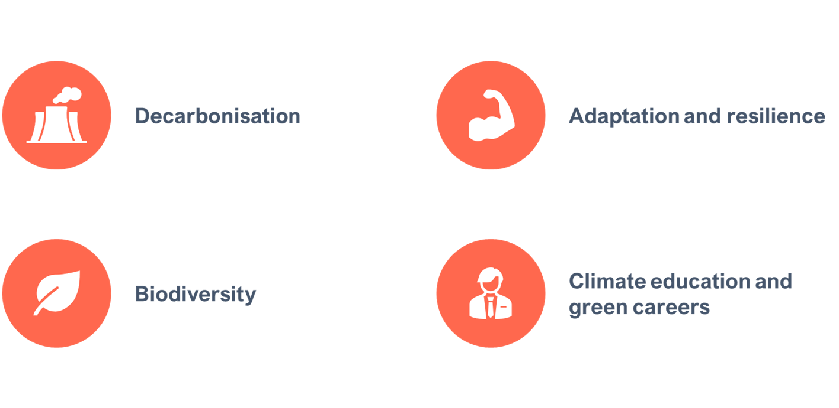

**Pillar 1 – Biodiversity**

**Vision – A better environment for future generations: enhancing biodiversity, improving air quality and increasing access to, and connection with, nature in and around education and care settings.**

**Areas of action**

* Increase biodiversity in and around education settings​
* Improve air quality in and around education settings ​
* Create opportunities for children to access nature​
* Develop the skills and confidence of learners to take care of their local environment

**Co-benefits of biodiversity pillar -**

* Mental health and wellbeing
* Physical health
* Careers and skills of learners

**School specific goals -**

* e.g All students to have access to natural space

**SCHOOL NAME’S long-term goals in biodiversity**

|  |  |  |  |  |
| --- | --- | --- | --- | --- |
| **Action** | **Timescale to complete** | **Resources required** | **People to involve** | **Measures of success** |
|  |  |  |  |  |
|  |  |  |  |  |
|  |  |  |  |  |
|  |  |  |  |  |
|  |  |  |  |  |
|  |  |  |  |  |

**Pillar 2 – Decarbonisation**

**Vision statement – Net zero: reducing direct and indirect emissions from education and care buildings, driving innovation to meet legislative targets and providing opportunities for children and young people to engage practically in the transition to net zero.**

**Areas of action**

Reducing emissions created through:

* Energy usage and utilities
* Purchasing and services
* Transport to and from school
* Food and drinks

**Co-benefits of Decarbonisation pillar**

* Cost reductions through increased efficiency (school materials, food and energy)

**School specific goals -**

* e.g 50 % reduction in food waste

**SCHOOL NAME’S long-term goals in decarbonisation**

|  |  |  |  |  |
| --- | --- | --- | --- | --- |
| **Action** | **Timescale to complete** | **Resources required** | **People to involve** | **Measures of success** |
|  |  |  |  |  |
|  |  |  |  |  |
|  |  |  |  |  |
|  |  |  |  |  |
|  |  |  |  |  |
|  |  |  |  |  |

**Pillar 3 – Adaptation and Resilience**

**Vision – Resilience to climate change: adapting our education and care buildings and system to prepare for the effects of climate change.**

**Areas of action**

* Reducing the effects of overheating and/or flooding through physical or operational changes to the site
* Developing resilience in education settings to extreme weather events
* Developing staff, learner and community resilience to a changing environment

**Co-benefits of Adaptation and Resilience pillar for students**

* Attainment – students education is not affected by extreme weather

**School specific goals -**

* e.g Creating outdoor space that reduces overheating for learners
* e.g Whole-school (learners, staff and parents) prepared for heatwave days

**SCHOOL NAME’S long-term goals in adaptation and resilience**

|  |  |  |  |  |
| --- | --- | --- | --- | --- |
| **Action** | **Timescale to complete** | **Resources required** | **People to involve** | **Measures of success** |
|  |  |  |  |  |
|  |  |  |  |  |
|  |  |  |  |  |
|  |  |  |  |  |
|  |  |  |  |  |
|  |  |  |  |  |



**Pillar 4 – Climate Education and Green Careers**

**Vision statement – Excellence in education and skills for a changing world: preparing all young people for a world impacted by climate change through learning and practical experience.**

**Areas of action**

* Embedding climate education across the curriculum
* Building green skills in learners, staff and the education setting community
* Provide students with skills and opportunities to pursue

**Co-benefits of Climate Education and green careers pillar for students**

* Students prepared with skills they need for a future net zero world (employability, resilience and can play an active role in building a just transition)

**School specific goals -**

* E.g Embed climate education across curriculum
* E.g Have a yearly green careers week
* E.g Build agency in students to lead on taking climate action

**SCHOOL NAME’S long-term goals in adaptation and resilience**

|  |  |  |  |  |
| --- | --- | --- | --- | --- |
| **Action** | **Timescale to complete** | **Resources required** | **People to involve** | **Measures of success** |
|  |  |  |  |  |
|  |  |  |  |  |
|  |  |  |  |  |
|  |  |  |  |  |
|  |  |  |  |  |
|  |  |  |  |  |