Add School LOGO

School Name – Climate Action Plan

Date written -
Review date -
Signature from Senior leadership -
What have we already achieved?
Actions | Benefits to school

When will learners and staff be engaged in ideas generation for actions in our climate action plan?
Community engaged | When? | How?
Learners
Staff
Leadership and governors
Parents and care givers

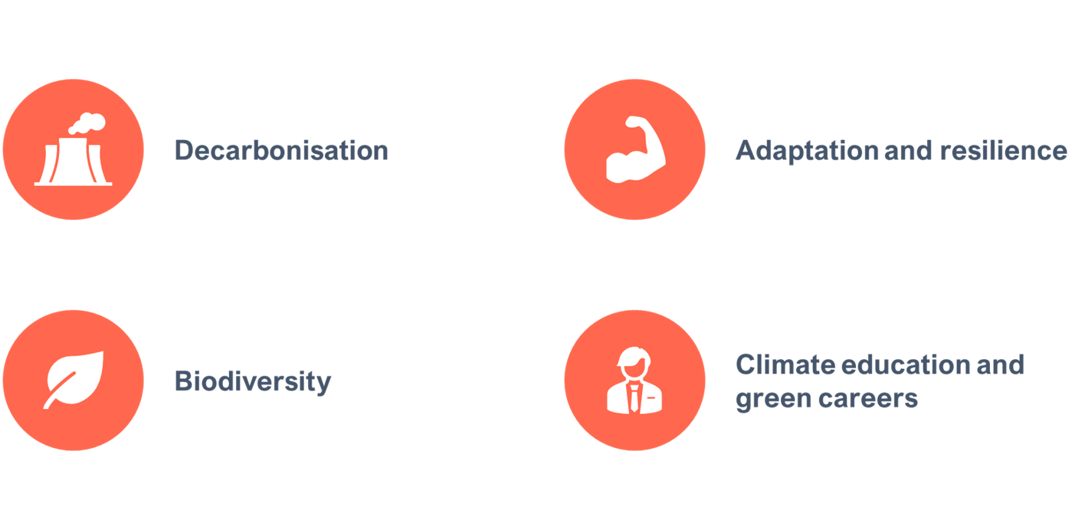
Pillar 1 – Biodiversity
Vision – A better environment for future generations: enhancing biodiversity, improving air quality and increasing access to, and connection with, nature in and around education and care settings.
Areas of action
- Increase biodiversity in and around education settings​
- Improve air quality in and around education settings ​
- Create opportunities for children to access nature​
- Develop the skills and confidence of learners to take care of their local environment
Co-benefits of biodiversity pillar -
- Mental health and wellbeing
- Physical health
- Careers and skills of learners
School specific goals -
- e.g All students to have access to natural space
SCHOOL NAME’S long-term goals in biodiversity

Action | Timescale to complete | Resources required | People to involve | Measures of success

Pillar 2 – Decarbonisation
Vision statement – Net zero: reducing direct and indirect emissions from education and care buildings, driving innovation to meet legislative targets and providing opportunities for children and young people to engage practically in the transition to net zero.
Areas of action
Reducing emissions created through:
- Energy usage and utilities
- Purchasing and services
- Transport to and from school
- Food and drinks
Co-benefits of Decarbonisation pillar
- Cost reductions through increased efficiency (school materials, food and energy)
School specific goals -
- e.g 50 % reduction in food waste

SCHOOL NAME’S long-term goals in decarbonisation

Action | Timescale to complete | Resources required | People to involve | Measures of success

Pillar 3 – Adaptation and Resilience
Vision – Resilience to climate change: adapting our education and care buildings and system to prepare for the effects of climate change.
Areas of action
- Reducing the effects of overheating and/or flooding through physical or operational changes to the site
- Developing resilience in education settings to extreme weather events
- Developing staff, learner and community resilience to a changing environment
Co-benefits of Adaptation and Resilience pillar for students
- Attainment – students education is not affected by extreme weather
School specific goals -
- e.g Creating outdoor space that reduces overheating for learners
- e.g Whole-school (learners, staff and parents) prepared for heatwave days
SCHOOL NAME’S long-term goals in adaptation and resilience

Action | Timescale to complete | Resources required | People to involve | Measures of success

Pillar 4 – Climate Education and Green Careers
Vision statement – Excellence in education and skills for a changing world: preparing all young people for a world impacted by climate change through learning and practical experience.
Areas of action
- Embedding climate education across the curriculum
- Building green skills in learners, staff and the education setting community
- Provide students with skills and opportunities to pursue
Co-benefits of Climate Education and green careers pillar for students
- Students prepared with skills they need for a future net zero world (employability, resilience and can play an active role in building a just transition)
School specific goals -
- E.g Embed climate education across curriculum
- E.g Have a yearly green careers week
- E.g Build agency in students to lead on taking climate action
SCHOOL NAME’S long-term goals in adaptation and resilience

Action | Timescale to complete | Resources required | People to involve | Measures of success

