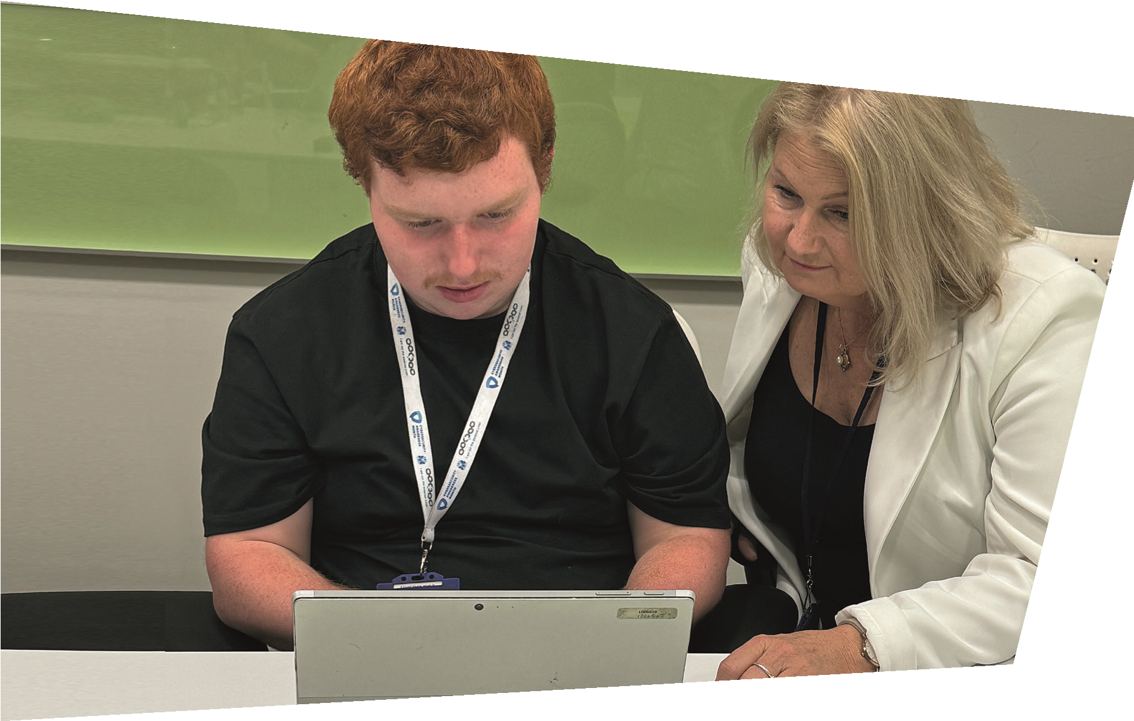
Let’s work together!
Life beyond barriers
Supported

Internship
Partnered

with companies
across

West London
Can you offer work experience

placements to Young Disabled People

and those with additional needs aged 16-24?
Action on Disability offer Mentor training.

Job Coach Support will also be provided.
Understanding how to become disability confident
and knowing how to support the young person has
helped with their own development.
To find out more about partnering with us, then get in touch by:

rabiatu.kuyateh@aod.org.uk
020 7385 2098
www.aod.org.uk
Enquire
We are Action on Disability and in a partnership with local councils and West London College, we run Supported Internships for Disabled Young People and those with additional needs to find paid employment.
The Supported Internships is a one year programme for Disabled Young People aged 16-24 years-old with an EHCP who are ready to progress from education into the workplace.
What can we offer you?
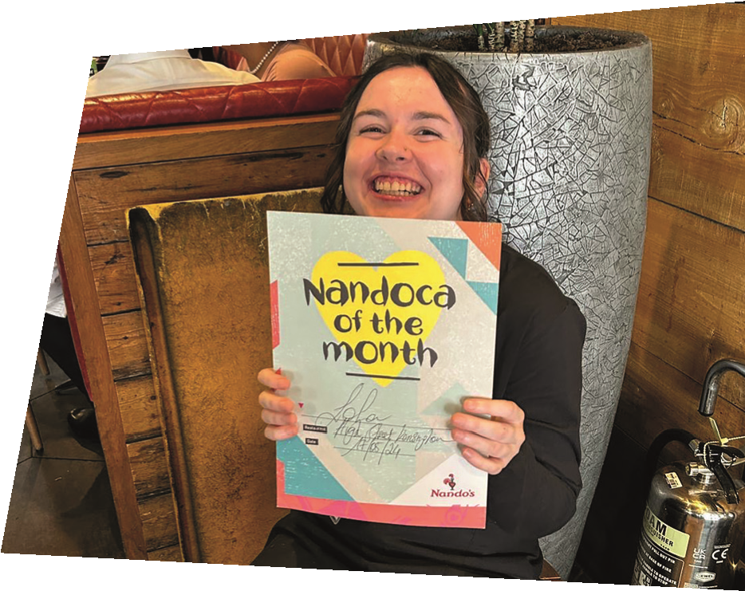
During the work placement, you will have Job Coach support, offering training and awareness. Engagement with the programme with enable you to become a Disability friendly organisation.
✘
✘
✘
✘
Who we are and what is

a supported Internship?
How you can get involved
If your organisation can host a work placement for four days a week, five hours a day, then we would love to work with you. You will be supporting our Disabled Young People to build transferable skills and transition from college into the world of paid employment.
©2024 Action on Disability. Registered charity number 1091518. Photography by Action on Disability.

