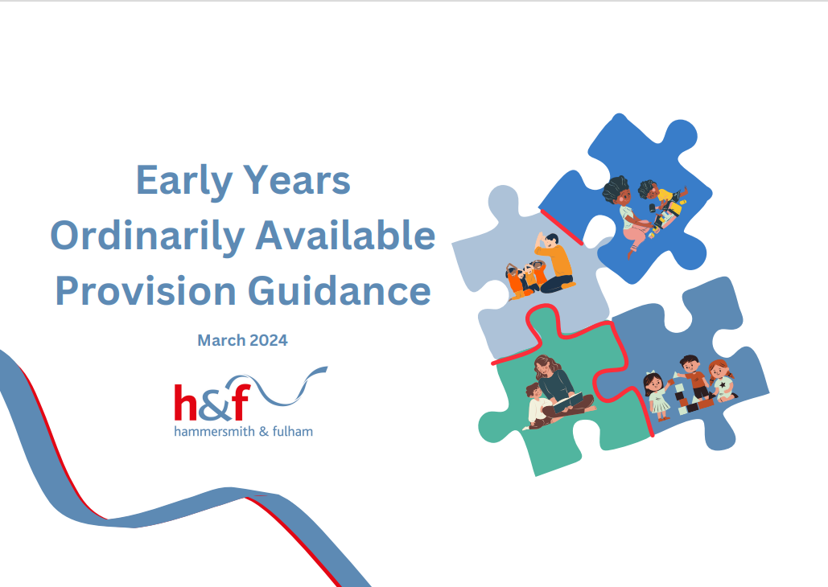

Table of Contents
Acronyms Document 3
Introduction 5
Reasonable Adjustments 7
Waves of Intervention 8
Assess, Plan, Do, Review Specific to Early Years 9
The Four Guiding Principals 10
The Unique Child 11
The Unique Child Summary Page (Print for Display) 18
Positive Relationships 19
Positive Relationships Summary Page (Print for Display) 25
Enabling Environments with Teaching and Support from Adults 26
Enabling Environments Summary Page (Print for Display) 36
Appendix 37

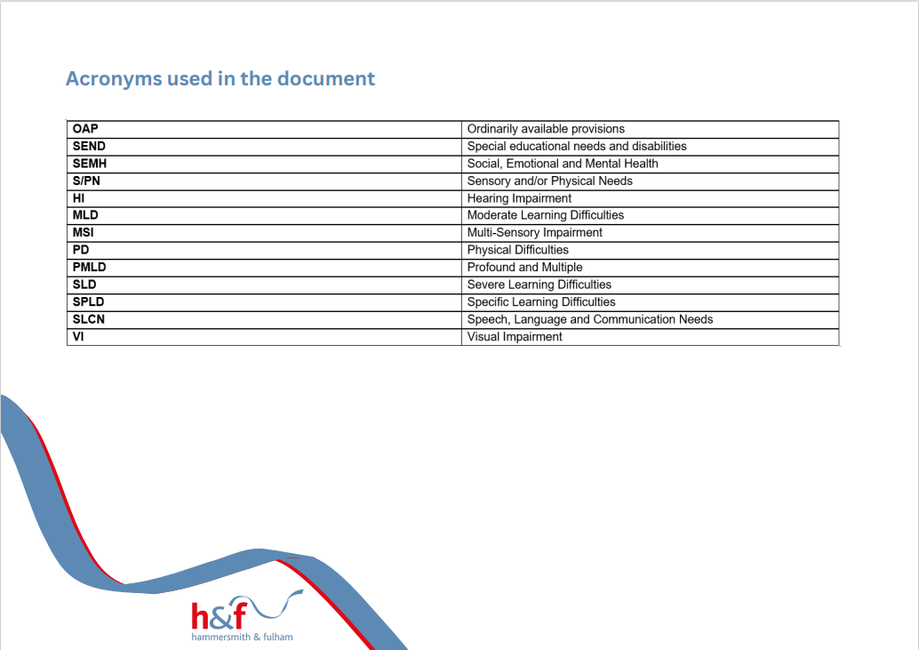
Acronyms Document
Introduction
We aim to ensure that all children with SEND and their families in Hammersmith and Fulham are well supported and have positive experiences whether the child is with a childminder, in a preschool, nursery or school nursery. This includes access to high quality teaching suited to their needs in their early years setting. To achieve this, access to the right support, in the right place and at the right time is essential. Wherever children live in Hammersmith and Fulham we want them to have their additional learning needs met. For most children, attending their local setting with other children from their community is the best way to ensure this happens. This document has been co-produced with education, health and social care professionals.
To achieve this, settings must have an inclusive offer that meets the needs of all children, including those with SEND. This offer is referred to as the Ordinarily Available Provision. It is the range of activities, opportunities and strategies that are offered as basic good practice to meet a range of additional needs without the need for a formal diagnosis or specialist support.
“Early Years Ordinarily Available Provision” refers to the support that all Hammersmith & Fulham early years settings should be able to provide for children, including those with SEND from within their own resources.

We expect our early years settings to comply with legislation, including the SEN Code of Practice 2015, the Equality Act 2010 and the Statutory Early Years Foundation Stage framework.
Using Early Years Foundation Stage’s Overarching Principles; the following information aims to support Early Years Providers in meeting the needs of children with SEND. For more information, please see the following links:
- EYS Statutory Framework for Childminders
- Development Matters – Non-Statutory Curriculum Guidance
- Early Years Foundation Stage Profile Handbook
- Statutory Framework for the Early Years Foundation Stage – For Group and School-Based Settings

The Local Offer
All Local Authorities must publish a SEND Local Offer; this is a central source of information and resources available for all children and their families with SEND in Hammersmith & Fulham.
Specific Areas of Need
A child has an identifiable SEND if their needs are such that the provider must put in support that is additional to or different from what is normally available to all children in the setting. Children may have needs in more than one of the following four broad areas of SEND:
- Communication and interaction (Speech, Language and Communication needs, SLCN)
- Cognition and learning (CL)
- Social, emotional and mental health difficulties (SEMH)
- Sensory and/or physical needs (S/PN)

Reasonable Adjustments
Under the Equality Act 2010, settings are expected to make ‘reasonable adjustments’ to ensure that children with SEND are not disadvantaged. These duties are ‘anticipatory’, meaning that settings should think ahead and consider what they may need to do to remove barriers and ensure that policies, practices and the environment are as inclusive as possible.
Many adjustments can be made at little or no cost. Health and safety issues should also be considered and not seen as barriers to inclusion. The settings should seek to remove barriers to include everyone safely in the life of the setting, The goal is to provide equality of opportunity and settings should be prepared to think creatively about how they can include all children. Some examples of reasonable adjustments:
   |      |   
Eva finds the nursery space overwhelming and at times needs some time out in a quiet, clam space. | Kai has a hearing impairment and wears hearing aids, which nursery staff know how to work. Staff are conscious about where Kai is seated for activities. | Alayah needs some activities to be differentiated so that she can access them. Her key person also incorporates her interests into activities. E.g. A Sensory basket
   |    |   
Billy has a vision impairment; his key person ensures Billy has access to toys which he can access through other senses (e.g., sound/touch). | Rashmi has a physical disability, staff make sure the activities are set up at an accesible level and the envrionment is safe. | Mateo has headphones he can wear if the environment is too noisy.

Waves of Intervention
Additional support for children with SEND is expected to be delivered in three successive levels or ‘waves’.

Specialist (personalised support) *

This is usually where external professional(s) may be asked to advise on more specialised support. This would form part of the subsequent cycles of the graduated approach.

*At these levels, it may be beneficial to consider applying for SENIF funding to support meeting the needs of the child. Please refer to the SENIF Criteria for more information on banding and eligibility.

Assess, Plan, Do, Review Specific to Early Years
The stages of the Graduated Approach 6-12 Weekly Cycle Specific to Early Years
You should use the ‘Assess, Plan, Do, Review' graduated approach to meeting children's needs as a continuous cycle. If a child isn't making expected progress, despite interventions matched to their needs, consider involving specialists, if they're not already involved. You should make this decision in partnership with the child's parents.

The Four Guiding Principals


Four guiding principles should shape practice in early years settings (January 2024). The following pages will have tables focusing on the first three guiding principles:
A Unique Child
Positive Relationships
Enabling Environments
Learning and Development

Pages 26-37
Pages 19-25
Pages 11-18
Every child is a unique child, who is constantly learning and can be resilient, capable, confident and self-assured.
Practitioners:
- Observe and understand each child’s development and learning, assess progress, plan for and act on next steps.
- Support babies and children to develop their own sense of identity.
- Identify any need for additional support
- Keep children safe
- Value and respect all children and families equally.

Children learn to be strong and independent through positive relationships.
Positive relationships are:
- Warm and loving and foster a sense of belonging.
- Sensitive and responsive to the child’s individual needs, feelings and interests.
- Supportive of the child’s own efforts and independence
- Consistent in setting clear boundaries.
- Stimulating
- Built on key person relationships in early years settings.

Importance of learning and development. Children develop and learn at different rates. (see the characteristics of effective teaching and learning” at paragraph 1.18). The framework covers the education and care of all children in early years provision, including children with SEND.
Practitioners teach children by ensuring challenging, playful opportunities across the Prime and Specific areas of development and learning, They foster the characteristics of effective early learning:
- Playing and exploring
- Active learning
- Thinking creatively and critically.
Children learn and develop well in enabling environments with teaching and support from adults, who respond to their individual interests and needs and help them to build their learning over time. Children benefit from a strong partnership between practitioners and parents and/or carers.
Enabling environments: value all people, development and learning. They offer:
- Stimulating resources and spaces, inside and outside, relevant to all the children’s cultures and communities
- Rich learning opportunities through play and playful teaching
- Support for children to take risks and explore.

How to Navigate the Guiding Principles Tables

Heading and Link to Prime Areas | Description of Expected  Ordinarily Available Provision (OAP)  This column applies to ALL children  in the setting | Strategies and Examples to Support Implementing the Expected OAP | Links to Area(s) of Need  (where applicable) | Additional Strategies to Support Specific Area(s) of Need

This column will link the expected OAP (where appropriate) to a specific Area(s) of Need:
- Speech, Language, and Communication Needs (SLCN)
- Social, Emotional, and Mental Health needs (SEMH)
- Cognition and Learning (CL)
- Sensory and Physical Needs (S/PN)
This column aims to provide a description of the expected OAP for ALL children your setting.
(this may include some general strategies)

This column provides strategies and specific examples to support staff implementing the expected OAP.
This column may also signpost to further information available, e.g., videos, relevant professionals to contact, and guiding documents.
This column will provide additional strategies to support children who have identified or emerging additional needs.

Emerging needs may be when a child is finding a skill or a particular activity tricky and may benefit from some further support. This may be before external professionals become involved.
This shows the heading for the focus of information presented in the row as well as how it links to the EYFS Prime Areas of Learning and Development:
- Personal, Social and Emotional Development
- Communication and Language
- Physical Development
- All 3 Prime Areas

The Unique Child

Every child is a unique child, who is constantly learning and can be resilient, capable, confident and self-assured.
Getting to know a child begins before they start their early year’s provision and continues throughout the child’s journey. Whether this be through assessment/observation, interaction with children or seeking the child and parents/caregiver’s voice.

Heading and Link to Prime Areas | Description of Expected  Ordinarily Available Provision (OAP)  This column applies to ALL children  in the setting | Strategies and Examples to Support Implementing the Expected OAP | Links to Area(s) of Need  (where applicable) | Additional Strategies to Support Specific Area(s) of Need
Background Information:  Personal Social Emotional development | Parent/Caregiver’s knowledge about their child is used to form initial and ongoing understanding about what the child can do, what they like and what they don’t like. This information including the required information is gained before the child starts in a setting and is part of an ongoing conversation between practitioners and parents/caregivers (e.g., All About Me, My Profile, please see the Appendix for example templates) | Use information from parents/other professionals to plan activities/ the environment/additional support needed to help the child settle in.  Settling children, crying children by Cathy Gunning  Transitions and settling in – A Guide for Practitioners | N/A | Birthto5Matters-download.pdf  Development Matters – Non-Statutory Curriculum Guidance
Meet in Advance: Personal Social Emotional development | There are planned opportunities for the child and parent/caregiver to meet practitioners and explore the environment before they start. | For example, home visits, stay and play sessions and/or taster sessions.  Transitions and settling in – A Guide for Practitioners | N/A
EAL:  Communication and Language | Understanding that every child’s family is also unique. It is important for practitioners to get to know every child and their families. To value and understand them. Children and families who have English as an additional language are fully supported. | Get help to improve your practice – English as an Additional Language | N/A
Risk Factors:  Personal Social Emotional Development | Practitioners are aware of the risk factors that impact individual children’s learning and development, including knowledge around ACES and disadvantaged groups. All staff are aware of their statutory duty with regards to safeguarding children. | https://www.teachearlyyears.com/a-unique-child/view/how-to-support-children-with-aces-in-early-years-settings  Childhood trauma: Adverse childhood experiences | Early Years Educator  Refer to settings own Safeguarding policy for implementing safeguarding procedures and pathways to report concerns. | SEMH: Some examples include, being withdrawn, difficulty forming relationships with staff/peers, and are overly emotional. | Speak to the Early Years Inclusion Team about potential staff Attachment training and sessions held by the Early year’s inclusion team Educational Psychologists.  Family support Service  Resources (beaconhouse.org.uk)
Other Professional Involvement:  Physical development | Where a child attends more than one setting, or already has a number of professionals involved, a clear communication channel is established to ensure all the children’s needs are understood. | Use information from parents/other professionals to plan activities/the environment/additional support needed to help the child settle in. | S/PN: Visual and hearing impairments, medical needs and physical disabilities. | Hold initial meetings with all professionals involved and parents/careers to ensure that all relevant information is gathered and shared with relevant members of staff, with parents/careers consent.  Speak with the early year’s inclusion and specialist teacher team for more support and advice as required.
Challenging Behaviour:  Personal Social Emotional Development | Practitioners understand that the behaviour individual children display is based upon how a child communicates. When a child is distressed, withdrawn or finding it difficult to engage positively in learning, practitioners can carry out in depth assessments to clarify their concerns and discuss the child’s difficulties with their parents/caregivers, involving other professionals as necessary. | Anna Freud/Pacey – Managing Challenging Behaviour in the Early Years | SEMH: Anxiety in busy unpredictable environments  Displaying behaviour that challenges.  Desire to follow own agenda.  SLCN: Finds it hard to express and communicate wants and needs to key adults. | - Preparation for change of activity, environment or routine  - Small group / 1 to 1 tasks and activities  - Calm learning environment  - Clear communication of expectations  - Visual timetable  - Use of social stories  - Transition groups e.g., getting ready for nursery or getting ready for school - see Transition forms in appendix.  - Consistent message but flexible approach  - Reasonable adjustments are made and consistently delivered.  - Explore and try to understand the basis for the behaviour and recognise that behaviour is a method of communication (e.g., use of ABC to explore the purpose of the behaviour and what the child is trying to communicate)  - Consideration of the timetable and supported transitions  - Explore the sensory needs of the child  - Explore communication needs of the child  - Help the child to co/self-regulate  - Have a safe space for children to co/self-regulate  - Risk assessment and individualised safety plans implemented  - Communication with home/family e.g., what is going on at home, other agencies’ involvement?  - Regular review of Assess, Plan, Do, Review (see page 7)  - Consider using signs, starting with 2/3 commonly used signs and building this up with time.  - If interested, you could consider training staff in a specific program e.g., Makaton  - Using visuals – e.g., photos of snack time  - Communication in print/pecs. PECS is communication system which settings can choose to use.  - Form an attuned relationship with the child and speaking with the parent/careers to find out common wants/needs and how this child may communicate with them.
Assessment of Progress:  All three prime areas | There is an embedded cycle of assessment for all children. Assessments take on many forms and should have a clear purpose. Assessments and observations should not take a practitioner away from interacting with children and Ofsted do not need to see physical evidence/examples of assessments or observations. | Assessment can be used to help identify if a child is at risk of falling behind and address this quicky. The Development Matters Document observation checkpoints can support with this assessment.  The Early Years Developmental Journal can be helpful to capture progress when this occurs more slowly due to a known or emerging need.  A celebratory approach to SEND Assessment in the Early Years.  SEND and alternative provision improvement plan - GOV.UK (www.gov.uk)  Think about the child’s development, what will their next milestone be, what do they need to get there?  Take a look at Julian Grenier’s video around assessment. | CL: Despite appropriate differentiation making less than expected progress over time across the curriculum and working below age related expectations | - Differentiation to ensure the development of literacy, numeracy, expressive language, communication skills, minimise behaviour and emotional dysregulation and promotion of appropriate interpersonal skills with other children or young people.  - Clear and simple instructions, breaking down longer instructions and giving one at a time.  - Visual timetable  - Visual cues and prompts  - Recognising and celebrating success in other areas of their life.  - Allow learning breaks.  - Break instructions into smaller steps and provide task planners.  - Repeat instructions or information and check for understanding of tasks  - Provide multi-sensory learning opportunities
Next Steps:  All three prime areas | Every child has clear ‘Next Steps’ that are individual to their learning and development. These ‘Next Steps’ should be shared with the parent and supported with advice around activities and experiences. | EYFS next steps examples:  EYFS Identifying next steps for assessment and planning | N/A | The next steps should be clear and tailored to the individuals learning and development. This should involve the child’s Key person and shared with their parents/carers.
2-Year Progress Check:  All three prime areas | The Progress check at 2 must be undertaken for all children on roll aged between 2 years and 3 years. This is done in collaboration with the parent/caregiver. A written summary is provided for parents /caregivers. It is good practice to liaise with the local health visiting team regarding 2-year checks. | Explaining the Progress check at 2 to parents  Progress check for 2-year-olds | N/A
Graduated Approach:  All three prime areas | Where assessment indicates a concern about a child’s development this must be shared with the parent/caregiver and adaptive (differentiated) support should be put in place to address the child’s need, this is when the ‘Graduated Approach’ would begin. | Explaining the graduated approach to parents/carers  Please refer back to page on Graduated Response for a visual representation of the Assess, Plan, do and Review cycle. | N/A | For support about how to share development concerns with parents, Barnardo’s have a useful document to support this.
Consent for Sharing:  All three prime areas | Written consent is to be obtained from parents so information can be shared with professionals as necessary. | Consent forms should be signed by parents/carers to share information or for external professional involvement. | N/A | When required, the appropriate consent for involvement forms should be signed by parents/carers. It is important that parents/carers understand what the form is for and the purpose of external professional involvement.
Assess, Plan, Do, Review:  All three prime areas | A 6-12 weekly cycle of Assess, Plan, Do, Review is used to ensure that children with Support Plans are making progress. | Please refer back to the assess, plan, do, review section of this document. | N/A | Target monitoring evaluation may be a useful tool to monitor the progress made by individual children. When reviewed, if progress has been made then the target could be changed or the next step. If progress has not been made, it would be a good time to consider what could be done differently to support the child making progress.
Childrens communication:  Communication and Language | Listening to the voices of individual children is embedded in practice. Children’s views are sought particularly around their own strengths and difficulties. This is used as part of the child’s assessment and enables practitioners to provide an interesting and challenging curriculum. | Listening to Children’s perspectives  How children may communicate and ways we can listen. E.g., observations, choices and direct questions:  Listening and understanding – help for early years providers.  Let’s listen | SLCN: Difficulties saying what they want and being understood | - Modelling language  - Repeating back what they have said so that they hear a clear model  - Small group or individual language sessions  - https://lbhfinspirehub.com/  - Language programme devised by a SALT  - Allow time for child to process and respond, count to 5 before prompting, repeating or further questioning.  - Slowing down your responses to encourage them to do the same.  - Use of a variety of language rich activities e.g., rhymes, songs, poems, pretend play.  - All attempts to speak/communicate are supported.  - Providing an additional method of communicating e.g., symbol communication (symbols), use of ICT e.g., through Talking Mats  - Reduce pressure to speak and provide alternative means of contribution such as pictures and gestures.
)

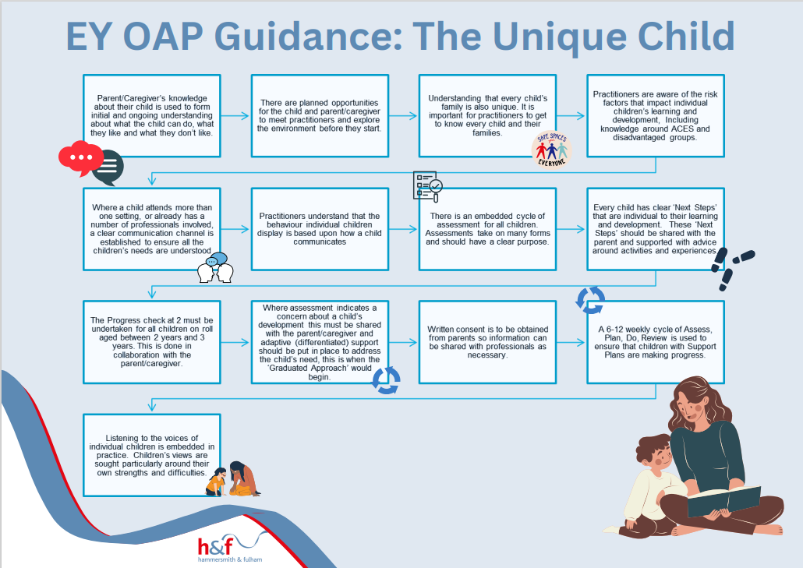
The Unique Child Summary Page (Print for Display)

Positive Relationships

‘Children learn to be strong and independent through positive relationships’ therefore, it is important to build positive relationships with children, parents/caregivers, colleagues, key partners and the community. This ensures you are offering high quality early years provision. Relationships can be complicated; families are unique, and some parents/caregivers face specific challenges which in turn may create barriers to engagement/developing trusting relationships. It is important to get to know individual families and understand their unique circumstances, exploring different and creative ways to build a co-operative partnership.

Heading and Link to Prime Areas | Description of Expected  Ordinarily Available Provision (OAP)  This column applies to ALL children  in the setting | Strategies and Examples to Support Implementing the Expected OAP | Links to Area(s) of Need  (where applicable) | Additional Strategies to Support Specific Area(s) of Need
Parent Partnership: Assessment:  All three prime areas | A strong partnership with all parents is fostered. Parents/caregivers knowledge about their child is central to initial and ongoing assessments about their child. | Information from the DfE EYFS Support pages | N/A
Parent Partnership: Learning: All three prime areas | Information about what and how children are learning is readily available to parents. Parents/Caregivers are regularly provided with information to support children’s learning at home. | Information about what their children are learning. | N/A
Named Key Person:  All three prime areas | Every child has a named Key Person, and every parent/caregiver knows who their child’s key person is.  The Key Person ensures their key child’s learning and care is tailored to meet their individual needs. | The Key Person – Attachment and the role of the Key Person  EY key person Flowchart for children with emerging needs | N/A
Difficult Conversations:  All three prime areas | There is an identified space where sensitive conversations and meetings can be confidently held with parents/caregivers and professionals. | Tips for handling difficult conversations  Connecting with parents in early education | N/A
Emotional Literacy  &  Wellbeing:  Personal Social Emotional Development | A whole setting approach is used to develop emotional literacy, wellbeing and resilience and promote positive attitudes to everyone. | Tips on supporting positive relationships in the moment:  Positive Relationships: Behaviour - In the moment | Nursery World  Emotional Literacy in the Early Years:  Emotional Literacy in Early Years - London School of Childcare Studies  Speak to the Early Years Inclusion Team about potential staff training sessions. | SEMH: Distressed Behaviours may reflect:  - Anxiety  - Low self-esteem  - Poor attachment  - Presenting as significantly unhappy or stressed | - Focus on reducing triggers to anxiety and thereby distressed behaviours  - Flexible and creative use of rewards and consequences e.g., ‘catch them in a positive moment’  - Positive reinforcement of expectations through verbal scripts and visual prompts  - Calming scripts to de-escalate, including for example, use of sand timers for ‘thinking time’  - Emotion Coaching
Diversity:  All three prime areas | The Provider clearly shows a responsibility to ensure positive attitudes to diversity and difference. So that every child is included and so that they learn from the earliest age to value diversity in others. | Tips on supporting positive relationships in the moment  Supporting Equality and Diversity  Anti-racism in the Early Years  Unconscious Bias  Unconscious bias in the observation, planning and assessment process  Equality Guidance in Early Years Settings | N/A
Professional Development:  All three prime areas | The workforce is well skilled and experiences and meets the requirements for suitable people within the EYFS. | Keep up to date with the Hammersmith and Fulham local offer, see what trainings are coming up which you can send staff to ensure continued professional development.  SEND Local Offer | London Borough of Hammersmith & Fulham (lbhf.gov.uk) | N/A
External  Support:  All three prime areas | The provider has developed positive relationships and/or knows how/when to contact key partners including:  - Safeguarding Team  - The Early Years Team  - The Early Years Inclusion Team  - Local Schools / Nurseries  - Inspire  - JCT  - The Health Visiting Team  - Social Care  - NHS | Safeguarding teams:  familyservices@lbhf.gov.uk  LADO@lbhf.gov.uk  Early Years’ Service:  eyfservice@lbhf.gov.uk  Ensure you have a robust cycle of CPD, Staff 1:1 and peer observations in place. With a clear Support plan where further development is needed. Support from the Early Years Team if required. | N/A
Quality Practitioner-Child  Interactions:  Communication and Language | Children are supported by knowledgeable practitioners who understand when to stand back, when to interact and what to offer individual children.  Interactions - Help for early years providers - GOV.UK (education.gov.uk) | Ensure you have a robust cycle of CPD, Staff 1:1 and peer observations in place. With a clear supportive plan where further development is needed. Support from the Early Years Team if required.  Anna Freud/Pacey – Managing Challenging Behaviour in the Early Years  Emotions – Help for Early Years Providers  Meeting the needs of all children | SLCN: Child does not understand or use social rules of communication | Children who have been placed on the Social Communication Pathway must be referred to the INSPIRE Specialist Teacher – it is the expectation the Early Years Provider will do this – if you are unsure whether the child is on this pathway please liaise with the child’s family and health visitor  - Modelling / role play  - Small group sessions  - Social Stories by Carol Gray  - Prompts – symbols, signing systems  - First (you are doing this) and Next (you are going to be doing that) boards.  - Social Communication, Emotional Regulation, and Transactional Support)  - Training (scerts.com)
Transitions:  All three prime areas | Transitions for children are carefully planned with parents/caregivers, the child and receiving providers/key person. SENCO shares relevant information with next provider.  This will be adapted to meet children’s individual needs where necessary.  Transitions to other rooms are carefully considered, the key person supports the child. They should consider transition timing, consistency and pace. | Effective transition and emotional wellbeing in the early years  Understanding and supporting transitions  For examples of transition support documents, please see the appendix.  EARLY YEARS SUMMARY TRANSFER FORM Universal v1 interactive form.docx  EARLY YEARS SUMMARY TRANSFER FORM SEND v1 interactive form.docx | N/A  SLCN: Difficulties understanding what is being said to them  SEMH: Difficulties following and accepting adult direction | - Consider how much information a child can process when giving instructions e.g. awareness of complexity of vocabulary and amount of information carrying words.  - Reduce your language to meet the needs of the child. Use match plus one i.e. child says ‘car’ you say ‘fast car’  - Ask children to repeat instructions to clarify their understanding.  - Provide visual prompts. For example, objects of reference, Now and Next boards, timetables, story and song props etc.  - Give extra time to process what has been said.  - Think about the environment and limiting any distractions.  - Check you have engaged the child’s attention before talking to them; use their name first before giving them an instruction.  - Check that hearing has been tested.  - Check their understanding using BLANKS levels of questioning level 1-2  - Speech-and-Language-Therapy-Pack-Blanks-Levels.pdf (cognus.org.uk)  - Look for patterns and triggers to identify what may be causing distressed behaviours.  - Positive scripts - positive language to re-direct, reinforce expectations e.g., use of others as role models.  - Calming scripts to de-escalate, including for example, use of sand timers for ‘thinking time’.  - Limited choices to engage and motivate.  - Flexible and creative use of rewards and consequences e.g., ‘catch them being good’ reward systems.  - Visual timetable/supports and use of visual cues e.g., sand timers to support sharing.

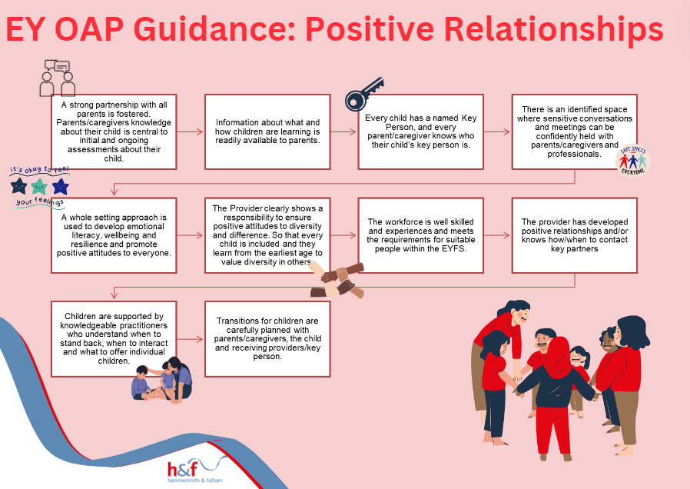
Positive Relationships Summary Page (Print for Display)

Enabling Environments with Teaching and Support from Adults

Children learn and develop well in enabling environments with teaching and support from adults, who respond to their individual needs and help to build their learning over time. Children benefit from a strong partnership between parents/caregivers and practitioners.

Heading and Link to Prime Areas | Description of Expected  Ordinarily Available Provision (OAP)  This column applies to ALL children  in the setting | Strategies and Examples to Support Implementing the Expected OAP | Links to Area(s) of Need  (where applicable) | Additional Strategies to Support Specific Area(s) of Need
Welcoming Environment:  Personal Social Emotional Development | The environment is warm, welcoming, and nurturing and facilitates a sense of belonging. | For example, children and parents are greeted warmly, notice board is reflective of the different language’s family speak, management team are available to speak with parents. Cozy and quieter areas are available for children (base space).  Enabling environments  Open ended resources are available. Children can lead their play the adult is a co-facilitator.  The child’s key person should remain consistent. | SEMH: Presenting as significantly unsettled persistently after a transition period to the setting. | - Key worker and adults to check in at the start and end of the day.  - Safe place/quiet area in the setting  - Feedback is used to collaborate and plan with parent /carer, to ensure consistency between the home and setting.  - Use of visuals to identify triggers and means of overcoming them.  - Build rapport and trust in a reliable adult.  - Examples of how a child presents themselves as unhappy: Running about/ physical movements, removing themselves from specific areas, silence and crying.
Space:  Physical development | There is sufficient space for children to move and collaborate and encourage exploration and risk-taking both in both the indoor and outdoor environment. | Enabling environments:  Risky play in the early years: Promoting safe exploration | N/A | The space should also support independent play e.g., by placing mats or cushions under an indoor climbing structure.
Risk Assessment:  Physical development | When necessary, risk assessments are completed for individual children – this is completed in partnership with the child’s parent/caregiver and shared within the whole provision. | Help! I need to do a risk assessment | S/PD: Physical sensitivity including hyper and hypo responses and possible sensory difficulties  Sensitivity to sensory stimuli  HI: related to equipment. | - Individual Sensory Profile  - Practitioners to collaborate with other professionals to share strategies and advice to support the child’s sensory diet (this term should be explained in the glossary)  - Sensory reduction planning  - Staff training through CPD.  - Sensory resources.  - Flexibility with uniform policy  - Consideration to the environment e.g. noise, room temperature, visual stimuli, proximity  - Flexible approach to transitions  - Access to safe place  - SCOPE provides a support and information resource for teachers and other professionals as well as promoting and facilitating links between teachers.  - Pdnet is an online network for those supporting children with physical disability, enables the sharing of a range of professional resources to support the learning and education of children with physical disabilities.  - Risk assessment to be produced by the setting on management of hearing aids, when being worn by the child. This should include: batteries must be kept safely out of children’s reach and the setting should check with parents/carers that battery safety locks are fitted and working on hearing aids.  - Spare batteries and testing kit from home, to be used in the nursery. Risk Assessment in place for batteries use.
Total Communication Approach:  Communication and Language | All staff understand and implement a Total Communication Approach within the environment, this is consistent for all children including those with SEND. | The total communication approach is about using the right combination of communication methods for each person. This approach helps an individual to form connections, ensures successful interactions and supports information exchanges and conversations.  Creating good communication environments and enabling environments. | SLCN: Difficulties with language and Difficulties with communication | - Use the child’s name first to draw their attention followed by key word Instructions e.g., _____, stop.  - Use positive language, telling them what you want them to do.  - Simple instructions, using literal language (avoiding sarcasm and figures of speech)  - If appropriate use of symbol communication  - Much of what we communicate is non-verbal so be very aware of your own body language  - Awareness of appropriate tone of voice (calm, not too loud)  - Awareness of rate of speech (slow down)  - Awareness of appropriate environment (noise, room, temperature, lighting, room layout)  - Awareness of use of language (some children may need a language-rich environment, others may need it to be kept simple)
Listening Conditions:  Communication and Language | Adjustments are made to the acoustic environment such as soft furnishings, blankets on tables, creating quiet corners. | Improving listening conditions | HI: Children who have impaired hearing | - Please you liaise with the INSPIRE Specialist Teacher Team inspire@lbhf.gov.uk  - Staff should speak clearly and ensure they are always visible to children.  - Staff should have the light source on their face not behind them. For example, not standing with their back to the window or sun.  - Acoustically optimal listening conditions in general room, for example areas of the nursery to be carpeted.  - Quiet area available regularly for small group work.  - All staff in the setting to be made aware of the child’s hearing loss and any related equipment by the nursery SENCO.  - Wearing optimally always working equipment (hearing aids or implants), if appropriate.  - Managing and minimising background noise as much as possible, especially during language and listening activities.  - Wearing optimally always working equipment (hearing aids or implants), if appropriate.
Displays:  All three prime areas | Displays are meaningful and appropriate for all children. | Example: Displays are at the child’s height and children choose if they would like to display their work. A WOW wall.  Creating Interactive Wall Displays | N/A | Displays are at the child’s height.  Displays can be interactive for the children to enjoy. For example, photos of the child’s family can be Velcroed on a display to allow children to pull them off the wall and look at/share with a peer or adult.
Visual / Hearing Impairment:  Physical development | Children who wear glasses and/or hearing aids are encouraged to wear them are seated in the optimum position during group times/ mealtimes. | Please seek advice from the INSPIRE Specialist Teachers for children with visual or hearing impairment.  Home - Inspire (lbhfinspirehub.com)  Improving listening conditions | S/PD: Hearing impairment | - Sitting in a position for children to see adults in all activities.  - Managing and minimising background noise as much as possible, especially during language and listening activities.  - Access to visuals, to use a natural gesture and good facial expressions to support communication and understanding of everyday routines and activities.  - Ensuring glasses are worn by children who need them.  - All staff in the setting to be made aware of the child’s hearing impairment and any related equipment by the nursery SENCO.  - Hearing impairment and related language needs to be included on learning profile/learning journal.  - The NDCS (the National Deaf Children’s Society).
Accessibility of Environment: Physical development | - Ensure the activities and environment meet the developmental needs of all the children who attend, from very young babies to older children. | Information on supporting children with diverse needs  Meeting the needs of all children | PD: Physical disability | - Please liaise with the Occupational Therapy service if you have a child with a physical disability  - Children and Young People's Occupational Therapy - H&F | London Borough of Hammersmith & Fulham (lbhf.gov.uk)  - Staff to collaborate with other professionals to share strategies and advice to support the child.  - Moving and handling training accessed where appropriate.  - Provision of small support equipment e.g., adapted pencils, pens, paintbrushes, cutlery, and scissors  - Ensure environment is accessible for specialist equipment e.g., Walkers, standing frame, specialist seating and hoisting. Ensure use of specialist equipment  - Enable access to ICT equipment e.g., computers, iPads / lightbox.  - Staff training for care and hygiene support .  - Risk assessments and Personal Emergency  - Evacuation Plan
Interests:  Personal Social Emotional Development | Close attention is paid to individual children’s interests, and this implemented into daily planning of play opportunities. | Play activities are offered for individual children’s interests. This can be rotated around weekly/bi-weekly to provide opportunities for all children’s individual interests to be presented during play. | N/A | Individual interests should be used to encourage learning (e.g., using cars as counters if the child is interested in cars).
Resources & Expectations:  Physical development | Activities, resources, and furniture such as table and chairs are child height and accessible.  The environment is accessible and resources within this can be moved and used in a variety of ways. | Activities are placed at appropriate heights, including floor level. Children are not asked to sit on chairs for all activities. | N/A | - Tummy Time activities: What is 'Tummy Time' and when should you start it? - BBC Tiny Happy People  - For older children: Lay long rolls of paper on the floor with a selection of drawing materials e.g., pens/crayons.  - Children can have a themed focus as well draw to music  - Possible training: Welcome to Write Dance Training | Write Dance Training
Busy Environment:  All three prime areas | Allow children the time and space to focus and reduce noise distractions. |  | SEMH: Anxiety in busy unpredictable environments | - Preparation for change of activity, environment, or routine  - Small group / 1 to 1 tasks and activities  - Calm learning environment  - Clear communication of expectations  - Visual timetable  - Use of social stories  - Transition groups e.g. getting ready for nursery or getting ready for school
Smells & Noise:  Physical development | Practitioners are aware of smells and noise in the room and any children who may be impacted by these. | Sensory Profile link  Information on Early Years Professional development course   Sensory Profile - TEMPLATE.docx   Sensory Profile - EXAMPLE.pdf | N/A | Some children might be sensitive to sensory stimuli, so it is important to consider the smells and noise levels in the nursery environment.  You can offer a ‘calm corner’ with gentle music played into earphones to support children that are overstimulated by noise levels.  You can use a child’s preferred scent (e.g., using essential oils) on a piece of cloth for the child to use when smells are becoming overwhelming for him/her.
Lighting:  Physical development | Practitioners are aware of lighting in the room e.g. use of natural light, who is facing the light, where you stand/sit in relation to light with relation to facilitating group time and story time. | Sensory Profile link  Information on Early Years Professional development course  Sensory Profile - TEMPLATE.docx  Sensory Profile - EXAMPLE.pdf | S/PD | Try to have good lighting in the setting to enable pupils to see adults faces and lip patterns.  - Dimmer switches options  - Low energy LED lighting  - Natural light from unobstructed windows and doors.
Wait for 8:  Communication and Language | Children are given time to process information before being asked to respond. Staff use WAIT FOR 8 seconds. | Wait for 8 is a reminder to give children time to understand what you have said and think of their reply or response according to level of ability in communication of their developmental age. | N/A | Use the Wait for 8 strategy for children with SEND, but if you find that they need more time then give more time to process information.  Alongside giving extra time to process information, you can also use simple language, break down instructions, and use visuals and/or gestures to support spoken language.
Break Down Tasks:  Communication and Language | Tasks are broken down into small manageable steps. These steps are shown explicitly.  The pace and order of activities is relevant to maintain interest and attention of all children.  Key information and strategies are shared with all relevant Practitioners e.g. My Profile (see Appendix 34, 35) | Photo cards are shown of each step to support children’s understanding. This could be used to show the process for handwashing or baking cakes. | N/A | Photo cards are shown of each step to support children’s understanding. This could be used to show the process for handwashing or baking cakes.  When giving verbal instructions for tasks:  - Make sure you have the child’s attention first  - Go down to the child’s level  - Use simple language  - Break down tasks (more on this below)  - Use visuals and/or gestures to support spoken language  Repeat instructions of tasks if necessary.
Model Language:  Communication and Language | Modelling is used to aid understanding | Circle times are not too long and includes opportunities for movement breaks such as dancing and action.  Examples of how to model language | N/A | Use of supporting adults to remodel as necessary to enable consolidation of understanding.
Visual Support:  Communication and Language | Visual Supports are used throughout the setting – including visual timetables, now and next boards, clear concise instructions with visual prompts (particularly during transitional parts of daily routine), stories, songs, props and puppets. | - Picture version of the routine of the day is displayed and children are shown which part of the routine is coming next  - Real objects are used to support children’s understanding of the routine, such as coats shown for outdoor play and nappies/potty shown for changing or toileting.  - Photo cards are shown of each step to support children’s understanding. This could be used to show the process for handwashing or baking cakes.  - Examples of how and why visual supports are useful | SLCN | Use of visuals support children understand what is going to happen next, as visual supports increase predictability and can reduce anxiety.  For children with SLCN, personalise the visual support for the specific child and use consistently throughout the setting.  Please see examples of different types of visual supports below:  - Objects of Reference: Use real objects to represent or ‘stand for’ an activity, person, or place (e.g., a bowl for lunch time, a teddy for nap time) to support the child’s understanding of the everyday routine. See examples of using objects of reference here.  - Use photographs of the child engaged in different parts of the routine to create a visual timetable or now/next board to support children with transition and what is coming next. Make sure this is portable or displayed at the child’s level.  - Label the environment: Use a picture and written word to label different parts of the nursery (e.g., water tray, using a picture and the written word to help organise the environment for the child and support with tidying up time as well.
Independent Learning:  All three prime areas | Strategies are used to actively promote independent learning through pre-teaching, overlearning, differentiated resources where appropriate. | Set up the environment and play opportunities around themes of the week / term to encourage pre-teaching, overlearning, and independent learning through play.  For example, when teaching about farm animals: set up play opportunities using farm figurines, offer a sensory tray with hay, read books about farm animals, provide arts & craft activities around farm animals (cutting, sticking, colouring farm animals). | N/A | - Use the themes of the week / term to set up the play opportunities for the children to encourage independent learning of the topics through play.  - For children with additional needs, try to use multisensory learning experiences.  - For example, when teaching about farm animals: set up play opportunities using farm figurines, offer a sensory tray with hay, read books about farm animals, provide arts & craft activities around farm animals (cutting, sticking, colouring farm animals).  - Use language related to the theme and topic to support children learn new words within context.
Seating:  All three prime areas | Seating and grouping of children take account of individual needs and routinely provide opportunities for access to role models, structured opportunities for conversations and sharing of ideas and access to additional adults where they are available. | Seat children according to their individual needs. | N/A | Try to seat children with additional needs near the front of the classroom or near a supporting adult to help with their attention and listening, hearing and processing of information, and to be able to receive adult support more easily.
Additional Adults:  All three prime areas | Use of additional adults is planned to maximise their impact on children’s learning. | Additional adults to go around and support children where and when needed. | N/A | Additional adults to provide individualised support for children with additional needs.  For example:  - Repeating instructions to the child  - Helping the child get started on the activity  - Modelling the activity in a 1:1 or small group context  Providing a differentiated activity
Positive Relationships:  Personal Social Emotional Development | Strategies are used to build and maintain positive relationships across the whole setting. There are opportunities to develop peer awareness, sensitivity, and support for different needs both in and out of the setting. | https://www.earlyyearsmatters.co.uk/eyfs/positive-relationships/ | SLCN:  Difficulty with social communication and developing relationships. | - Small group / 1 to 1 tasks and activities to cover turn taking and social skills  - Clear communication of expectations  - Develop group work skills by targeted sessions to address specific skills, e.g., turn-taking, conversation, and feelings.  - Fun group interventions. https://send.eani.org.uk/sites/default/files/2023-07/Play%20Activities%20to%20Support%20Communication%20and%20Interaction  - Opportunities for supported play with peers  - Modelling successful play and social interactions  - Giving support to respond to conflict in relationships and resolve difficult situations.  - Giving support to develop understanding of emotions of child and peers  - Positive peer role models  - Clear boundaries.

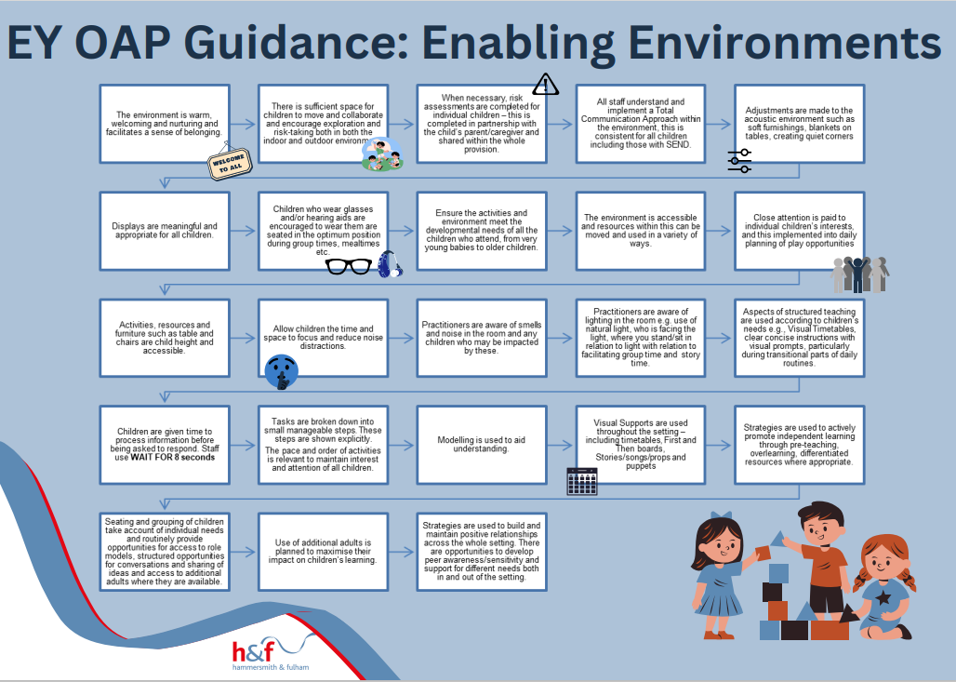
Enabling Environments Summary Page (Print for Display)

Appendix
Target Monitoring Evaluation (TME)
Setting Targets: Target setting is an important aspect of monitoring a child’s progress. This focuses on setting achievable, developmentally appropriate targets, for each specific child. Using Target Monitoring Evaluation helps to understand if what has been put in place is supporting the child as intended as well as measure its success. Targets can be written by the nursery SENCO, the child’s key worker and with the parents. Targets should be set before support is put in place and reviewed after a set time period (e.g., after 4 weeks). When setting targets for children it is important that all targets are SMART.
S: Specific – to the child and intervention.
M: Measurable – ensure that you can measure the impact, e.g., ‘2/3 times a session’.
A: Achievable – ensure that the target is developmentally appropriate for the child.
R: Relevant – ensure that all targets are child focused, not adult focused.
T: Time-bound – include a realistic time scale for the target to be met by.

How to use TME:
- Set up to four targets per child, following the SMART target principles.
- Each target should be written into the relevant box, with a summary of what is being put in place to support the child meeting the target.
- The person completing the form should rate where the child is on the scale before support is put in place, with 10 representing target met consistently. They can rate this by circling or highlighting the number in a colour, with the date written next to the number.
- Targets should be reviewed after a set period of time (e.g., every 2 or 4 weeks).
- When reviewing the target, the person reviewing circles the number the child is now at, adding the date next to the number. For example:
- If a child is meeting a target before the set review time, mark this on the TME form with the date.

For support completing TME, please contact the Early Years Inclusion Team.
Child’s name: |  |  | DOB: |  | Targets set: |  |  | Review dates:
Setting name: |  |  | Area of need: |  | Set by (initials & role): |  |  | Reviewed by (initials & role):
Target 1:
Summary of support put in place to achieve target:

1 | 2 | 3 | 4 | 5 | 6 | 7 | 8 |  | 9 | 10
Target 2:
Summary of support put in place to achieve target:

1 | 2 | 3 | 4 | 5 | 6 | 7 | 8 |  | 9 | 10
Target 3:
Summary of support put in place to achieve target:

1 | 2 | 3 | 4 | 5 | 6 | 7 | 8 |  | 9 | 10
Target 4:
Summary of support put in place to achieve target:

1 | 2 | 3 | 4 | 5 | 6 | 7 | 8 |  | 9 | 10

Example All About Me and Play Plan templates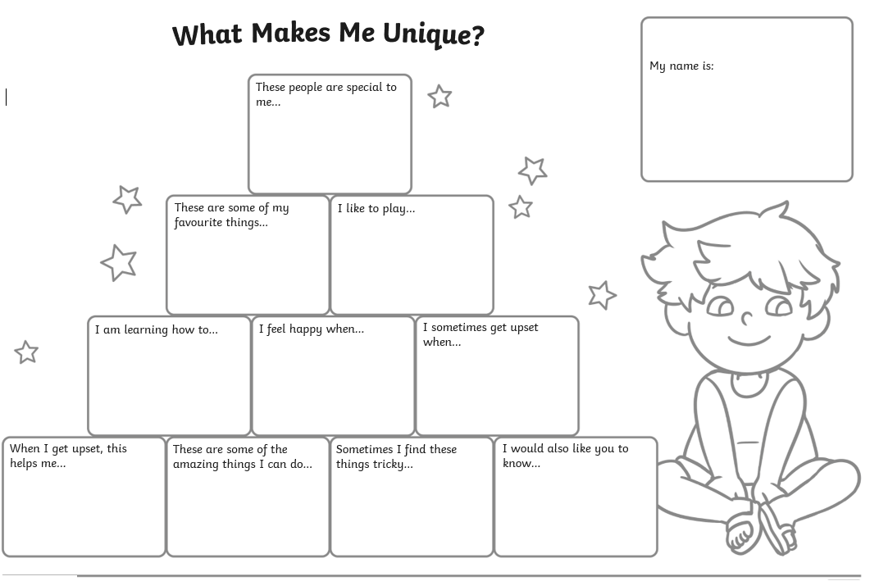
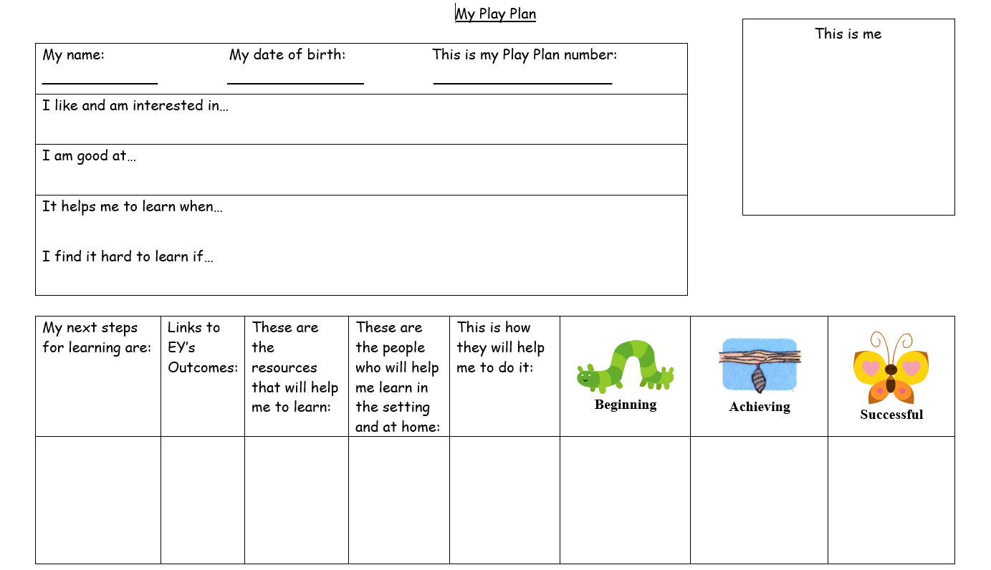
Name of Setting

Insert Setting logo if desired
Early Support
for children, young people and families

MY EARLY YEARS SEND SUPPORT INCLUSION PROFILE
My Name is:

Today’s Date:

Date of Birth:

Child’s name Inclusion profile
Date Agreed:
Signed Parent/Carer:
Signed Early Years Childcare Provider:
Date To Start From: Proposed Review Date:
Outcome  (what you aim to achieve and by when) | Intervention  (e.g. what activity you will put in place to achieve the outcome) | Staff Ratio  (e.g. – 1:1/ Small Group) | Staff Member  (e.g. – Senco) | How Often- how long  (e.g. – daily – 5 minutes)

Observations to support meeting the Outcomes
Outcome Number | Observations/Discussion/ Evaluation | Emerging  Seen for the first time (Date) | Developing  Seen Sometimes  (Date) | Achieved  Seen often  (Date)
1.

2.

3.

Child’s name SEND Support Plan Review
The outcomes, Interventions and support sections in this plan will be reviewed by the Early Years Childcare Provider at least every 6 weeks. The review will look at the effectiveness of the support and its impact on child’s progress against the outcomes.
Changes to the outcomes and support will be agreed according to child’s progress and development.

The One Page Profile and other sections will be updated by the parents/ carers.

The review of support will involve my parents and me.

Signed……………………………………………………………

Parent/ Carer……………………………………………………

Early Years Child Care Provider……………………………...

Date………………………………………………………………

Review Date…………………………………………………….

Observations to support meeting the Outcomes
Outcome Number | Observations/Discussion/ Evaluation | Emerging  Seen for the first time (Date) | Developing  Seen Sometimes  (Date) | Achieved  Seen often  (Date)
1.

2.

3.

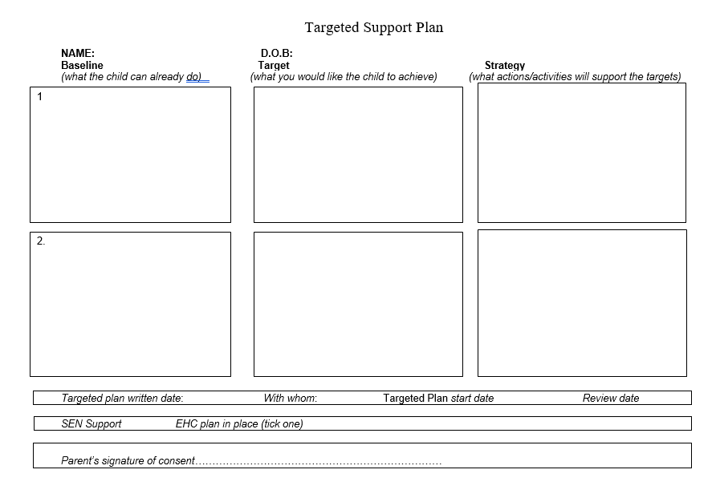
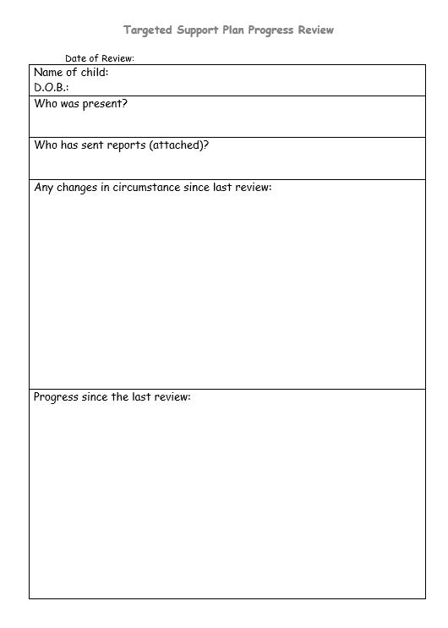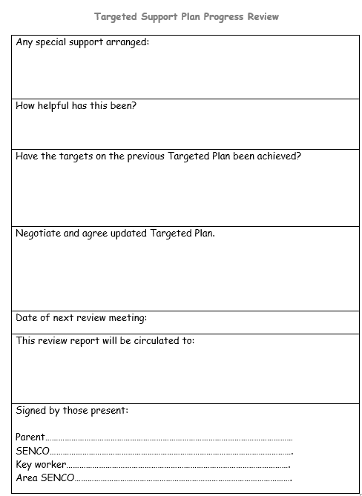
Things I like doing at home and nursery:
- E.g., Music – singing songs.
Things I find tricky at home and nursery:
- E.g., New foods which are not familiar to me, this is mainly finger foods.

Hello, my name is……..



I would like help to:
- E.g., To understand when a child has finished playing with me.

Things that calm me down:
- E.g., Looking at books and story time
What I find helpful:
- E.g., When I am shown or told about a change to the routine.

I don’t like it when:
- E.g., Change of routine.




Additional information from the nursery:

Additional information from my parents:

These are the latest documents as of January 2024. Please ensure you remain up to date with changes released regarding these documents by keeping up to do with the Department for Education Website.
Equality Act Guide for EY - FINAL2_0.pdf (councilfordisabledchildren.org.uk) – see for more information.
If you have further questions about reasonable adjustments please contact the inclusion team would be happy to discuss reasonable adjustments with you.

