OUTSIDE LEARNING – RECOVERING CREATIVITY AND WELLBEING
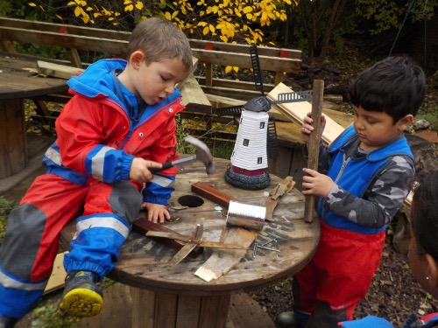

There is a new project getting underway for children in our schools and early years settings. It is a positive and innovative educational response to the restrictions that all of us have been living under with COVID. It has certain key ideas:
- Schools and settings work best when they share their ideas and best teaching and learning experiences with others.
- Outside learning is an exciting, creative, rewarding, nurturing and positive educational experience. The new non-statutory Development Matters makes planning for outside learning rewarding and simple.
- When our younger children learn outside they make connections and develop a ‘hands-on’ knowledge and respect for our natural world.
- Each local community in Hammersmith and Fulham has a range of exceptional outside resources that can be easily accessed.
There are various stages of this project. We will be sharing Early Years Foundation Sage (EYFS) experiences of growing plants and learning about wildlife, setting up dens, performance and role play areas outside, engaging in physical development and learning about our weather and the seasons. Fact-sheets, look-books and video files will be created of successful outside initiatives for all to share. We anticipate that our schools and early years settings will spend planned time using our local parks and open spaces for outside learning and lessons, learning about wildlife and nature, and engaging in environmental trails.
We are hoping that our older pupils in our primary schools will make more use of our local parks and access the resources and expertise of our community groups to widen their outside learning programme. We intend to host our first pupil-led debate to discuss issues around climate education and outside learning.

For further details of this summer term programme, contact Teresa Kiely: Teresa.kiely@lbhf.gov.uk

