Fanny Eaton (1835-1924)
Model of Art

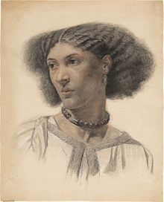

Fanny Eaton left Jamaica in the 1850s to come to England. She became associated with a very influential art movement called the Pre-Raphaelites. She modelled for many of their painters while she lived in Hammersmith. Fanny Eaton appears in many famous works of art some of which can be in seen in Tate Britain today. She was commemorated with a Google Doodle in 2020.

