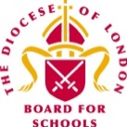


Spring Term 2022– First Edition!

Dear Colleagues,

Welcome to the first edition of the RE Newsletter for Community Schools for 2022. I do hope that you all had a wonderfully relaxing break during the holiday period and that the New Year will be a happy and healthy one for you. As always, I am looking forward to working with you in the coming weeks and months in a variety of contexts, not least at the different Network Meetings, though for the foreseeable future, those will continue to be online! Remember that I am always here to offer you help, advice and support with RE (or Collective Worship). You may be:

- preparing teaching and learning
- reviewing and revising RE documentation such as schemes of learning and policy statements
- organising existing resources and/or selecting new ones
- developing your own subject knowledge.

I would be delighted to hear from you. Do not hesitate to contact me if you would like to make an appointment and I can assist you in person, online, by email or over the telephone.

Lesley Prior

Adviser for RE in Community Schools

RE IN COMMUNITIES NEWSLETTER
Contact Details: Lesley Prior
Part time Adviser for Religious Education in Community Schools
London Diocesan Board for Schools
36, Causton Street
London
SW1P 4AU

Tel. No: 07808 761 148
lesley.prior@london.anglican.org

- LB Brent: 3rd February, 19th May  - LB Camden: 27th January  - LB Hammersmith & Fulham: 24th February  - RB Kensington &  Chelsea/City of Westminster: 3rd March, 16th June  - LB Harrow: 15th March, 26th May  - LB Hounslow: 10th March, 7th June  - RB Kingston/LB Richmond: 22nd February, 10th May  Please register in the usual way using your own LA’s online systems or contact me for more details. | Dates of Future Primary RE Network Meetings  2022

Online Resources from the Interfaith Network

During Inter Faith Week last November, the IFN launched a number of videos that can be used in schools’ assemblies and as part of collective worship and these may also be relevant for RE.

The videos focus on real people who are engaged in inter faith activity, some of whom do not profess a religious faith themselves. Several of the videos feature young people and others more mature adults. Each film is between three to five minutes long and has been developed to promote reflection on two key themes: Friendship and Social Action.

These videos were initially created for Inter Faith Week (which takes place every November) but can be used at any time to enable pupils to reflect on what it means to be a friend and what it means to do good in one’s community. Acess them via this link: https://www.interfaith.org.uk/resources/school-assemblies-collective-worship

Holocaust Memorial Day

Holocaust Memorial Day is held every year on 27th January. Schools can find a wide variety of resources on the Holocaust Memorial Day Trust (HMDT) website.

Resources to Support Study Visits to Places of Worship

These free resources to enhance study visits to places of worship for pupils in Year 3 and above include an introductory film, classroom clips, illustrated guides and a quiz for Buddhist, Christian, Hindu, Jewish, Muslim and places of worship. The materials have been produced by The Arts Society Birmingham in collaboration with places of worship, Birmingham faith leaders and other organisations.

These may be downloaded now without charge from this link:
https://birmingham-faith-visits.theartssociety.org/?utm_source=emailmarketing&utm_medium=email&utm_campaign=professional_natre_members_newsletter_no_download_november_2021&utm_content=2021-11-04

#REChatUK

You may already know about NATRE’s monthly Twitter forum, taking place on the first Monday of every month between 8-9pm. These fast-paced, fun and informative discussions are a great way to discover new ideas, resources and conversations. The forum is also an effective place to network and meet new people on Twitter. Follow @NATREupdate on Twitter, and the hashtag #REChatUK.

Teaching about Holy Week and Easter

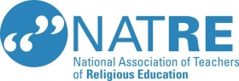

This webinar will help teachers and Subject Leaders involved in RE in primary schools to prepare their teaching and learning about what are arguably the most important moments in the Christian Year.

It will include twelve ideas for teaching about Holy Week and Easter providing creative, thoughtful and inspirational ideas for teaching about Jesus’ last days and the ways in which many Christians today commemorate and/or celebrate these events.

The online event takes place on 21st February between 3.45 pm – 5.45 pm and costs £40 with reductions for NATRE members. Full details and a registration form can be found here:

https://www.natre.org.uk/courses-events/upcoming-courses-events/12-ideas-for-teaching-holy-week-and-easter-webinar/

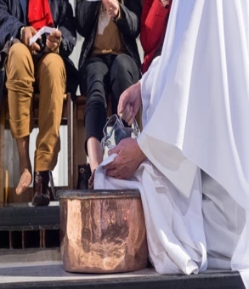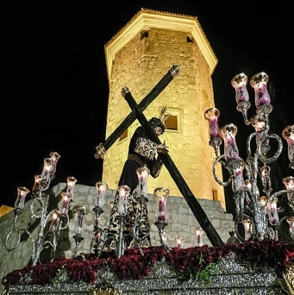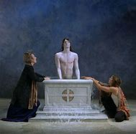

Resources for Teaching About Religious Dress

For those teaching in and/or supporting RE in the EYFS and Key Stage 1, the BBC’s CBeebies series What’s On Your Head? includes four programmes that link to RE focusing on the kippah, the hijab, the bishop’s mitre and the turban.

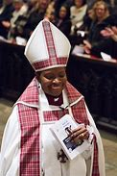

Each clip is just five minutes long and so perfect for use within an activity or lesson as a focus for promoting subject knowledge and developing questioning skills.

Find the programmes here: https://www.bbc.co.uk/iplayer/episodes/m000scc9/whats-on-your-head

Fiction and Non Fiction Books for RE

The Alligator’s Mouth is an independent children’s bookshop in Richmond, stocking books for babies through to teenagers, as well as a small selection of cards and board games. It often work withs local schools, providing events or stocking libraries. Regular events in the shop include a storytime, bookclub, comics club and more to encourage all forms of creativity. There are frequent author and illustrator visits to look out for. In the past, the shop has welcomed Jacqueline Wilson, Chris Riddell, Cressida Cowell, Oliver Jeffers and Axel Scheffler. It has been shortlisted for The British Book Awards Children's Bookseller of the Year.

The shop was founded by Tony West who has ten years experience in primary education as a qualified teacher. His time in schools means he is ideally qualified to identify the books teachers need. He has worked in the book trade for over twenty years now and along with his colleagues can advise teachers on the kind of materials that might meet their needs, including in RE.

When I visited recently, here are some of the titles that particularly attracted me!

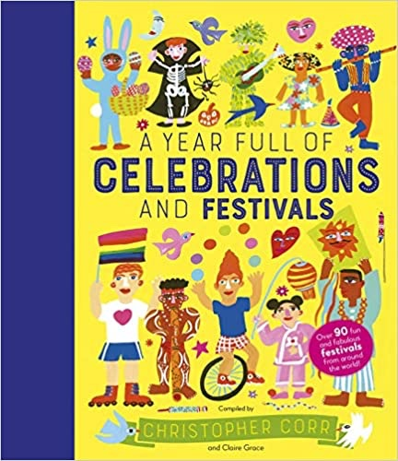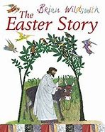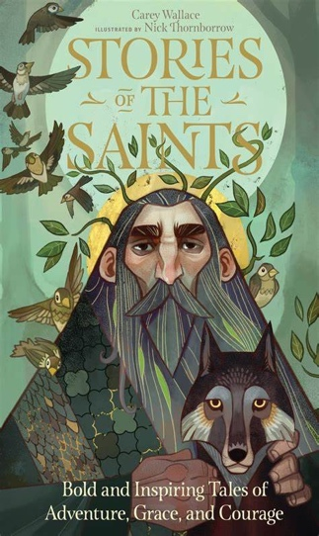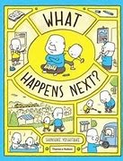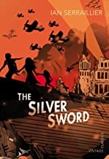

Find more details about the shop and its online services here: https://www.thealligatorsmouth.co.uk/

Worldviews in RE

I’m sure that many of you will have been asked the question ‘What is the point of Religious Education?’, but I wonder what you think and what answer you might give? Often there are misunderstandings that surround our subject; some people think that it is encouraging children to be religious, whereas others assume that we simply teach children about a few places of worship and some key beliefs or festivals. The reality is that RE is none of these things.

In a recent article, primary school teacher Katie Freeman explores some responses to these concerns, talks about her own practice and analyses the recent recommendation that teachers should move away from an approach focused on specific faiths and beliefs to teaching about worldviews. There is much food for thought here as well as examples of what this might mean in terms of teaching and learning! See this link to read her fascinating piece in full: https://www.teachwire.net/news/religious-education-in-primary-schools-whats-the-point

Sharing Good Practice in RE

Traditionally, this newsletter has been a vehicle for me to highlight relevant materials, news and resources with all of you! But I am sure that in turn, many of you have excellent contributions of your own to make that would benefit those who reads this bulletin on a regular basis – potentially, that is anyone with responsibility for coordinating and leading RE across ten different local authorities in London!

So, would you be willing to share any elements of your own practice in a short paragraph, with perhaps a picture or two? If so, here are some suggestions of aspects you might like to cover!

- Have you taken a risk in your teaching which has led to great results?
- Have you implemented a new resource/used a new strategy?
- Have you been on a great visit that has enhanced the RE teaching for you pupils?
- Have you had an inspirational visitor into your school?
- Or have you done something else that is worth sharing with others?

If the answer is yes to any of the above, then I would love to hear from you. Please send me an email by the end of January 2021 telling me a little more. I should so like to celebrate all the excellent and innovative work that is going on in your schools and classrooms!

WhatsApp Groups for Subject Leaders for RE in Primary Schools

As some you will already know, there are WhatsApp Groups for the Primary RE Networks in the following LAs: Brent, Harrow, Hounslow and Kingston/Richmond.

These exist to allow members to interact easily between the termly meetings by raising questions, sharing resources, curriculum plans and other useful ideas and materials. If you are from one of the above LAs would like to join one of these existing groups, please email me at lesley.prior@london.anglican.org with your full name, LA and preferred number.

If you are in one of the other LAs where this newsletter is circulated and would like a WhatApp Group there, I am happy to set one up, so again, just send me the necessary information!

