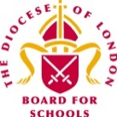
Spring Term 2022– Second Edition!


Dear Colleagues,

Welcome to the second edition of the RE Newsletter for Community Schools for this term. I do hope that you are all looking forward to some rest and relaxation during the spring holiday period which is fast approaching now. As always, I have very much enjoyed working with you in the last few weeks and months not least at the different Network Meetings, though of course those have all been online, rather than face to face. It has also been wonderful to share ideas and respond to questions using the various WhatsApp Groups that exist for Primary Subject Leaders in RE in many LAs now. Please contact me with you name, school and LA if you would like to be added.

Remember that I am always here to offer you help, advice and support with RE (or Collective Worship). You may be:

- preparing teaching and learning
- reviewing and revising RE documentation such as schemes of learning and policy statements
- organising existing resources and/or selecting new ones
- developing your own subject knowledge.

I would be delighted to hear from you. Do not hesitate to contact me if you would like to make an appointment and I can assist you in person, online, by email or over the telephone.

Lesley Prior

Adviser for RE in Community Schools

RE IN COMMUNITIES NEWSLETTER
Contact Details: Lesley Prior
Part time Adviser for Religious Education in Community Schools
London Diocesan Board for Schools
36, Causton Street
London
SW1P 4AU
Tel. No: 07808 761 148
lesley.prior@london.anglican.org

- LB Brent: 19th May*  - LB Camden: 14th June*  - LB Hammersmith & Fulham: 23rd June*  - RB Kensington &  Chelsea/City of Westminster: 16th June  - LB Harrow: 26th May*  - LB Hounslow: 7th June*  - RB Kingston/LB Richmond: 10th May *  Please register in the usual way using your own LA’s online systems or contact me for more details. In LAs marked with an asterisk, a WhatsApp Group is available. | Dates of Primary RE Network Meetings  2022

Spirited Arts Competition

Join hundreds of schools from around the world taking part in this year's Spirited Arts competition run by NATRE, the National Association of Teachers of RE! It welcome entries in (almost!) any art form your pupils can think of, including:

- Art (painting, drawing, sketching etc)
- Poetry
- Photography
- Dance
- Music
- Drama
- Sculpture

Winning entries will provide a good response to one of the five themes, and judges will be asking is it original? Is it well-crafted and (most importantly!) is it excellent RE? The thmes this year are:

- We have far more in common with each other than that which divides us
- God’s Good Earth? (“Beautiful World, Wonderful God?)
- Searching for God
- A View of the World
- Celebrations: Big Days and Big Ideas

Pupils can enter individually, in pairs or groups, or as whole class, year or school entries.

The annual competition starts at the beginning of every school year and runs through the spring and summer terms. All entries must be received before 31st July 2022.

Many schools host their own Spirited Arts competition and send their ten winning entries in to the international competition. What a great way to engage all your teachers and pupils and raise the profile of RE in your school!

Don't forget to check out the supporting resources & ideas section below - including a FREE webinar for both Primary and Secondary teachers.

Ready to enter your pupils work? Complete the online submission for here.

Resources to Support Teaching and Learning about Humanism

Humanists UK has relaunched the Understanding Humanism website with a wealth of new FREE resources to support teaching about humanism!

Humanism is a non-religious worldview shared by millions of people in the UK. Teaching about humanism alongside religions is the best way to deliver a high-quality and inclusive education about religion and worldviews and this is why it features in agreed syllabuses for RE across London.

These new resources for pupils of all ages have been organised into several core areas of knowledge to support young people’s understanding of a humanist approach to life. Designed by teachers, for teachers, you’ll find information sheets, presentations, activities, films, assessment ideas, and humanist perspectives on a wide range of questions and topics.

Understanding Humanism resources support pupils as they explore big questions about the non-religious:

- How do humanists decide what to believe?
- Can you be good without a god?
- How do non-religious people find meaning and happiness?

As well as…

- How many non-religious people are there?
- What are the origins of humanism?
- What influence has humanism had on society today?

Give your pupils the opportunity to explore, discuss, and critically evaluate the humanist approach to life!

You can also book a visit from one of the free, trained, and accredited school speakers to answer your pupils’ questions. Teachers gave them an average rating of 4.9 out of 5 in 2021!

Humanists UK also offer teacher training and online courses to support teacher CPD through subject knowledge development and practical advice for the classroom.

Discover more at www.understandinghumanism.org.uk!

And follow the Understanding Humanism team on Twitter on @HumanismEdu to keep up to date with new resources and information.

Ramadan

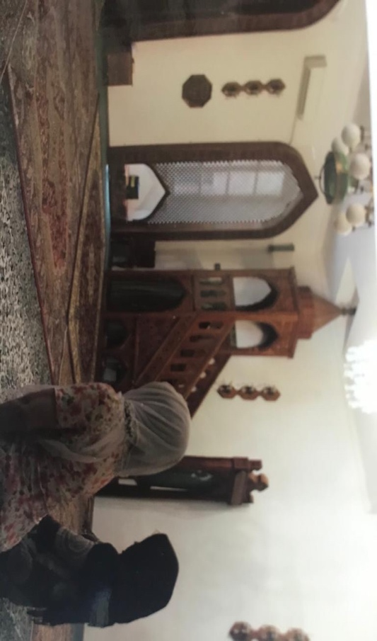

You will already know that Ramadan is fast approaching now and I send all my good wishes for those of you who will be marking this important time! This year, the first part of Ramadan falls during the spring holiday period, but schools should take care to be sensitive to the needs of Muslim members of their communities when they return after the break. Did you know that many SACREs have produced guidance to support staff in this way? Please see the following examples for advice and help:

LB Harrow SACRE:
https://www.harrow.gov.uk/downloads/file/23994/fasting-during-the-month-of-ramadan.pdf

LB Hounslow SACRE: https://democraticservices.hounslow.gov.uk/documents/s123225/Ramadan%20Guidance%202016%20edited.pdf

RB Kensington and Chelsea SACRE:
file:///Users/priorl/Downloads/SACRE%20Ramadan%20Guidance%20(1).pdf

Guidance on Selecting Resources for RE

Are you and your colleagues sure that when you choose resources dealing with religions and other worldviews, they…

- are factually correct?
- are sensitive and will not cause offence to members of your school community and/or others?
- convey a fair and balanced view of religious and other traditions?
- carry an authentic voice?

It is crucial not to underestimate the difficulties of teaching about religions and worldviews. The subject matter is complex, dynamic and sensitive, far from easy to convey in the concise and straightforward terms offered by some resources and required for some lessons.

The RE Council of England and Wales therefore offers the following guidance in order to:

- support teachers in providing well resourced, good quality Religious Education.
- facilitate the accurate presentation of beliefs and practices across the curriculum, in subjects such as Citizenship, Sociology, PSHE, Geography, and History.
- help teachers navigate the complexities of the subject and avoid misrepresentation and offence.
- foster better understanding of religious beliefs and practices.
- enable adequate research and fact-checking.
- encourage critical evaluation of published resources.

Looking for Accuracy, Sensitivity, Balance and Authenticity

Accuracy
It is possible (and often necessary, particularly for younger and less able pupils) to summarise beliefs and practices clearly. However, care needs to be taken that resources do not contain over-simplifications or omissions that can lead to distortion. Religious and other traditions are rarely homogeneous, and they develop and change; the best resources will recognise this.

Sources
- Look for indications that expert advisers, including academics, faith organisations and faith representatives, have been consulted at all key production stages;
- Check whether resources draw on primary sources, which contribute to accurate representation of religious traditions and may foster pupils’ interpretive skills.
- Check that provenance and context of quotations, for example from individuals, sacred texts and other documents, is given.
- Ensure that publishers and their sources respect the educational purpose of the resource (for example, that they are not trying to convert pupils).

Religious Believers Visiting Schools
In addition, now that most of the restrictions imposed by the pandemic have been lifted, I have had a number of requests for guidance to support schools wishing to invite visitors into schools to help children and young people to learn about religions and non-religious worldviews. This document provides guidance and a code of conduct produced by the National Association of Teachers of RE (NATRE) which is a member organisation of the RE Council: https://www.religiouseducationcouncil.org.uk/wp-content/uploads/2017/09/Voices-of-faith-and-belief-in-schools.pdf

Sharing Good Practice in RE

Traditionally, this newsletter has been a vehicle for me to highlight relevant materials, news and resources with all of you! But I am sure that in turn, many of you have excellent contributions of your own to make that would benefit those who reads this bulletin on a regular basis – potentially, that is anyone with responsibility for coordinating and leading RE across ten different local authorities in London!

So, would you be willing to share any elements of your own practice in a short paragraph, with perhaps a picture or two? If so, here are some suggestions of aspects you might like to cover!

- Have you taken a risk in your teaching which has led to great results?
- Have you implemented a new resource/used a new strategy?
- Have you been on a great visit that has enhanced the RE teaching for you pupils?
- Have you had an inspirational visitor into your school?
- Or have you done something else that is worth sharing with others?

If the answer is yes to any of the above, then I would love to hear from you. Please send me an email telling me a little more. I should so like to celebrate all the excellent and innovative work that is going on in your schools and classrooms!

Interfaith Encounters, Workshops and Teaching Resources

The Faith and Belief Forum is a London based interfaith charity working to build good relations between people of different faiths, beliefs and cultures in schools, universities and communities. It has funding to deliver free interfaith encounter primary & secondary workshops in Brent, Camden and Ealing across the next three years. It is currently able to offer 4-6 free of charge online workshops per school for years 6-9. (2 classes per workshop with only a small £25 admin charge in total.) The Encountering Faiths & Beliefs Workshops, which can be booked here, bring real-life experiences of faith, belief and identity into the classroom via a panel of trained speakers that pupils can engage with in an interfaith Q&A.

The Schools Linking Programme is an encounter programme that involves offering primary/secondary teachers free interfaith/intercultural CPD to deliver up to three link days across the academic year, with a school from a different faith/belief/demographic. This programme is supported by access to free of charge KS2 and KS3 Interfaith Online Resources, Skills For Dialogue. They can be used by schools as stand-alone resources to support RE/PSHE/RSE/citizenship, or alongside the Workshops and Linking Programmes to support learning.

Look out for a new Online Resource, The Art of Q&A, which equips students(KS3+) with tools to be able to ask and answer questions about sensitive topics with confidence and skill. The lesson plans will be available to download free of charge from the website within the next few months. Please do sign-up to the newsletter, here, if you’d like to stay up to date with the education programme offers in your area.

For those in schools in other LAs, the Encountering Faiths & Beliefs Workshops, which can be booked here, for the summer term are currently available virtually via Zoom at £300/£500 per half/full day.

