DAY AND NIGHT

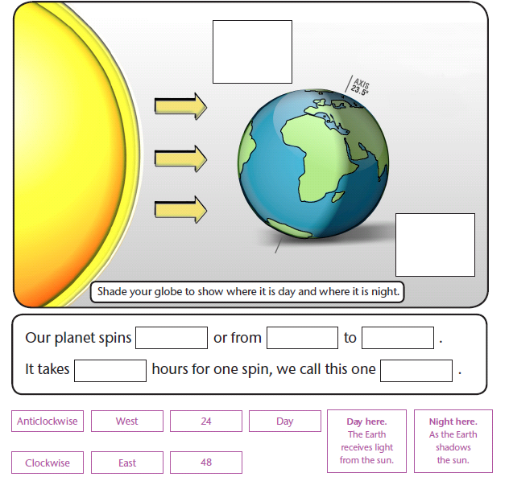
Fill in the diagram and sentences using the information below. You can use them more than once.

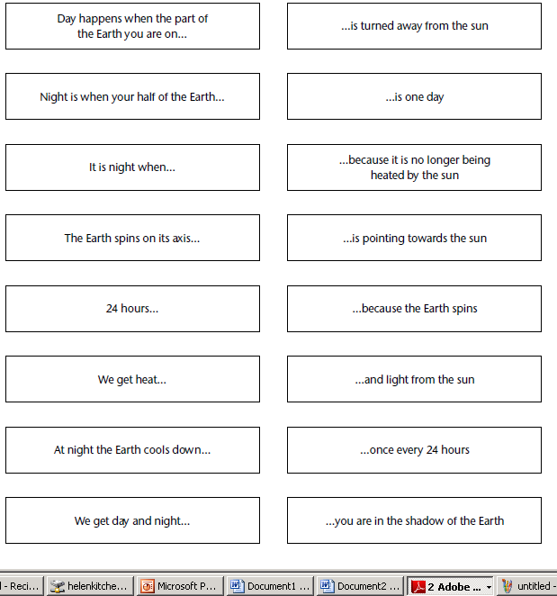
Colour code the matching sentences

