Magic Squares

In a Magic Square the rows, columns and diagonals all add up to the same number. This is the magic number. Complete the following magic squares and find their magic numbers.
1) 2) 3)
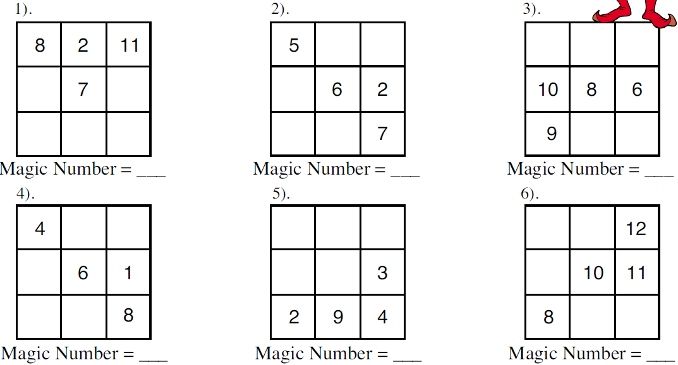

Magic Squares

In a Magic Square the rows, columns and diagonals all add up to the same number. This is the magic number. Complete the following magic squares and find their magic numbers.
1) 2) 3)

Magic Squares

In a Magic Square the rows, columns and diagonals all add up to the same number. This is the magic number. Complete the following magic squares and find their magic numbers.
1) 2) 3)

Magic Squares

In a Magic Square the rows, columns and diagonals all add up to the same number. This is the magic number. Complete the following magic squares and find their magic numbers.
1) 2) 3)

