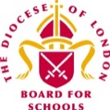
Summer Term 2022– First Edition!


Dear Colleagues,

Welcome to the first edition of the RE Newsletter for Community Schools for this final term of the academic year. I do hope that you are all enjoyed a well-deserved break during the spring holiday period – whether you were celebrating Easter, Holi, Pesach or Vaisakhi (or any other festival!), marking Ramadan or simply enjoying some time for yourselves, I trust you had a restful and relaxing time! I will look forward to catching up with you at the different Network Meetings, or perhaps in visits to you in your schools. It has also been lovely to keep in touch via the various WhatsApp Groups that exist for Primary Subject Leaders in RE in many LAs now. Please contact me with your name, school and LA if you would like to be added.

Remember that I am always here to offer you help, advice and support with RE (or Collective Worship). You may be:

- preparing teaching and learning
- reviewing and revising RE documentation such as schemes of learning and policy statements
- organising existing resources and/or selecting new ones
- developing your own subject knowledge.

I would be delighted to hear from you. Do not hesitate to contact me if you would like to make an appointment and I can assist you in person, online, by email or over the telephone.

Lesley Prior

Adviser for RE in Community Schools

RE IN COMMUNITIES NEWSLETTER
Contact Details: Lesley Prior  Part time Adviser for Religious Education in Community Schools  London Diocesan Board for Schools  36, Causton Street  London  SW1P 4AU  Tel. No: 07808 761 148  lesley.prior@london.anglican.org | 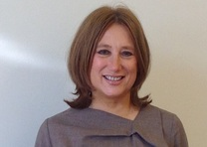

- LB Brent: 19th May*  - LB Camden: 14th June*  - LB Hammersmith & Fulham: 23rd June*  - RB Kensington &  Chelsea/City of Westminster: 16th June  - LB Harrow: 26th May*  - LB Hounslow: 7th June*  - RB Kingston/LB Richmond: 10th May *  In LAs marked with an asterisk, a WhatsApp Group is available. | Dates of Primary RE Network Meetings  2022

Religions and Worldviews on the BBC

I am sure that all of you already make good use of the RE resources produced by the BBC to support this vital area of the curriculum. But did you know that on BBC iPlayer, there are many other programmes that are part of the organisation’s general output which may also be incredibly useful to us? You may not want to show any of these in their entirety, but they do include lots of wonderful clips that illustrate the different rites, rituals and sacred places that are at the heart of our subject! You may also find these programmes really helpful in broadening your own knowledge and understanding of the material you and your colleagues are required to teach!

- Being: https://www.bbc.co.uk/iplayer/episodes/p096g86x/being

Every faith marks the circle of life with age-old rituals and ceremonies. But how are they celebrated and commemorated in a multi-faith, modern Britain? Each of these five programmes is devoted to rites of passage ceremonies in one of the five major religions included in our RE syllabuses (Buddhism is excluded!). I particularly enjoyed the images of family puja in the Hinduism episode!

- A Believer’s Guide: https://www.bbc.co.uk/iplayer/episodes/m0015xtw/a-believers-guide-to

This series also focuses on life's pivotal moments - from becoming parents to losing a loved one. In times of challenge, crisis and change, it shows how believers from five different faith traditions (again, no Buddhism!) find strength through their religious beliefs and the communities of which they are a part. I loved the Jewish episode in which a boy and his grandad share their Bar Mitzvah celebrations!

- Sacred Wonders: https://www.bbc.co.uk/iplayer/episodes/m0007fhl/sacred-wonders

Find out what people do for faith in the most spectacular sacred places on the planet. These three programmes include some truly fabulous clips of sites that may well be known to you already as well as some that are not so well known, from scenes in the langhar at the Golden Temple in Amritsar to a service at the Anglican Cathedral of St John the Divine in New York City celebrating the animal companions of its congregants on the Feast of St Francis of Assisi! If you want to see snakes and camels in a church, this is for you!

- Pilgrimage: https://www.bbc.co.uk/iplayer/episodes/b09w7lc0/pilgrimage

Seven personalities with differing faiths and beliefs put on their backpacks and waterproofs and set out on foot, by road and sea, travelling over 1,600km to learn about a key figure in early British Christianity, St Columba: an Irish monk born 1,500 years ago who helped spread the faith from Ireland to Scotland. This is a lovely example of how people of various religious backgrounds and views can reflect on these respectfully with one another – I really liked the scenes where they visit different places of worship together, such as a mosque and a Benedictine monastery and their reflections on their experiences. These interviews with the participants may also be of interest to you and perhaps to some of your older pupils too: https://tvfeatures2022.bradfordzone.co.uk/category/pilgrimage/

Resources from the Jewish Museum to Support Teaching and Learning

Sign up to the Jewish Museum’s Teachers’ Newsletter and be the first to hear about the launch of its new materials: https://jewishmuseum.org.uk/whats-on/mailing-list

The Inclusive Judaism Image Library allows you to access photos from Britain’s vibrantly diverse Jewish community and use them directly in your classrooms. By downloading these images for free, you can feel confident that you are teaching representative, inclusive and authentic Judaism in your schools. All images have curriculum links to Jewish festivals, life cycle events and synagogue worship for schools, representing the UK’s vibrantly diverse Jewish community. See: https://jewishmuseum.org.uk/schools/in-the-classroom/inclusive-judaism/

There is also an online CPD session for teachers (costing £10) on 6th July! See this link for more details on how to register: https://jewishmuseum.org.uk/event/inclusive-judaism-online-teachers-cpd/

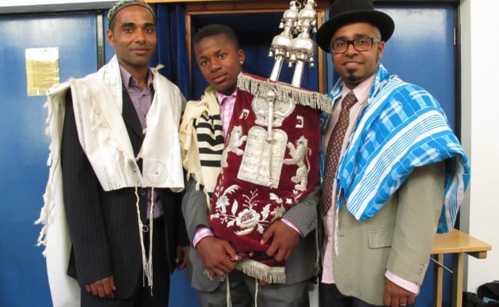

Curriculum Planning

NATRE held a curriculum symposium recently to think about how you might plan for great RE in your school! You can watch recordings of the talks and access the associate resources here: https://www.natre.org.uk/about-natre/projects/curriculum-symposium/

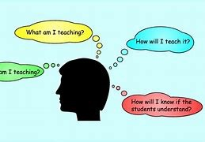

Muslim Artefacts/Artworks In Teaching and Learning

Take a look at this fantastic resource for anyone seeking Islamic Artefacts/artworks to use in lessons. Bayt Al Fann is Arabic for Art House. It is a global home for artists, creatives and communities to collaborate, connect and co-create the future of Islamic art and culture. It is artist led and receive no public funding. Bayt Al Fann is a house for everyone, Muslim and non-Muslim to explore the past and future of Islamic art together. See: https://www.baytalfann.com for more details.

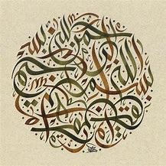

Story Tent

Story Tent offers easily accessible online teaching materials to support KS2 pupils to learn more about religions and worldviews through the lens of story. Story Tent has created ‘Story Bank’ which contains stories from different religions and worldviews. Each story comes with a set of questions that can be used in teaching, and a video where pupils can see a person from that religion or worldview reading the story. These materials are designed to be used flexibly to meet the different demands of diverse school contexts, for example school assemblies, guided reading and themed days. See: https://www.storytent.concordant.online

Anti-Racism and Mental Health in Schools

The Anna Freud Centre has created a free online training course designed to improve education staff’s understanding of the impact of racism on mental health. Black and racially minoritised young people can experience racism in many areas of their lives - including at school. Racism can have significant mental health consequences for young people. This might include children who also experience issues because of their religious or non-religious beliefs. Through this new e-learning course, staff will learn practical strategies for tackling racism in schools, and how to introduce a whole-school approach to anti-racism and mental health. It is completely free and available for anyone to access once they have registered. Visit www.annafreud.org/antiracismelearning to sign up.

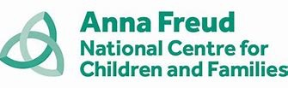

British Library Resources

I am delighted to say the education team at the British Library have reworked and made available their eight sacred stories for the classroom – they can be accessed through this link: https://www.bl.uk/sacred-texts/activities/sacred-stories

