On 24 May 2022 the Office for National Statistics published weekly provisional figures on deaths registered in England and Wales from 2020 including where coronavirus (COVID-19) was mentioned on the death certificate. Data are up to the week ending 13 May 2022.
The data are provided by the date the death was registered and also the date the death occurred. There is usually a delay of at least five days between occurrence and registration.
Weekly data are presented by 5-year age group and sex for England and Wales as a whole and for persons of all age by region and local authority of usual residence. Cumulative numbers of deaths are also presented by place of death.
Also published were provisional counts of deaths in care homes caused by the coronavirus (COVID-19) by local authority which are published by the ONS and Care Quality Commission (CQC) jointly. This contains daily mortality data in care homes reported to the CQC up to 4pm on 20 May 2022.
The data tables and further explanations and definitions can be accessed here. This article explains the differences between various data sources that report on coronavirus (COVID-19) deaths.

Key points
Registrations
For the week ending 13 May 2022 there were 674 deaths registered in England mentioning COVID-19 on the death certificate. Of these, 48 were for London residents.
The highest number of deaths registered in this week in London was for Bromley, Wandsworth residents (n=5).
This equates to a cumulative total of 164,741 deaths registered in England from week ending 03 January 2020 until 13 May 2022. Of these, 23,311 were for London residents. The cumulative total up to 13 May 2022 for 2022 is 17,255 for England and 1,991 for London.
The highest number of deaths registered across this period in London was for Croydon residents (n=1,220) and the highest number of deaths registered so far in 2022 was for Croydon residents (n=118).
Figure 1: Deaths registered each week where COVID-19 mentioned on death certificate by week ending date – London residents in 2022
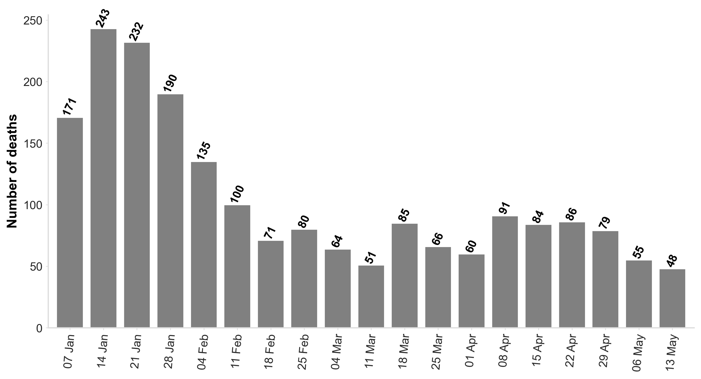

In week 19 of 2022, registered deaths mentioning COVID-19 on the death certificate were higher than those in the same period of 2021 and lower than those in the same period of 2020.
Figure 2: Deaths registered where COVID-19 mentioned on death certificate by week and year – London residents 2020, 2021 and 2022
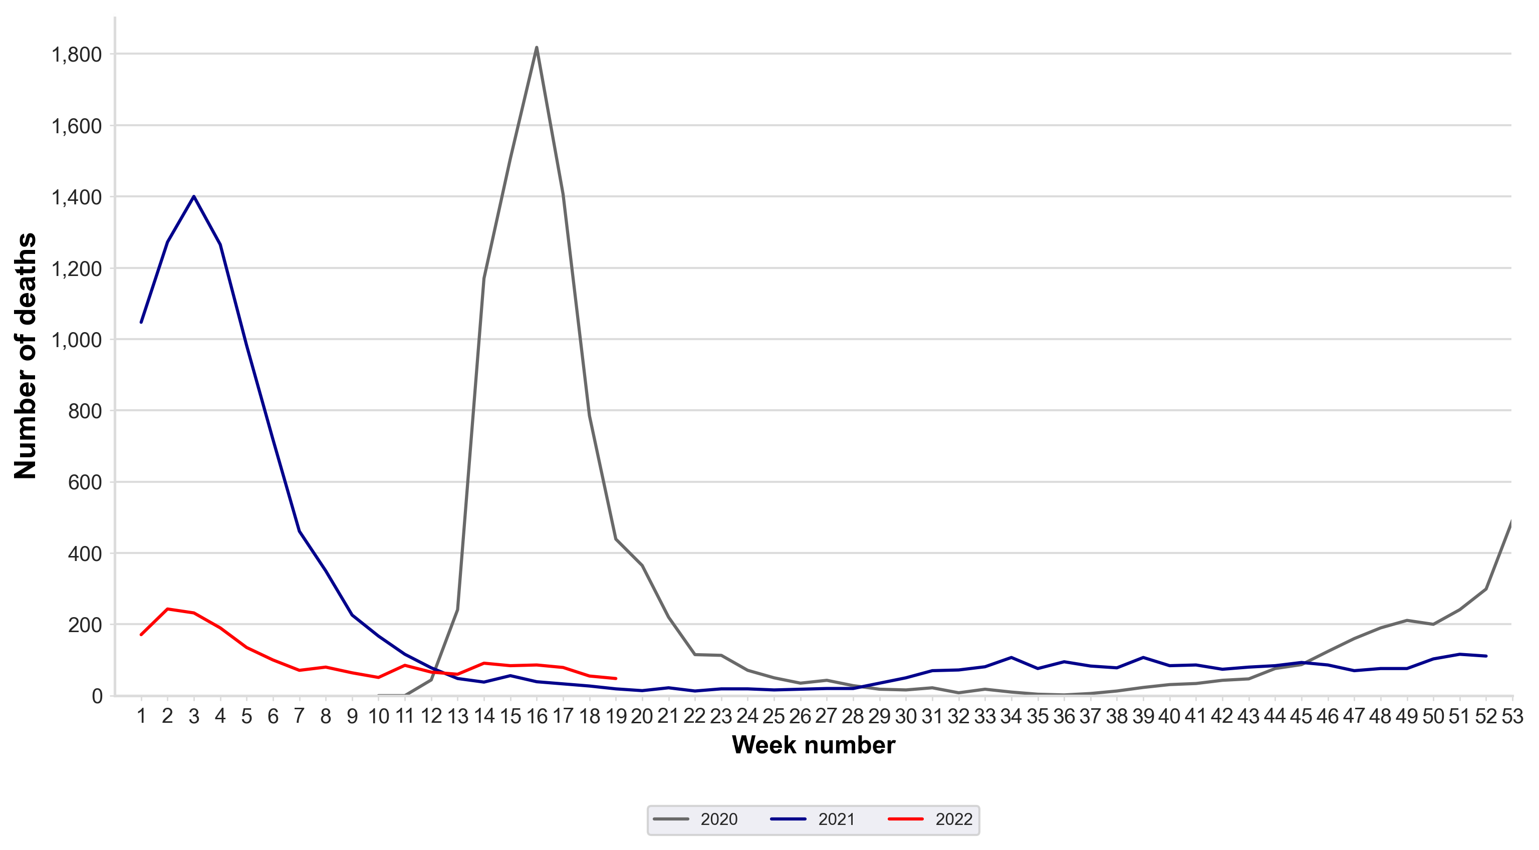
Place of death by date of registration of death
Hospital
In England for deaths registered in the week ending 13 May 2022, the proportion of deaths that had been registered which occurred in hospitals was 65.1% (n=439). In London this equated to 81.2% (n=39).
In England, the cumulative proportion across the period was 69.9% (n=115,190). In London this was 78.5% (n=18,295).
In England, for deaths registered during 2022 up to 13 May 2022, the proportion occurring in hospital was 68.2% (n=11,764). In London this was 78.8% (n=1,568).
At home
In England for deaths registered in the week ending 13 May 2022, the proportion of deaths that had been registered which occurred in the deceased’s home was 10.2% (n=69). In London this was 4.2% (n=2).
In England, the cumulative proportion across the period was 6.4% (n=10,531) and in London this was 8.9% (n=2,075).
In England, for deaths registered during 2022 up to 13 May 2022, the proportion occurring in the deceased's own home was 8.8% (n=1,521). In London this was 8.4% (n=167).
Care homes and hospices
In England for deaths registered in the week ending 13 May 2022, the proportion of deaths that had been registered which occurred in care homes and hospices was 23.7% (n=160). In London this was 14.6% (n=7).
In England, the cumulative proportion across the period was 23.0% (n=37,824) and in London this was 11.7% (n= 2,730).
In England, for deaths registered during 2022 up to 13 May 2022, the proportion occurring in care homes and hospices was 22.2% (n=3,825). In London this was 12.0% (n=239).
Figure 3: Deaths by date of registration up to 13 May 2022 by week where COVID-19 was mentioned on the death certificate in care homes and hospices in London during 2022
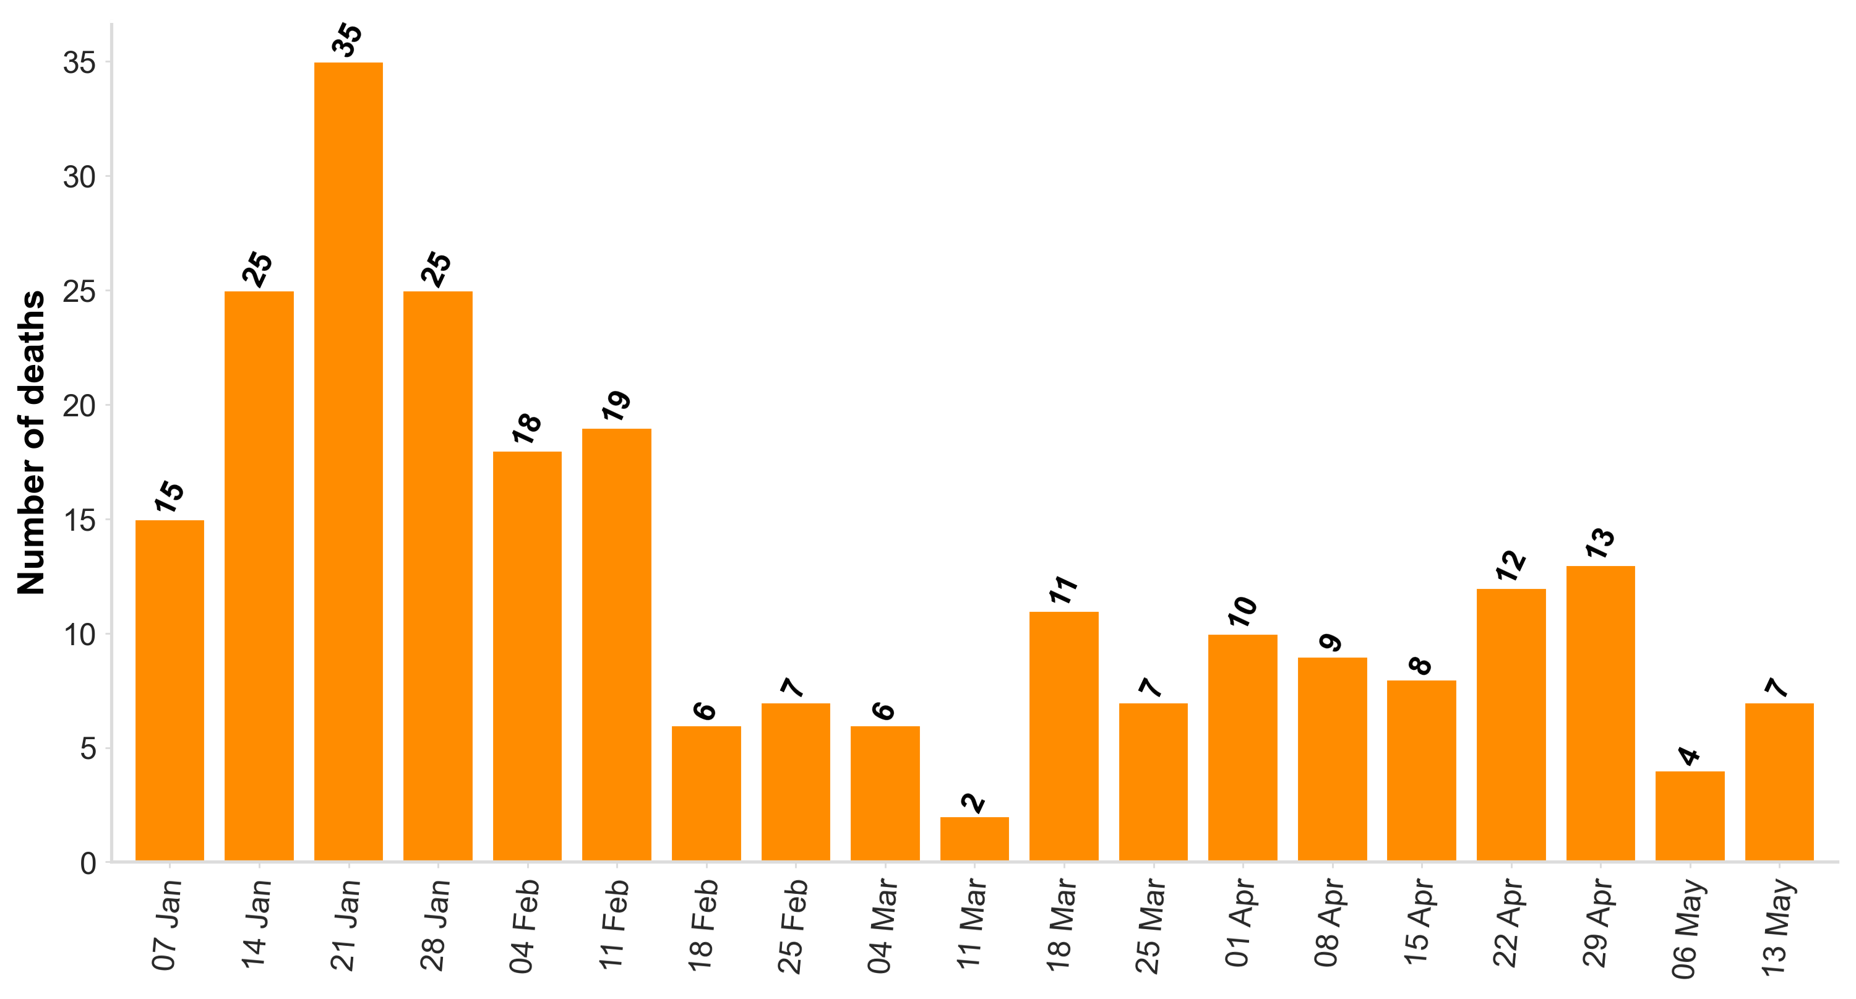

Table 1: Death registrations by region of England and place of death, crude rate per 100,000
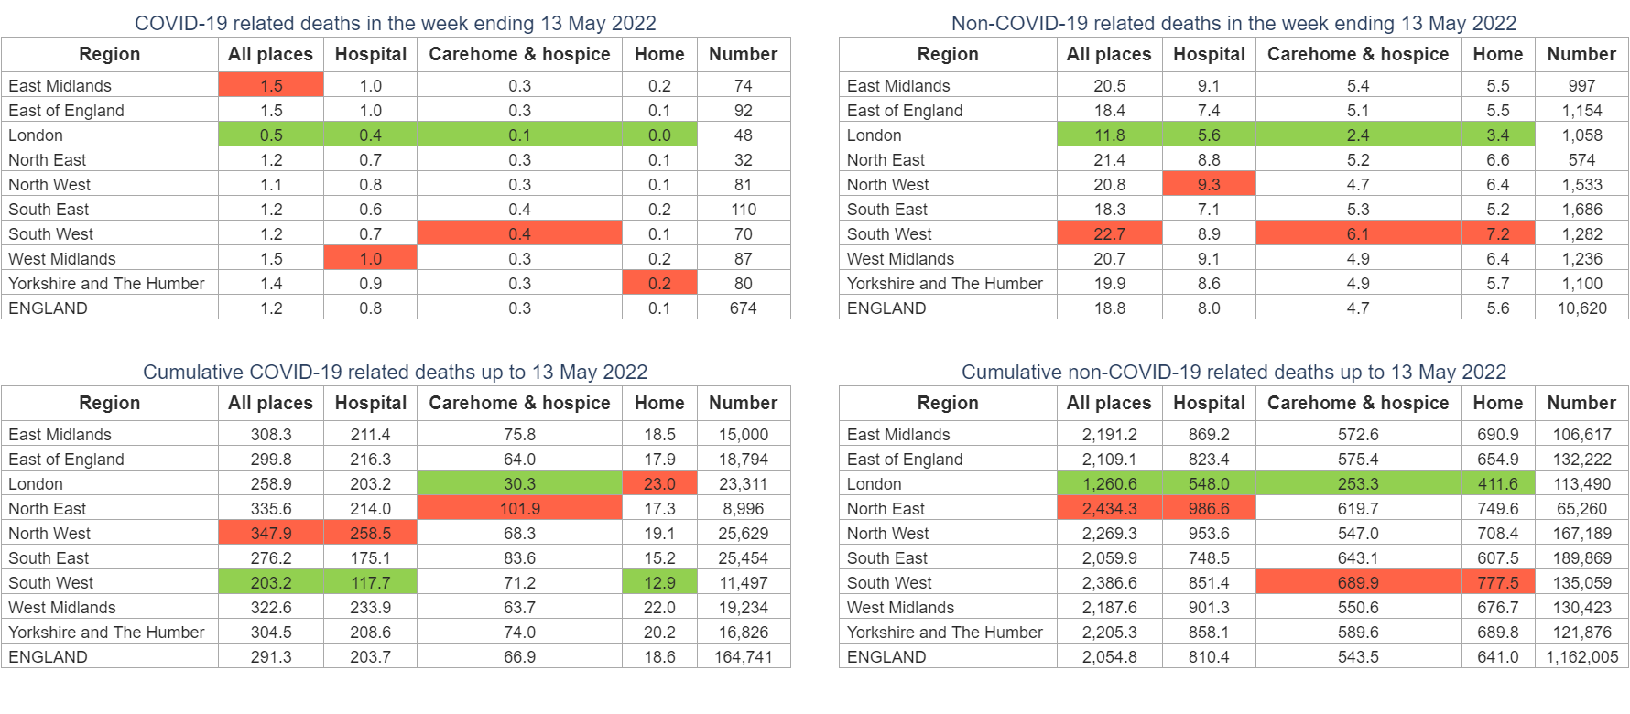
Death registrations by region of England
In the week ending 13 May 2022, London had the lowest COVID-19 and non-COVID-19 mortality rates in England for all places of death. Cumulatively, from 03 January 2020 up to 13 May 2022, London had the second lowest COVID-19 mortality rate and the lowest non-COVID-19 mortality rate for all places of death.

Table 2: Proportion of deaths registered by 13 May 2022, where COVID-19 is mentioned on the death certificate, by place of death, London boroughs
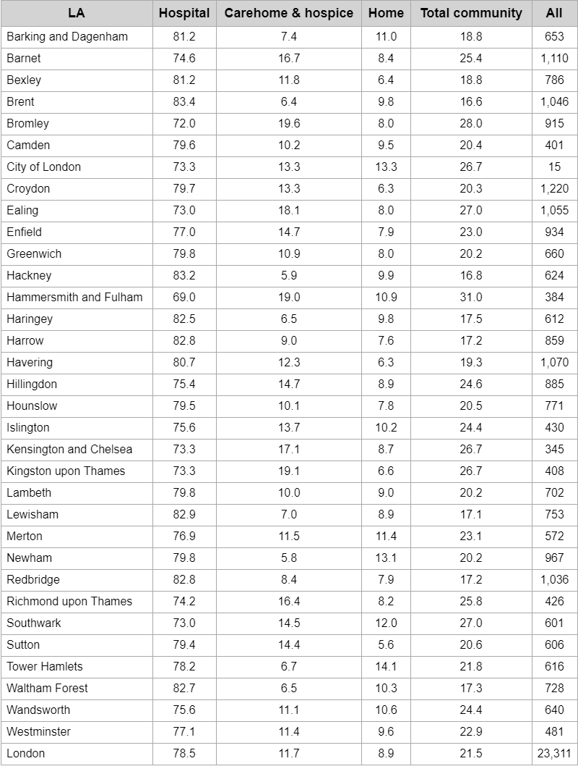
Daily deaths in care homes reported to the Care Quality Commission (CQC)
There were 10 deaths from COVID-19 in residents of care homes in England reported to the CQC on 20 May 2022. This brought the cumulative total of care home deaths from COVID-19 from 10 April 2020 to 33,638. This accounted for 14.2% of all deaths reported in care homes over this period. During 2022 up to 20 May 2022 there were 2,914 deaths from COVID-19 accounting for 7.1% of all deaths in care homes.
In London, 0 COVID-19 deaths were reported to the CQC on 20 May 2022. This brought the cumulative total from 10 April 2020 to 20 May 2022 to 1,850 and accounted for 12.7% of all deaths reported in care home residents over this period. During 2022 up to 20 May 2022 there were 135 deaths from COVID-19 accounting for 5.5% of all deaths.
Within London, Barnet had the highest number of reported care home deaths from COVID-19 across the period (n=150) and this accounted for 13.5% of all deaths in Barnet care homes.
Tower Hamlets had the highest proportion of deaths in care homes from COVID-19 across the period (27.4% of all deaths) but the number of deaths were lower at 29.
Figure 4: Deaths in care homes reported to the CQC by date of report up to 4pm on 20 May 2022, London during 2022
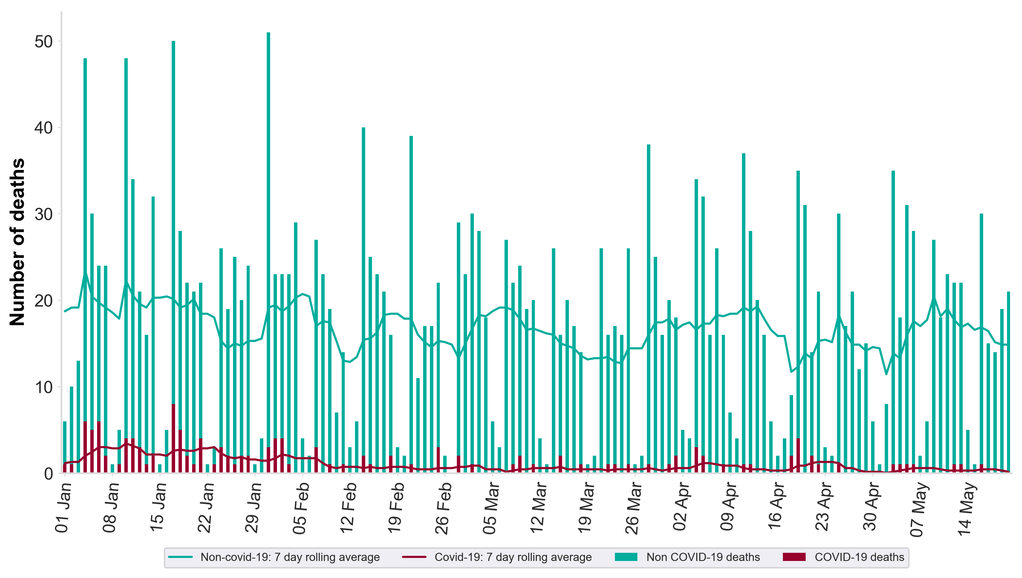

Notes:
1. Data provided by the CQC.
2. Figures are for deaths CQC are notified of on the days specified. Figures only include deaths that were notified by 20 May 2022 and may be an underestimate due to notification delays.
3. Figures are for persons who were resident in and died in a care home.

