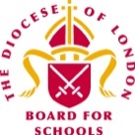
Summer Term 2022– Second Edition!


Dear Colleagues,

Welcome to the final edition of the RE Newsletter for Community Schools for this academic year. I do hope that you have found them to be both interesting and a support to you in all aspects of your work as a Subject Leader! I am sure you are now all looking forward to some rest and relaxation during the summer holiday period – whatever your plans may be, I wish you well! When we return to work in September, I will look forward to catching up with you at the different Network Meetings, or perhaps in visits to you in your schools. Finally, if you are moving on from RE, thank you for your enthusiasm and commitment to our subject and please pass this newsletter to your successor!

Do keep in touch via the various WhatsApp Groups that exist for Primary Subject Leaders in RE in many LAs now. Please contact me with your name, school and LA if you would like to be added. Remember that I am always here to offer you help, advice and support with RE (or Collective Worship). You may be:

- preparing teaching and learning
- reviewing and revising RE documentation such as schemes of learning and policy statements
- organising existing resources and/or selecting new ones
- developing your own subject knowledge.

I would be delighted to hear from you. Do not hesitate to contact me if you would like to make an appointment and I can assist you in person, online, by email or over the telephone.

Lesley Prior

Adviser for RE in Community Schools

RE IN COMMUNITIES NEWSLETTER
Contact Details: Lesley Prior
Part time Adviser for Religious Education in Community Schools
London Diocesan Board for Schools
36, Causton Street
London
SW1P 4AU
Tel. No: 07808 761 148
lesley.prior@london.anglican.org

- LB Brent: 20th October, 28th February, 9th May*  - LB Camden: 1st November, 7th March, 6th June*  - LB Hammersmith & Fulham: 29th November, 23rd March, 20th June*  - RB Kensington &  Chelsea/City of Westminster: 24th November, 23rd February, 22nd June  - LB Harrow: 27th September, 19th January, 27th April*  - LB Hounslow: 18th October, 14th March, 25th May*  - RB Kingston/LB Richmond: 8th November  - 9th March, 13th June*  In LAs marked with an asterisk, a WhatsApp Group is available. | Provisional Dates of Primary RE Network Meetings  2022/23

New RE Resources from the BBC

You will already be well aware of the BBC Bitesize Resources for RE, but do you check into the site regularly to see what is newly available for the different Key Stages? There is some very useful information and also short clips for you to use in your lessons, covering the six main world religions featured in locally agreed syllabuses across London, along with materials relating to secular world views as well!

- Key Stage 1: https://www.bbc.co.uk/bitesize/subjects/zxnygk7
- Key Stage 2: https://www.bbc.co.uk/bitesize/subjects/z7hs34j

As a young teacher, when I was first given responsibility for RE in my school – without having any background in the subject! – I also found it useful to develop my own knowledge and understanding by accessing the BBC’s RE materials for secondary schools! You and your non-specialist colleagues might like to do the same?

Resources from Humanists UK to Support Teaching and Learning

If you and/or your colleagues are teaching about non-religious worldviews such as humanism as part of your RE curriculum, here are three ways that Understanding Humanism (the education wing of Humanists UK) can help!

- Free School Speaker Visits
You can book a FREE visit (online or in person) from one of their trained school speakers who can talk about humanism to your classes and answer your pupils’ questions.

- Free Resources for Teachers
The revised and updated Understanding Humanism website provides a wealth of new FREE resources for ages 5-18, to support your teaching about humanism. Designed by teachers, for teachers, you will find information sheets, presentations, activities, films, assessment ideas, and humanist perspectives on a wide range of questions and topics. Check out the user guide to help you get started.
- Teacher Training Webinars
Sign up for one of the twilight training webinars. Offered for teachers at both primary and secondary level, this engaging CPD will deepen your subject knowledge of humanism, and support you with practical ideas for the classroom.
Finally, if you have any questions about Understanding Humanism, the school speaker service, or the training, send an email to: education@humanists.uk. You can also follow Understanding Humanism on Twitter at @HumanismEdu to hear about new resources and other updates.

Re-Think RE

RE-Think RE is a campaigning group sponsored by the RE Council of England and Wales. It promotes high quality education in Religion and Worldviews for all pupils in all schools, taught by well qualified and trained teachers. It believes that this can be simply achieved. It wants:

The Government to fund a National Plan for RE to ensure the subject is properly resourced and taught by professionally trained teachers and to enact a statement of entitlement to a high-quality education in Religion and Worldviews for all pupils.

Headteachers and Governors to make the teaching of RE a celebrated part of the curriculum, to ensure that pupils make progress in RE and to regularly monitor the quality of the provision in RE.

Parents and families to understand and value the role of RE in their children’s learning and preparation for adult life, and champion the subject in their school.

See www.rethinkre.org for more details – the FAQs section may be particularly helpful in enabling you to develop your own school’s vision for the role, nature and purpose of RE in the curriculum.

Finally, the group has also graded the performance of schools, government and the subject itself in a comprehensive review of five years of data. The data comes from a variety of sources, including an Ofsted subject report, public surveys, school workforce data, freedom of information requests, and interviews with teachers and students. It is the biggest ‘state of RE’ report for five years – how does RE in your school compare to the national picture? Check by clicking here: https://www.rethinkre.org/re-report-card

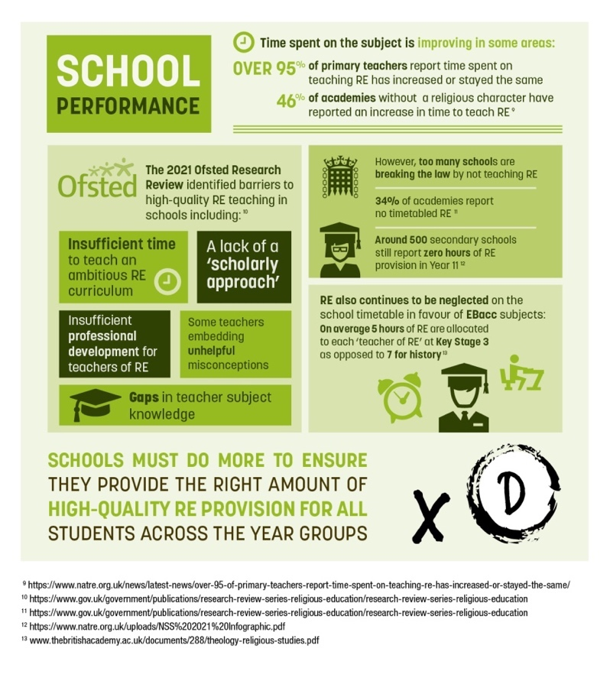

British Museum Exhibition

Feminine Power: The Divine To The Demonic is currently a major exhibition at the British Museum. The first one of its kind, Feminine Power takes a cross-cultural look at the profound influence of female spiritual beings within global religion and faith. It provides opportunities for us as Subject Leaders to explore the significant role that goddesses, spirits and saints have played – and continue to play – in shaping our understanding of the world.

Bringing together sculptures, sacred objects and artworks from the ancient world to today, and from six continents, the exhibition highlights the many faces of feminine power – ferocious, beautiful, creative or hell-bent – and its seismic influence throughout time.

It raises key questions for us as religious educators, such as:

• How do different traditions view femininity?
• How is female authority perceived in different cultures?
• How do we present femininity and gender identity in religions today?

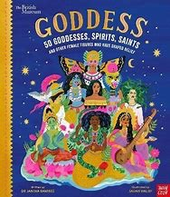

This book for children by Dr Janina Ramirez accompanies the exhibition and should be a worthwhile purchase for your school! On the British Museum website, you will also find a link to educational resources for Key Stage 2 and there is a possibility for some free visits to the exhibition for school groups. But make haste! It closes at the end of September!

See this link for more information: https://www.britishmuseum.org/exhibitions/feminine-power-divine-demonic#schools

RE and Ofsted
At the recent conference for the National Association of SACREs (NASACRE), Dr Richard Kueh, the Lead Inspector for RE at Ofsted spoke about the role, nature and purpose of the subject in the wider curriculum.

He highlighted the need for teachers to ensure that we provide opportunities for our learners to engage actively and thoughtfully with the wide range of religious and non-religious traditions that they will encounter locally, nationally and globally, in all their complexity and diversity. He also reminded us that our subject should prepare our learners to take their place in multi-religious and multi-secular societies. Finally, he emphasised the need for RE to be not only intellectually challenging, but also personally enriching.

In light of these remarks, how might you respond to the following questions which may be asked of Subject Leaders for RE during an Ofsted Inspection?

- Can you explain the place of RE in your school and the contribution it makes?

- Do you have a curriculum map and if so, how and why is RE arranged in a particular way?

- What is your intent in regard to RE in the school?

- How does RE in EYFS and/or KS1 prepare children for what they will experience in KS2?

- How do you sequence RE within any particular phase within the school?

- How do you define the intent for each individual unit of learning?

- How do you know that your pupils are achieving in the context of your intent?

- When do you have assessments?

- Why are they scheduled when they are?

- How do they meet the intent of your curriculum?

- What do you do for the wider curriculum?

- Do you have visits or trips or speakers?

- What additional opportunities are there for your pupils?

We have discussed some of these questions in recent Network Meetings but they are listed here for your future reference!

Free Self-Study Online Course

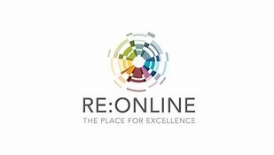

RE:ONLINE is offering a free self-study course. See: https://www.reonline.org.uk/professional-development/free-self-study-courses/

An Introduction to Religion and Worldviews for Primary Practitioners

This self-study course is for anyone involved in teaching Primary RE/ Religion and Worldviews who would like to improve their knowledge and skills. Whether you are an Early Career Teacher, an HTLA, a school-based mentor, an ITE provider, lead teacher or classroom teacher, this course offers up-to-date CPD in the subject, connecting to Teachers’ Standards, current RE/ Religion and Worldviews recommendations and high quality teaching and learning.

The course comprises three Activities, covering three aims:

• To think about the purpose of RE/ Religion and Worldviews in the curriculum
• To consider high quality teaching and learning in RE/ Religion and Worldviews
• To gain confidence in developing RE/ Religion and Worldviews subject knowledge

Once you have completed the course you can ask your mentor, lead teacher of Headteacher to sign off you work (full details in the course instructions). Send your signed form to trec@cstg.org.uk to receive a certificate of completion.

When you register you will receive a password to access the course.

Course length: You can take as long as you like to complete the course as it is self-directed study. The course is designed to take 12 hours. It is recommended you complete the activities over one to three months.

Cost: The course is free. You simply need to register, and you will be sent an email with the password to access the course materials.
If you have any questions please email trec@cstg.org.uk

