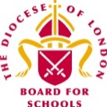
Autumn Term 2022– First Edition!


Dear Colleagues,

Welcome to the first edition of the RE Newsletter for Community Schools for this academic year. I do hope that the new term has begun well for you, though I am sure that you are already looking forward to half term! I will look forward to catching up with you at the different Network Meetings, or perhaps in visits to you in your schools. Finally, if you are new to the RE leadership role in your school, you are most welcome to our subject community.

Do keep in touch via the various WhatsApp Groups that exist for Primary Subject Leaders in RE in many LAs now. Please contact me with your name, school and LA if you would like to be added. Remember that I am always here to offer you help, advice and support with RE (or Collective Worship). You may be:

- preparing teaching and learning
- reviewing and revising RE documentation such as schemes of learning and policy statements
- organising existing resources and/or selecting new ones
- developing your own subject knowledge.

I would be delighted to hear from you. Do not hesitate to contact me if you would like to make an appointment and I can assist you in person, online, by email or over the telephone.

Lesley Prior

Adviser for RE in Community Schools

RE IN COMMUNITIES NEWSLETTER
Contact Details: Lesley Prior
Part time Adviser for Religious Education in Community Schools
London Diocesan Board for Schools
36, Causton Street
London
SW1P 4AU
Tel. No: 07808 761 148
lesley.prior@london.anglican.org

- LB Brent: 20th October, 28th February, 9th May*  - LB Camden: 1st November, 7th March, 6th June*  - LB Hammersmith & Fulham: 29th November, 23rd March, 20th June*  - RB Kensington &  Chelsea/City of Westminster: 24th November, 23rd February, 22nd June  - LB Harrow: 1st December, 19th January, 27th April*  - LB Hounslow: announcement to follow!*  - RB Kingston/LB Richmond: 8th November  - 9th March, 13th June*  In LAs marked with an asterisk, a WhatsApp Group is available. | Dates of Primary RE Network Meetings  2022/23

Planning Resources for RE

I am sure many of you will be aware that several commercial companies are offering (for purchase!) packages of RE plans and supporting materials for use in schools. Some of these companies make significant claims about the ways in which their products can support you in meeting the requirements of the statutory documentation governing the subject in your particular context – these are as follows:

- If you lead RE in a community school that is under the control of the LA then you MUST follow the locally agreed syllabus for your Borough.
- If you lead RE in a community school with academy status, then you may choose to follow the locally agreed syllabus for your Borough, but you are not obliged to do so.
- If you are in the voluntary aided sector – for example in a Church of England or Catholic school – then you should follow the syllabus prescribed by

I would like to make it clear that to my knowledge, such claims are usually made without ANY official endorsements from the bodies responsible for these statutory and legally binding parameters for RE.

Before purchasing any such materials, I would advise you therefore to check carefully with the appropriate body for RE in your area and for your category of school (generally the SACRE or the Diocese). You should receive relevant advice and guidance from such a body about whether or not any purchase your school might make in this regard is actually going to help you to deliver its official obligations where RE is concerned. Do contact me if you need further information about how to proceed – I will be happy to help!

Interfaith Week

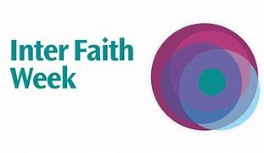

Interfaith Week takes place from 13th to 19th November 2022. This annual event provides your school with an ideal opportunity to raise the profile of RE in your schools and also allows you to focus on this theme in PSHE, RSHE or in Collective Worship. The Interfaith Network (IFN) has produced some special materials for schools which may be of interest to you and your colleagues.

- Link to primary resource: https://www.interfaith.org.uk/resources/learning-about-inter-faith-activity-a-primary-resource;
- Link to secondary resources: https://www.interfaith.org.uk/resources/inter-faith-activity-in-the-uk-a-teacher-resource-for-secondary-pupils;
- Golden Rule resource https://www.interfaith.org.uk/resources/shared-values-golden-rule;

The IFN website is also a good first port of call if you are looking for suitable speakers to come and contribute to your lessons on RE as it lists local and national bodies representing a wide range of religions and worldviews. See this link for further details: https://www.interfaith.org.uk/members/list

Holocaust Memorial Day

Holocaust Memorial Day, organised by the Holocaust Memorial Day Trust (HMDT), takes place on Friday, 27th January 2023. The theme for this time is Ordinary People.

SACREs, LAs and schools can find a wide variety of resources here: https://www.hmd.org.uk/resources/?genocide=any&resource_type=11&age=23

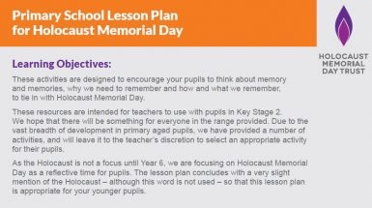

The HMDT also recommends Generation to Generation (G2G), a charity that provides speakers to tell their family’s Holocaust stories online, or face-to-face, to a variety of audiences. Through these engaging and historically accurate presentations, integrating first-hand survivor testimony, G2G works to ensure the lessons of the Holocaust are learned, promoting tolerance of all groups in society.
To consider how G2G can support your school, and to book a speaker, visit https://www.generation2generation.org.uk or book onto a free introductory event for educators at: https://www.generation2generation.org.uk/news/events/

Finally, many of you will already be familiar with this book which can be a useful tool in raising this challenging subject with pupils in Key Stage 2 and above. It is by Roberto Innocenti.

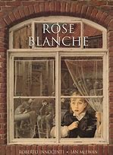

Big Ideas for RE!

How are children and young people going to successfully navigate this complex world in which we live?

How are they going to make the best of their lives through the joys and sorrows that come to us all?

How are they going to engage sensitively and critically in the matters of religion, belief and identity which shape this world?

How are they going to interpret their own experience of life’s diversity and know how to weigh up the multitude of voices and values coming at them from all angles through different forms of media?

Several very highly respected religious educators (who have played a key role in the subject nationally) are curating a fantastic set of ideas, plans and resources built around six Big Ideas for RE.

Although their materials on this website do NOT constitute a complete syllabus, they do hope that they can be used to meet some of the requirements of locally agreed and other statutory syllabuses for RE. They are providing teachers and curriculum developers with the tools that are needed to build a coherent, progressive and highly effective programme of education in religion and worldviews.

Their free website https://bigideasforre.org/ includes:

- A full explanation of the Big Ideas with key publications

- programmes of study for 5-18 year olds

- exemplar units of learning for 5-18 year olds

- a blog with news and guidance for SACREs, Agreed Syllabus conferences and teachers.

You can read more about the background to the project here:

https://www.reonline.org.uk/resources/putting-big-ideas-into-practice-in-religious-education/

Shap Calendar of Religious Festivals
The 2022-2023 Wallchart and the eCalendar are now available from Shap! This is the best and most reliable calendar of this kind and an essential resource for any individual Subject Leader for RE as well as colleagues of all kinds across every school. Put one on the wall of your staffroom! It lasts until December 2023!

More details are available at: www.shapworkingparty.org.uk

Withdrawal from RE

It is often a sensitive issue when parents or guardians seek to exercise their legal right to withdraw their child from the subject we love and which we believe is such a vital part of the curriculum.

This can often stem from misunderstandings families may have about the role, nature and purpose of our subject in today’s curriculum. Whatever the reasons however, it is important for all schools to deal with any such request sensitively and carefully and with full knowledge of the statutory regulations involved.

This helpful document – produced by the National Association of Teachers of RE in collaboration with the NAHT – may help to steer you through the complexities of the process.

https://www.natre.org.uk/uploads/Free%20Resources/18-15676_NAHT%20RE%20withdrawal%20document_final.pdf

Please remember that I am also happy to offer advice and support if you need it.
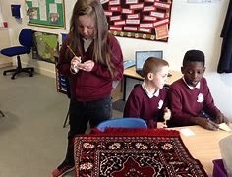

Preparing to Teach Advent and Christmas!

Is it not much too soon to be thinking about the place of Advent and Christmas in the RE curriculum? It is still only October, but my local shops are already stocking Christmas biscuits, chocolates and puddings and I have seen cards and decorations on sale too! Perhaps like some of our well known retailers, teachers also like to make their preparations early so that we can be organised and ready for the last few hectic weeks of this term?

If you are in that category, I would like to share some examples for Christmas books for use across the different age groups in the primary school – these all focus either on the Nativity story itself or on aspects of the Christian meanings and messages of the festival.

For EYFS, I recommend The Christmas Book by Dick Bruna, most well known as the author of the ‘Miffy’ books – it tells the traditional tale simply and well, and the illustrations are bright and lovely. Second hand copies can be picked up cheaply online!

For Key Stage 1, Celebration Song by James Berry is wonderful! Set against a Caribbean background, a poem by this award-winning resonates with the cadences of the West Indies as it creates an intimate portrait of Mary and Jesus as Mother and Child.

For Lower Key Stage 2, The Tale of the Three Trees helps children to explore the particular place of Jesus in Christianity and draws on aspects of various Gospel stories, not only the Nativity. It has been produced in various different versions and editions – I particularly like the one by Angela Elwell Hunt.

For Upper Key Stage 2, this beautifully illustrated book is by one of my favourite publishers for children, Barefoot Books. The Greatest Gift: The Story of the Other Wise Man is a thought provoking retelling by Susan Summers of the tale by Victorian writer Henry Van Dyke. Artaban, the mythical fourth wise man, stops to help a dying person and is too late to give his present to the King of Kings at his birth in Bethlehem. So begins a long journey amongst the poor, the sick and the hungry, bringing comfort to those in need. But will he find what he is looking for?

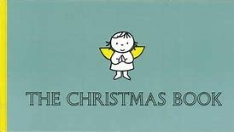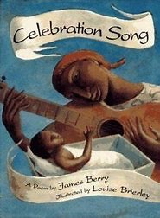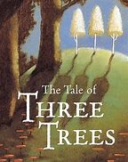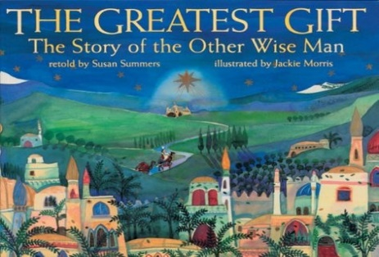

Do you have your own favourites you would like to share? Please send them on to me! Thank you!

