April & May 2023 Timetable of support groups and courses at
Maggie’s West London
Please contact us at: email: london@maggies.org • Telephone: 0207 386 1750 • Website: www.maggies.org to talk to our team about joining a group.
Please add your telephone number to your enquiry email (V) – virtual (C) – centre, face to face (B) – booking required
Monday | Tuesday | Wednesday | Thursday | Friday
Hair loss support with Headwrappers  (V + B)  First Monday of each month  11am – 12pm  April 3rd, May 3rd (Wednesday)  Prostate cancer support group (C)  First Monday of each month  10.30am - 11.30am  April 3rd, May 15th  Primary breast cancer support group (C)  Second Monday of each month  11am – 12pm  April 17th, May 15th  Head and neck support group (C)  Third Monday of each month  Midday-1pm  April 17th, May 15th  Men’s group (C)  Fortnightly 2:30pm – 4:30pm  April 3rd, 17th, May 22nd  Decluttering workshop (C + B)  Please register your interest for the next course  Fatigue workshops (C + B)  2 - week course  Please register your interest for our next course | Yoga (V)  Weekly at 10am  Drop-in relaxation group (C)  Weekly at 11am  Nutrition workshop (C + B)  Please register your interest for the next course  Online introduction to mindfulness (B)  Please register your interest  Brain tumour support group (C)  Second Tuesday of each month  12.00pm - 1.30pm  April 11th, May 9th  Living Alone with Cancer (C + B)  First Tuesday of each month  1-2pm  April 4th, May 2nd  Thyroid Cancer Support Group  Third Tuesday of each month  12- 1pm  April 18^{th,} May 16th  Introduction to mindfulness (C + B)  Please register your interest  Mindfulness course – 8 weeks (C + B)  Please register your interest  Chinese Cancer Networking Group  4th Tuesday of each month  2-4pm | Young Women’s Group (C + B)  Fortnightly 11.30-12.30  Ovarian Germ Cell Support group (V)  Fourth Wednesday of each month  1.30-3pm April 26th, May 24th  GTD on-treatment support group (V)  First Wednesday of each month  1.30-3pm  GTD post-treatment support group (V) Third Wednesday of each month  1.30-3pm  Look Good Feel Better (C + B)  Third Wednesday of each month  1pm – 3pm  April 19th, May 17th  Lung cancer support group (C)  Second Wednesday of each month 2pm - 3pm  April 12th, May 10th  Bladder cancer support group (C)  Fourth Wednesday of each month 2pm – 3pm  April 26th, May 24th  Young men’s group (V + B)  Fortnightly 3pm – 4pm  April 5^{th,} May 3rd + 17th  Secondary breast cancer support group (C)  Third Wednesday of each month  3:30pm – 4:30pm April 19th, May 17th | Yoga (C + B)  Weekly at 10am – 8-week course  Cancer Rehab programme (C+B)  Weekly at 12.30-1.30pm – except April 20th  Laryngectomy support group (C)  Last Thursday of each month  1.30pm - 2.30pm  April 27th, May 25th  Nordic walking (C)  Weekly at 2pm- except April 20th  Menopause & cancer workshop (C + B)  First Thursday of each month  2pm – 4.30pm  April 6th, May 4th  Gynae cancer support group (C)  Third Thursday of each month  2:30pm – 3:30pm  April 20th, May 18th  LGBTIQ+ support group (V)  First Thursday of each month  3pm – 4pm  April 6th, May 4th  Where Now? (C + B)  6 - week course  Please register your interest for the next course  Intimacy Workshop  Please register your interest for the next course | Expressive art group (C)  Weekly at  10am – 12pm or 12.30pm – 2.30pm  (Taking place only once in April - 28^{th)}  Introduction to Pilates (C + B)  First Friday of each month  11.30am – 12:15pm  May 5th  Friends and family group (C + B)  (C + B)  Weekly 1-2pm  Bereavement Course (C + B)  Please register your interest for the next 6-week course  Upper GI + Cancer of Unknown Primary (C)  First Friday of each month  3.30pm- 4.30pm  April 14th, May 5th  Will writing workshop (C + B)  Please register your interest for the next course  Sleep workshop (C + B)  Please register your interest for the next course  Managing Stress- 6-week course (C + B)  Please register your interest for the next course

Supporting Maggie's in 2023 maggies.west.london maggieswlondon maggieslondon
This Photo by Unknown Author is licensed under CC BY-SA
This Photo by Unknown Author is licensed under CC BY
This Photo by Unknown Author is licensed under CC BY-SA

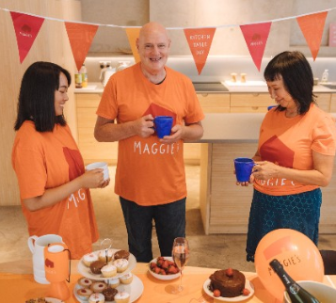
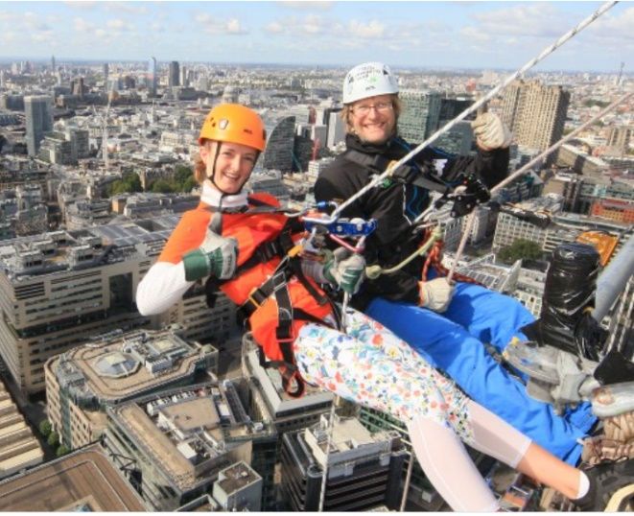

Kitchen table day
King’s Coronation on the 6 May or any other day in May

With your family and friends, host a coffee morning, BBQ, garden party or dinner party to celebrate the King’s coronation and support people with cancer.

Email to find out more: imogen.dalrymple@maggies.org
The Leadenhall abseil
Friday 16 June

Abseil down one of London's tallest skyscrapers with spectacular views over the capital. Take on the 'Cheesegrater' with friends and colleagues and raise money to support people with cancer.

To find out more, email: caroline.buckland@maggies.org

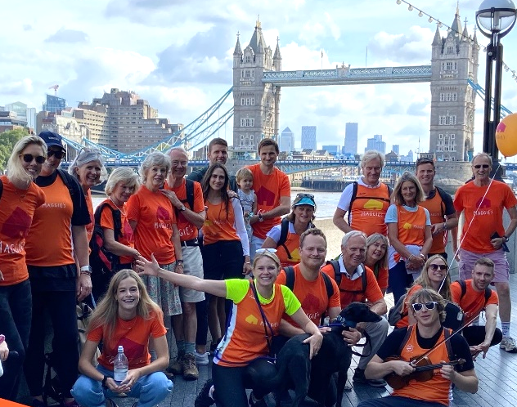
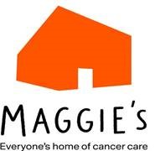
Do your own fundraising

Knit, bake, skydive or hike, cycle, run...! Whatever your talent, and whatever you love doing, you can help us continue to give people the support they need to find their way to cancer.

To find out more, visit: www.maggies.org/do-your-own-fundraising

FREE WILL WRITING service

We want to make it as easy as possible for you to write or update your Will, so we’ve partnered with local solicitors so you can write or update a basic Will for free.

For more details, please ask a member of staff or visit www.maggies.org/legacy
For more information about any of our events, ask to speak to a member of our fundraising team (Caroline, Emily or Imogen)
or contact us at: westlondonfundraising@maggies.org

Maggie’s is a national charity; we rely on the kindness and generosity of our local communities to fund each
of our Centres across the country, including Maggie’s West London. Any support is very gratefully received.

Text ‘MaggiesCHX’ to 70007 to donate £3.

