Virtual PVI SENCo Forum Agenda

5th March 2024 1-2.30 pm

Via Teams

Running order:

- Welcome & Introductions – JP & ALF - H&F Early Years Advisors –
- New SENIF Info & EYs OAP- PM /SS-Final draft
- Guest Speaker Karen Hayon SLT – SLT training programme-
- Alison JCT team invite – share new website and offer- enabling environments.
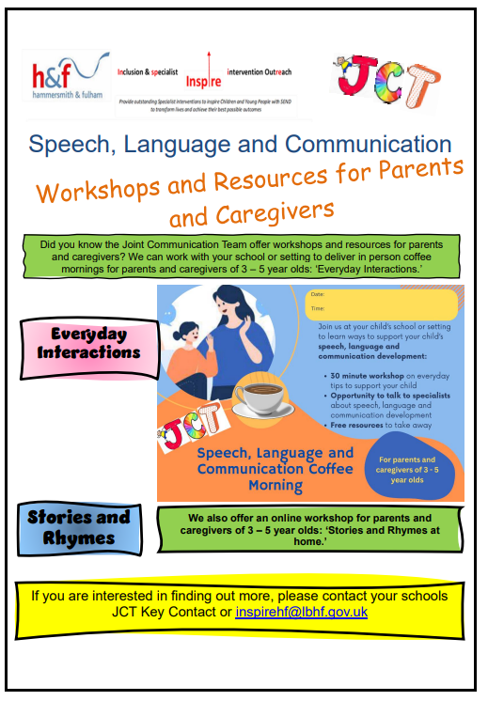
Home - Inspire (lbhfinspirehub.com)
- Andrea Boswell-(Transition training) INSPIRE promote training-
- Introduce new Inclusion Officer -Promote Inclusion Team – EYIT s flyer and SEHM training and Phone consultations-
- Deadline to apply 31st March for PVIs place on DfE funded Level 3 Early Years SENCO course

Early Years SENCO - Level 3 | Best Practice Network

- Peter Wilde – 2 yo checks CLCH- TBC

- Questions

- A.O.B.

