Press release 9 June 2024: No embargo
Conference: Starting from the Child?
7 June 2024 9.30-4.30
Join us for a critically important conference at Coram campus in London to start from the child and explore the continuum of learning and development from birth to seven years of age.
This special hey! conference will also launch the 5th Edition of ‘Starting from the Child?’ by Prof. Julie Fisher, in conjunction with Open University Press. This is an important opportunity to celebrate Julie’s work, the review of this seminal text, and her immeasurable contribution to the early years landscape.
Throughout the day we shall have a stellar line-up of speakers coming together to analyse and investigate the nature of effective, appropriate, and responsible early education practice.
The conference day will conclude with Julie in conversation with hey! programme director Jan Dubiel, with a question time, book signing, and drinks reception.
“Prof Julie Fisher has consistently been one of the clearest, most thoughtful and informed voices in the early years profession.
Her principled and considered perspective has both inspired and enabled generation of early years educators to review and refine their craft.
It is, therefore, apposite, and timely that that ‘Starting from the Child’, has been updated to re-contribute to the important debate regarding how we understand and frame the best quality education for children in the early years.
I sincerely hope that its impact will continue to enlighten and challenge all those concerned with ensuring that children experience the most effective provision.”
Jan Dubiel, programme director, hey!

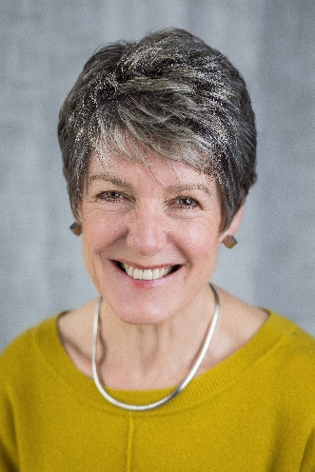
Conference: Starting from the Child?
7 June 2024 at Coram Campus, 42 Brunswick Square, London
We will be examining how key principles are embedded in children’s experiences of early education provision and how these progresses from birth to seven years of age. The conference will pose and reflect upon the key questions of:
- How do we maintain a consistency of principles and practices that effectively support and empower learners in a seamless continuum from birth to 7?
- How could and should each age and phase build on and learn from each other?
- How do we define and sustain exemplary practice in early education and the EYFS?
- How do we continue to draw from research and evidence to innovate and enhance provision in line with principles?
The conference will hear from:
- Ruth Sharp and Oliver Germyn exploring how we empower children’s learning and development from birth to 2.
- Alison Whelan discussing the pedagogical landscape for 3 to 5-year-olds.
- Dr Sue Allingham examining how we extend appropriate approaches and the understanding of Curriculum to age 7.
- Jan Dubiel with an overview of the hey! mission, our achievements to date and future project work and plans.
- Prof Julie Fisher launching the 5th edition of ‘Starting from the Child’ by reviewing the principles and challenges of effective early years practice, and how this is continually evolving. Followed by a question-and-answer session in discussion with Jan Dubiel.
- Social book signing and drinks reception.

Agenda
9:30 | James Hempsall OBE will welcome everyone to the conference and provide an introduction to the purpose of the day.
9:45 | Jan Dubiel will review the work of hey! one year on, and provide a summary and celebration of projects and achievements.
10:00 | Ruth Sharp and Oliver Germyn will explore how we empower children’s learning and development from birth to 2.
10:45 | Break
11:15 | Alison Whelan will discuss the pedagogical landscape for 3 – 5 year olds.
12:00 | Dr Sue Allingham shall examine how we extend appropriate approaches and the understanding of curriculum to age 7.
12:45 | Lunch
13:30 | Prof Julie Fisher will discuss ‘Starting from the Child’ principles and challenges, and the changing landscape of early education provision.
14:15 | Discussions.
14:30 | Discussions, questions, and interview | Prof Julie Fisher and Jan Dubiel
15:00 | Official launch of book, signing and drinks reception.
17:00 | Close

Costs
£150 (ex VAT) per person to include:
- The whole day conference with information and slides
- Complimentary copy of the new Edition of Starting From the Child?
- Book signing and drinks reception
- Refreshments throughout the day and lunch.
Booking
- To book your place(s) now on Eventbrite click here
- If you need to request your place(s) and pay by invoice contact us here
- Places are limited and will be allocated on a first-come, first-served basis.

