LBHF Early Years Provider Portal

These user guides cover using the Early Year Provider Portal and includes extra information for providers offering extended 30 hours. If you wish to offer the extended hours, please contact your local Early Years Team.

The guides will show you how to log on and navigate, enter child data, and submit headcount claims, perform eligibility checks, record sufficiency and view a breakdown of funding based on your claim.

Contents
Logging onto the system 2
Changes to the Provider Portal 3
Estimates 3
Entering Actuals 4
Adding children 5
Add Child 5
Parent/Carer Details 5
Funding Details 6
Adding a child with Extended 15 Hours to the headcount 8
Eligibility Checker 8
Add Child 9
Parent Carer Details 10
Funding Details 11
Voucher Code Information 11
Children Rolled Over from Previous Term 13
Icons and links 14
Submitting your Headcount 15

Logging onto the system

To access the Provider Portal please click on the link below.

Sign In - Synergy (servelec-synergy.com)

This will take you to the login screen.

The Portal cannot be found via a web search, please only use the link provided.

Enter the username and password provided to you. Upon entry, you will be taken to the landing page for the portal.

This is an updated version of the Provider Portal, your login details have not changed

If you have forgotten your password, click the “Forgotten Your Password” link. You will be asked for your login ID. Click “Request Token Via Email”. A Token Code will be sent to the email address stored on the portal. Once received copy this into the relevant box and input/confirm your new password then click “Change Password”

Please ensure that you inform Felista.aloo@lbhf.gov.uk of any changes of email addresses or to check we have the correct details.

The Provider Portal is compatible with Microsoft Internet Explorer Versions 10 & 11, Microsoft Edge, Google Chrome & Apple Safari. We do not advise the use of any other browser software.

Changes to the Provider Portal

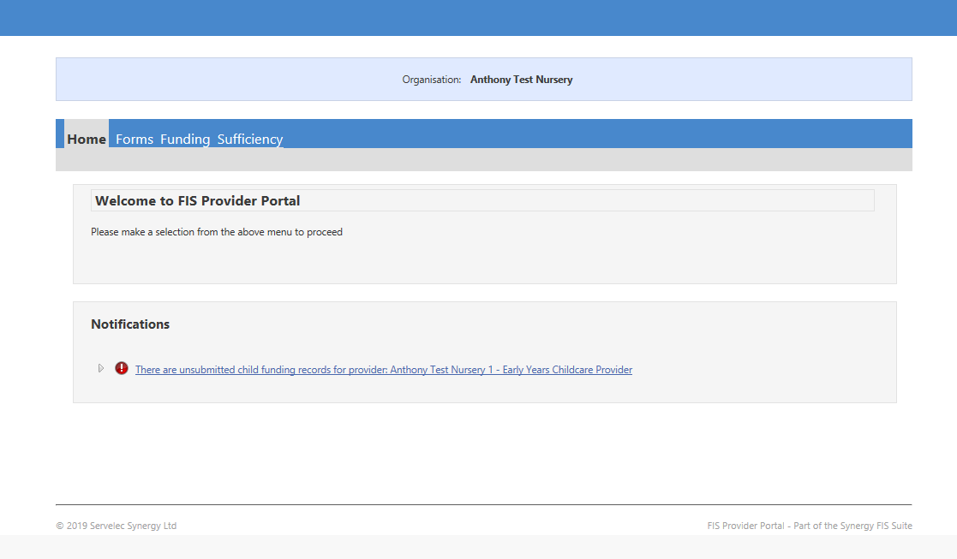

The latest version of the Provider Portal has some format changes.

- The Funding Tab – Current terms within the “Summary, Estimates and Actuals” are easier to find as they are marked with a Green Arrow

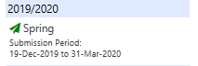

- Parent & Carer Details – consent check boxes to indicate consent for sharing data for 30 Hours or EYPP is given

Estimates

The estimate data is a request for child numbers/ hours for the upcoming term so an advanced payment can be made. It is not a request for child details.

In the past estimate data was requested to be added on Synergy by the provider, and although the feature is still available, providers should still NOT add the data here.

Instead, the Funding Officer manages the Estimates. Please provide this when requested by email. Any estimate data that providers add on Synergy will be deleted, as it should be submitted via email for the funding officer to check and manage.

Although estimate payments are made, without the actuals being entered at headcount to confirm the children, the assumption will be made that the child is not attending with you. This will result in the money being clawed back in the next payment. An email detailing portal open times for adding actuals is sent at the beginning of a new term.

Entering Actuals

Selecting ‘Actuals’ will take you to a screen that allows you to edit and enter new records for the term.

Select the Year and Term to be updated, live terms are shown with green indicators. (Providers registered for both the 2yr old and 3&4 yr. old offers will have two terms to update).

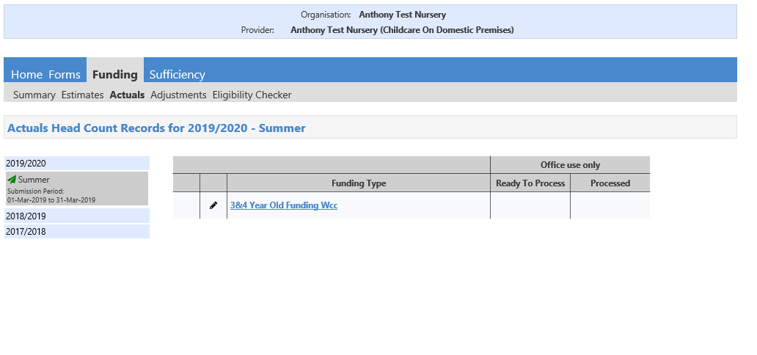

On selecting the “Funding Type”

If you are a new provider, the only option will be “Add Child”

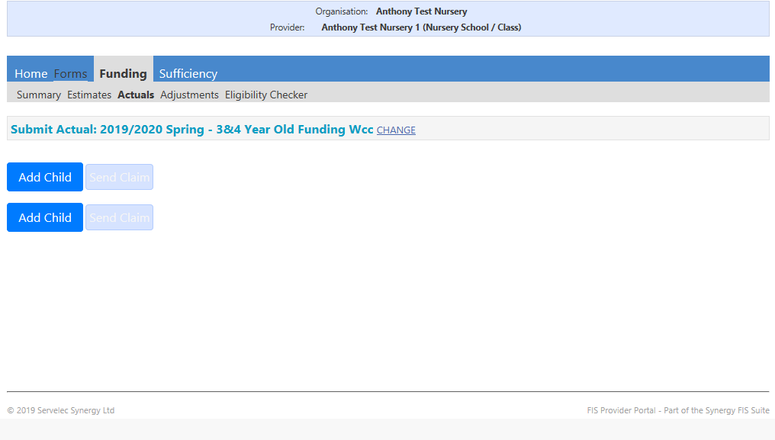

- Existing providers with children rolled over from the previous term will have a list of children automatically copied from the previous term. Here you can add and amend children’s attendance for the current term.

Adding children

Add Child

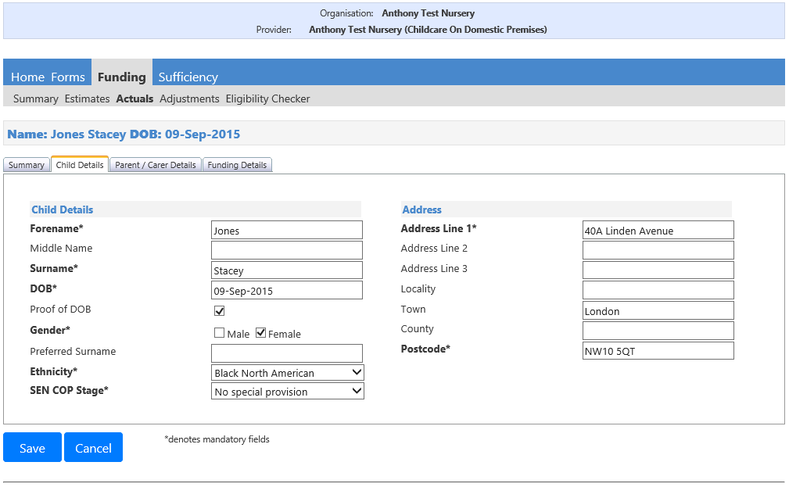

Complete all mandatory child details fields marked with a *; ensure that the address details are correct. If in doubt, please check the address with the parent.

Parent/Carer Details

If the child is not eligible for EYPP funding or your setting does not provide the additional hours, please leave this tab blank,

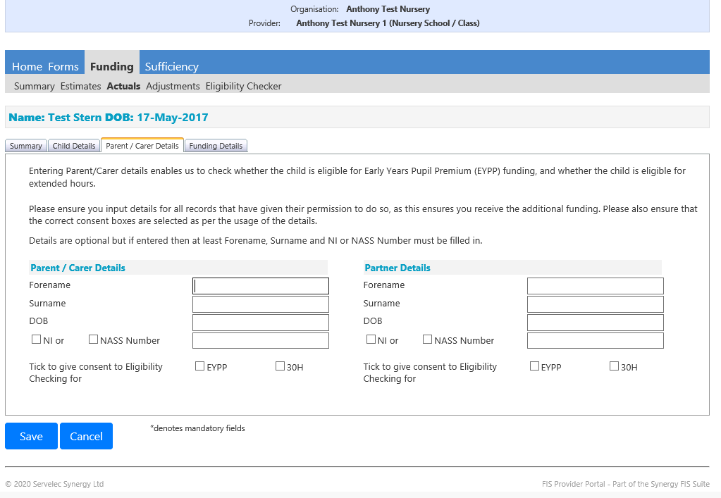

Consent for Eligibility Checking for either EYPP or 30 Hours funding must be ticked if this is being claimed

Funding Details
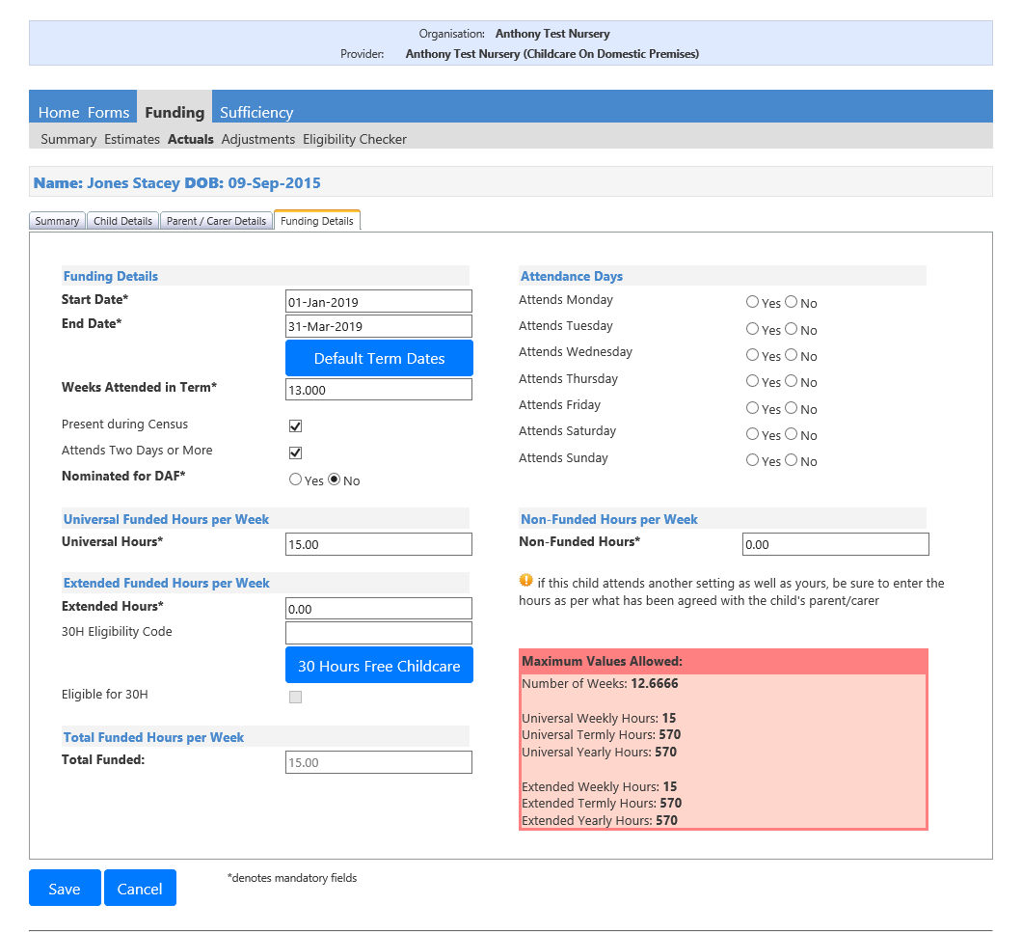

If child attends for the full term please use the default dates, if child starts/leaves on different dates please use them instead. These dates are not used by the system to calculate any funding. Instead, you should change the figure in ‘Weeks attended in Term’ accordingly.

The standard number of weeks for a full term of funding for most providers is 12.6666.
However, some providers open for less weeks. Please ensure you enter the correct number of weeks for your setting and in relation to the child’s attendance that term.

Nominated for DAF’. Only select ‘Yes’ if child claims Disability Living Allowance. Proof will need to be sent to the Funding officer, to arrange a one-off payment of £615 for the year.

‘Universal Hours’ is a maximum of 15, ‘Extended Hours’ should be ‘0’ unless claiming additional hours (maximum of 15) through a code. Enter any ‘Non-Funded Hours’, if none enter ‘0’. Please ignore “Attendance Days”, the red maximum values box is for office use only.

Click ‘Save’.

Adding a child with Extended 15 Hours to the headcount

Eligibility Checker

All parents wishing to claim 30 hours funding should have the eligibility code checked before the beginning of term. Start & End dates must fall between dates specified by local authority.

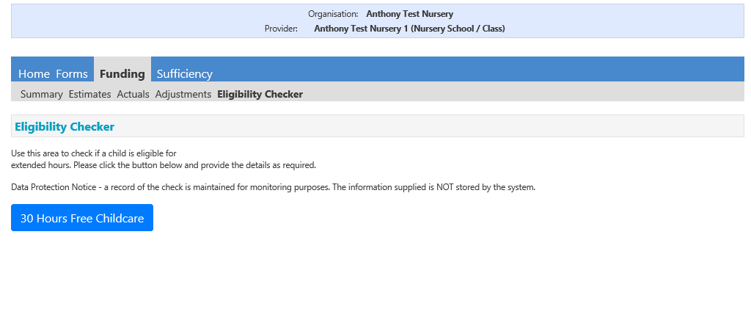

Select “30 Hours Free Childcare”

Enter the Eligibility Code, Child’s DOB & Parent’s National Insurance Number. Tick Consent Box and submit.

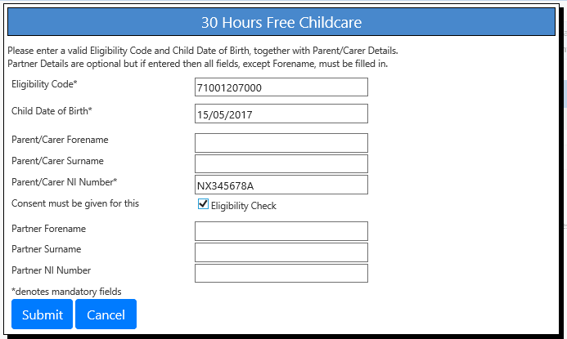

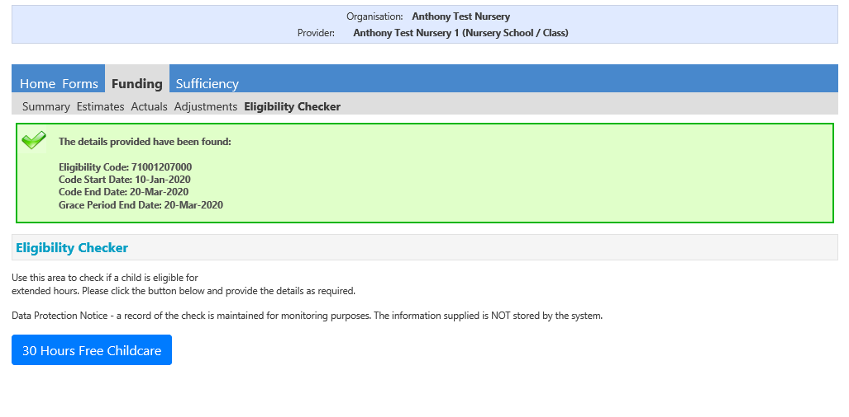

This shows a successful search, if the box is red please check the details again. The start date must be no later than the 14th of the first month in the new term to be valid.

Add Child

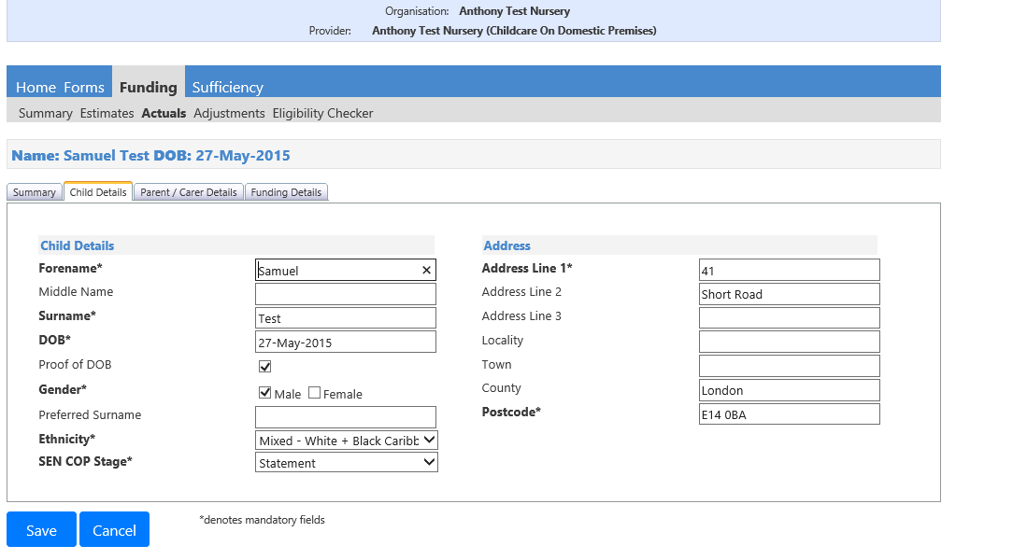

Complete all the mandatory fields on the ‘Child Details’ tab, please ensure the address details are correct otherwise the record cannot be validated. If in doubt please ask parent for proof of address.

Parent Carer Details
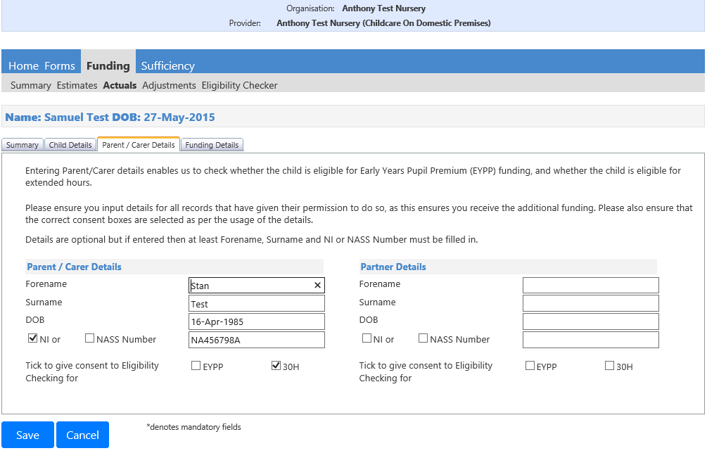

Add the parent’s details as above, remember to tick EYPP or 30 Hours consent boxes if claiming.

Funding Details
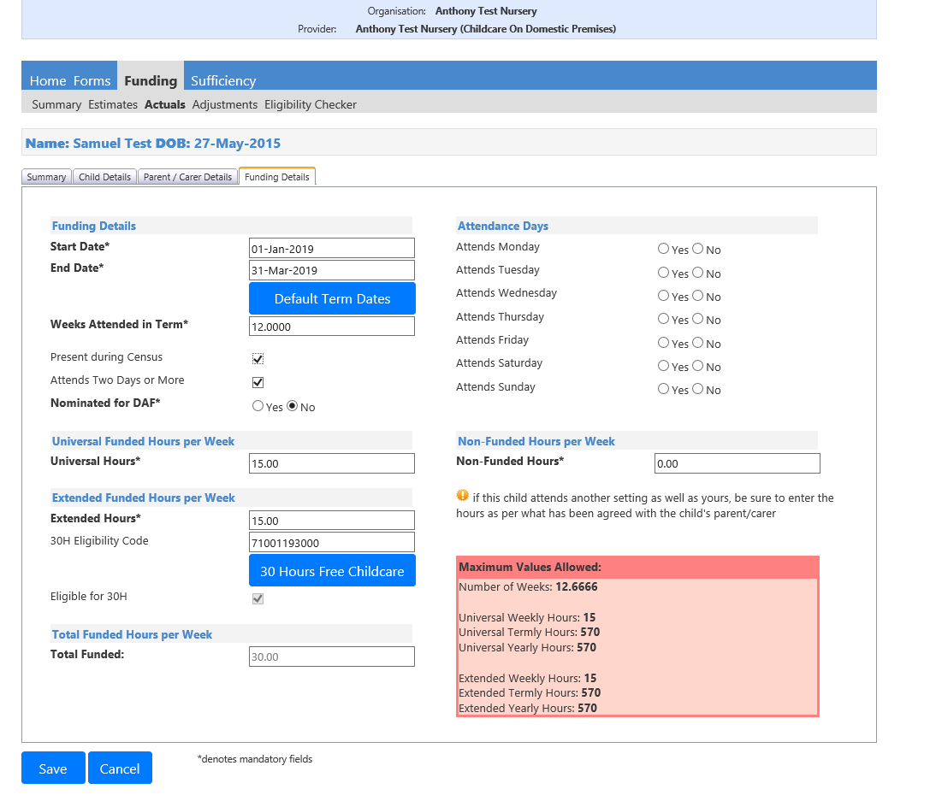

Complete all required fields: Universal Hours maximum value is ‘15’, ‘Extended Hours’ can be up to 15.

‘Present during Census’ should only be ticked in the Spring Term, ‘Nominated for DAF’ should be ‘No’ unless parents have nominated your setting to receive this payment, (this should only be selected once per year).

‘Attendance Days’ should be left blank; ‘Non-Funded Hours per Week’ should be set to ‘0’ unless the child attends over 30 hours per week.

Enter the 11-digit Voucher code. Then click “30 Hours Free Childcare”.

The voucher code and parent details will then be checked via the online ECS system. If successful, you will see the message below.

Voucher Code Information

Voucher Codes should be checked at the beginning or if possible before the end of previous term to ensure continuity of funding. Codes that have not been renewed by parents before end of a term may not be eligible for further funding.

The initial validation check includes the “Grace Period”. A code within its grace period is not acceptable at the start of term…

An example an eligibility check made for Spring Term 2020

- Start date 02/01/2020
- End date 25/03/2020
- Grace Period up to 20/04/2020

A renewed code must end after the 1st day of the new term to be eligible. E.G. (02/01/2020). If you check a code and its end date if before the 1st day of the new term it is not eligible.

New codes must start on or before the 14th day of the first month of term. If the code is not recognised providers should contact parents and ask them to speak to HMRC as a matter of urgency.

Cut of dates for applications for new codes or renewal:

31/03 for Summer Term
31/08 for Autumn Term
31/12 for Spring Term

If parent has not applied for ...or renewed the validation code before DFE cut-off dates below, the Authority is under no obligation to fund additional hours.

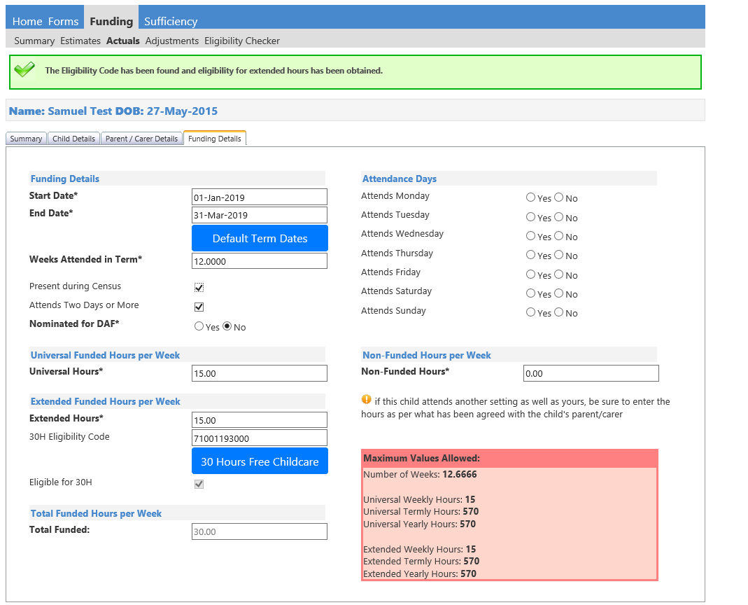

Click ‘Save’

Children Rolled Over from Previous Term

If you have children rolled from precious terms, various options are available:

- Edit Child
  - Child & Parent information can be amended before headcount submission only. Any field in the record can be amended.

- Add Child
  - New children can be added to the headcount before submission.

- Delete Child
  - Children can be deleted from the headcount before submission.

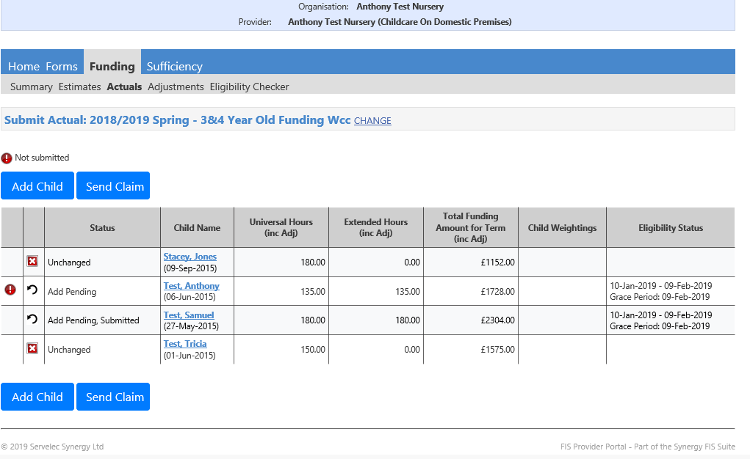

Icons and links

- Request Delete, same as link on previous versions request deletion of child from current headcount.
- Child record will be marked as unchanged, delete pending, edit pending, submitted pending or submitted.
- Link to child record, also shows DOB.
- All children receive up to 15 universal hours.
- 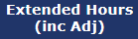 Extended hours only apply to children in receipt of the additional 15 hours funding.
- 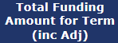 Funding per child including standard rate, and any weighted funding (deprivation and/or EYPP)
- Shows if child is receiving deprivation and/or EYPP.
- Applies only to children accessing extended hours. Shows voucher start & end dates and grace period.
- Child is now within grace period of the voucher. Eligibility for extended funding ends at the end of this period unless code is reconfirmed by parent/carer via the HMRC website.

Note that children marked with a record of unchanged will require amendment to allow Portal to recognise that new weightings or updated 30 hours codes that may need to be applied.

Click on the child record, and then select save ...this will insure that the record is updated if no weightings were applied for the previous term.

All Providers should check their headcount to ensure no children that have left in the previous term are still shown.

Submitting your Headcount

When you have made all your changes, click ‘Send Claim’.

On pressing ‘Send Claim’ you will be informed that the submission has been successful, and the following message will be displayed on the screen: 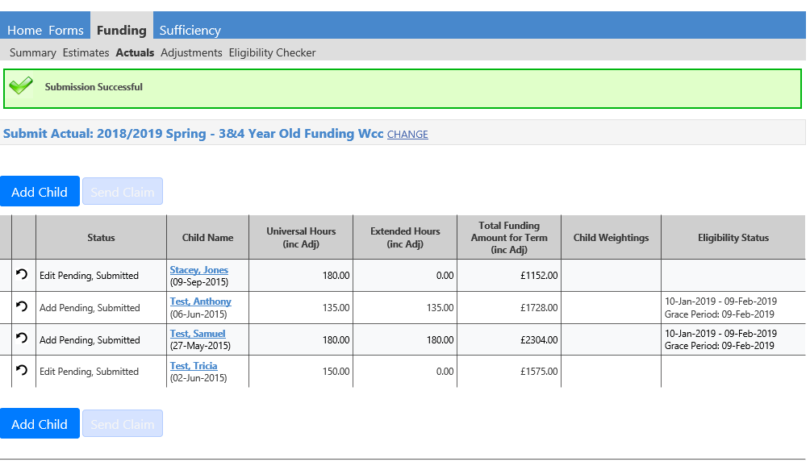

If your submission has not been successful, please check your records and resubmit. If you continue to have issues with submission, please contact.
Felista.aloo@lbhf.gov.uk

