**Early Years Pupil Premium (EYPP)**

This page is for childcare professionals who want to find out more about Early Years Pupil Premium (EYPP).

**What is the Early Years Pupil Premium?**

EYPP is additional funding paid to providers to support disadvantaged children within the setting. It is designed to give children from disadvantaged backgrounds the necessary support required to develop and learn, ensuring school readiness.

Providers are required to demonstrate that the EYPP funding is making a difference within the setting for the child applied for. Ofsted often requests evidence of this during inspections.

**Who can claim the Early Years Pupil Premium?**

From **2024-2025**, **Early Years Providers** may claim EYPP funding for children aged 9-months to 4-years who meet the eligibility requirements, regardless of the entitlement they are accessing. Children do not need to access the full 15-hour entitlement to be eligible for the EYPP as providers will be paid on a pro rata basis.

To be eligible for EYPP, the family should receive one of the following:

* Income Support
* Income-based Jobseeker’s Allowance
* Income-related Employment and Support Allowance
* Support under part VI of the Immigration and Asylum Act 1999
* The guaranteed element of State Pension Credit
* Child Tax Credit (provided they’re not also entitled to Working Tax Credit and have an annual gross income of no more than £16,190)
* Working Tax Credit run-on, which is paid for four weeks after they stop qualifying for Working Tax Credit
* Universal Credit (provided they have an annual net earned income equivalent to and not exceeding £7,400, assessed on up to three of the parent’s most recent Universal Credit assessment periods.).

Funding may also be available if a child falls into one of the following groups:

* adopted from care
* has left care through a special guardianship arrangement
* has left care and is subject to a child arrangement order (previously known as a residence order).

**How much will I be paid?**

EYPP is paid at a national rate of 68 pence per hour, with payment of up to £129 per term, for every eligible child who attends their setting. For example, if children are attending their full 15 hours of free early education per week, this would total as follows:

1 child - £387.60 each year

5 children - £1938 each year

10 Children - £3876 each year

15 Children - £5814 each year

**What is my role in promoting the Early Years Pupil Premium to parents and carers?**

Identify children who may be eligible at the earliest opportunity. The easiest way to promote and inform parents is to do this at the point when a parent registers at your setting.

Ensure that all staff are confident in talking face to face with parents about the benefits of the EYPP and checking their eligibility.

Consider making displays to show parents how the funding has been spent to encourage parents to share relevant information.

You may also look at including information on EYPP for parents on your website, in electronic newsletters or on social media pages. You may include how you have spent the funding and the impact it has had on the children.

**How can I spend the EYPP funding?**

You may choose how you spend the EYPP funding, however it must be based on the needs of the eligible children you have applied for at your setting. This could be through:

* pooling the EYPP to purchase shared services such as a Speech and Language Therapist
* joining with other settings to access training / resources
* improving staff member's qualifications
* accessing training or providing additional staff to implement specific strategies
* additional staffing to access research documents / strategies
* additional quality time and interaction for staff to spend with children eligible for EYPP enrichment opportunities / activities
* purchasing resources
* visits to home / school / external professionals’ additional space

**How do I claim the Early Years Pupil Premium?**

You may claim for EYPP funding at the same time as you claim your early years funding.

You need to ensure that parents’ have included the required information on their Parent Declaration Form i.e. parent / carer surname/s, parent / carer date of birth and parent / carer National Insurance number or National Asylum Seeker number.

Please ensure the parent / carer details and information is accurate and in full. If you do not provide all the information required or there are any errors, the families’ eligibility cannot be checked, and no funding will be allocated.

Please note, you must tick the EYPP consent box.

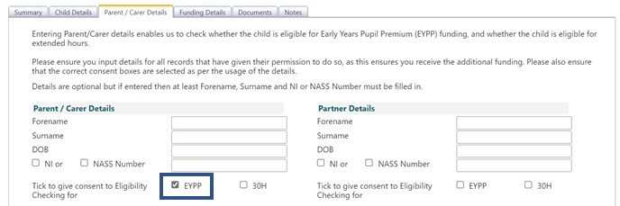

You will need to see a copy of the parents/r carers court order if they have indicated on the declaration form that their child belongs to one of the following groups:

* has been adopted from care
* has left care through a special guardianship arrangement
* has left care and is subject to a child arrangement order.

We will be able to check the eligibility of any children that have been identified as being looked after by the local authority. Please use the notes section to inform us of a looked after child (LAC).

**What happens next?**

An eligibility check will be carried out once you have submitted your funding claim, and the results will show up in the ‘Child Weightings’ column as EYPP. EYPP funding will be paid along with your balancing payment at the end of each term.

