# Guidance on checking Working Family Entitlement Codes

Providers are responsible for checking the **validity start and end dates** of working family entitlement codes before the beginning of the new term and before

offering a funded place. This applies to all children i.e. existing children and new children claiming Under 2’s, 2-year-old and 3&4-year-old Working Family Funding.

If a parent has a query about their eligibility for Working Family funding or problem applying online to HMRC, they need to contact HMRC directly on **0300 123 4097**. London Borough of Hammersmith and Fulham does not deal with the issuing of Working Family Codes.

Further information on ‘Early Years Entitlements’ including a useful ‘FAQs’ from the Department of Education can be found here: [The Family Hub | London Borough of Hammersmith & Fulham (lbhf.gov.uk)](https://www.lbhf.gov.uk/children-and-young-people/family-hub)

This document covers the different types of funding available, when to apply for Working Family Codes and eligibility. This also includes specific guidance on when a parent can begin to access Working Family Funding when on maternity/paternity or adoption leave, as this can also be affected by a parent’s return to work date.

# Completing an Eligibility Check

Eligibility checks are completed using the Eligibility Checker screen on the Portal. [Sign In - Synergy (servelec-synergy.com)](https://tri-borough.cloud.servelec-synergy.com/LBHF/FIS/Synergy/Login.aspx/?ReturnUrl=%2FLBHF%2FFIS%2FSynergy%2FAdmin%2F) This isn’t linked to headcount and will not update a child’s headcount claim. It is a standalone system which provides a ‘live’ check to show you on screen the start and dates of a parent’s code, as well as any ‘grace period’ dates at the time that the check is carried out.

To complete a code eligibility check you will need the parent’s permission to use their details:

* Parent’s 11-digit code number from HMRC
* Parent’s National Insurance number. If the parent is married/has a partner, also check if their details were used to apply for the child’s code and if so, you will need their National Insurance number too.
* Child’s date of birth

**This type of check is only for Working Family Codes.** If claiming 2-year-old ‘Disadvantaged’ funding for a child holding a **REFRENCE NUMBER** from H&F, please follow our guidance found on our website here: [2 year old childcare funding | London Borough of Hammersmith & Fulham (lbhf.gov.uk)](https://www.lbhf.gov.uk/children-and-young-people/family-hub/early-years-and-childcare/help-childcare-costs/2-year-old-childcare-funding)

# Using the Eligibility Checker

Login to the Synergy Provider Portal Click on **Funding,** then

**Eligibility checker**

then the blue ‘**Eligibility Checker for Working Family Entitlement** box:

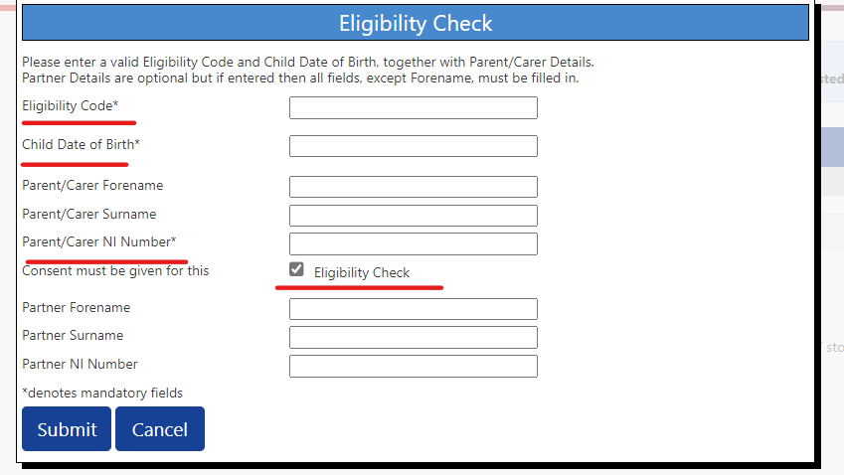The Eligibility check screen will appear as shown.

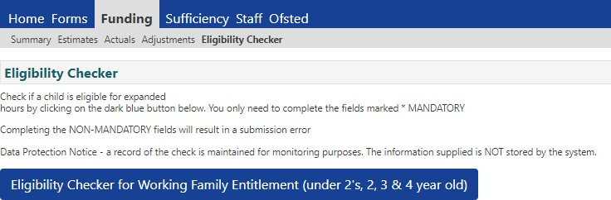

To carry out a check, only enter the mandatory information highlighted in red/shown with an asterisk.

If any more information is added in error, the check will not be carried out:

Please ensure you have ticked the consent box as shown. This confirms an ‘eligibility check’ can be carried out and without this ticked, your check will not be carried out.

Once the check is run, please use the information on page 3 to guide you through what is shown on screen, what the code dates shown mean and whether a Working Family code is valid for use in Autumn Term 2024.

# How to check if a code is valid for use?

* Run an Eligibility Check on the Synergy Provider Portal, following guidance on page 2.
* Using the results shown on screen you must check the start and end dates shown using the table below. This key information confirms if a parent’s Working Family code is valid for use in Autumn term 2024.
* If the code cannot be ‘found’ when completing your check, this means either the information used on your check is incorrect OR the parent does not have a code with HMRC. Please see further guidance on page 4.

**Key Information** - **When your code check shows a ‘green banner’ on screen THIS DOES NOT MEAN A CODE IS VALID FOR USE. All this shows is that the parent has received a code from HMRC.**

# Working Family Entitlement Codes for Under – Summary for Autumn Term 2024

Using the start and end dates now shown on screen following your completed eligibility check, you should review the dates shown in line with the table below. This will confirm whether a parent’s Working Family Code is valid for use in Autumn term.

|  |  |  |  |  |
| --- | --- | --- | --- | --- |
| **Code Start Date on screen** | **Code End Date on screen** | **Grace Period end date** | **Was child accessing 2YO or 3&4 YO Working Family funding in**  **Summer 2024 with you, using this code?** | **Can Working Family Code be used to claim funding in Autumn 2024?** |
| On or before 31 August 2024 | After 1 September 2024 | 31 December 2024 or later | N/A | **YES** |
| On or before 31 August 2024 | Before 31 August 2024 | 31 August 2024 or before | N/A | **NO** |
| On or before 31 August 2024 | Before 31 August 2024 | 31 December 2024 or later | YES | **YES** |
| On or before 31 August 2024 | Before 31 August 2024 | 31 December 2024 or later | NO | **NO** |
| After 1 September 2024 | After 1 September 2024 | 31 December 2024 or later | YES | **NO** |
| After 1 September 2024 | After 1 September 2024 | 31 December 2024 or later | NO | **NO** |

# Completing a code check and details not found – Next steps.

If HMRC do not hold a Working Family code using the details used in your eligibility check, you will see the example below.

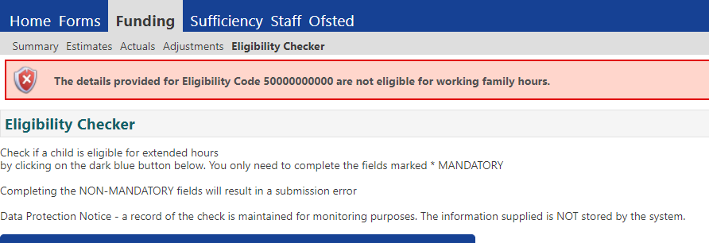

You now need to

* Re-check all information used on your eligibility check for errors. Check the 11-digit code number is correct, and there is no error with the National Insurance number entered or child date of birth used. Please also ensure tick box for ‘consent’ and run the eligibility check is ticked.
* If all information appears correct and the consent box is ticked, contact the parent. Ask them to confirm the information they have given you matches the details used when they applied for their Working Family Code. If the parent is married/has a partner, also check if the code was applied for with

their details, and run the eligibility check again using their information.

* If you remain unable to trace the Working Family code having followed these previous steps, please email [Renee.Daley@lbhf.gov.uk](mailto:Renee.Daley@lbhf.gov.uk). We need you to confirm in your email the 11-digit code number, the parent’s details and National Insurance number and child date of birth. If the parent is married/has a partner, please also include their details in your email too. We cannot take any further action unless all information is provided in your email to us.

**Key Information – Until a provider can confirm using the ‘eligibility checker’ that the parent holds a valid Working Family Code for Autumn Term, providers must not offer a Working Family funded place from September 2024.**