
and what you can do
WHY SCHOOL
BELONGING MATTERS

HAMMERSMITH & FULHAM EDUCATIONAL PSYCHOLOGY SERVICE

School Belonging Support Pack

School Belonging Support Pack 1
1. Introduction 2
2. Theoretical Foundations 3
3. Why School Belonging Matters: A Summary of Research Evidence 7
Academic Development & Outcomes 7
School Belonging as a Protective Factor 8
Physical Health & Risk Reduction 8
Belonging and attendance 8
Staff Wellbeing and Retention: The Ripple Effect of Belonging 9
Broader Social Impact 10
Notable Researchers 10
4. Whole School Strategies: Creating a Culture of Belonging 11
Encourage Positive Relationships 12
Foster a Positive School Climate 12
Value Learning 13
Proactively Support Mental Health 13
Engage Parents 13
Promote Equity, Inclusion and Representation 13
Classroom Strategies 15
5. Conducting Action Research 15
School Belonging Scales 16
6. More Practical Tools to support belonging 17
Staff Reflection Tools to Promote Belonging and Inclusion 17
Solution Circles 18
Circle of Adults 18
Pupil Voice Activities 19
PATH 20
Drawing the Ideal School 21
Using School Wellbeing Cards 21
Further Resources 21
References 22

School Belonging Support Pack for Secondary Schools

Introduction
This support pack is designed to help secondary schools foster a stronger sense of belonging among students. It integrates educational psychology theory, empirical research, and practical strategies to support student wellbeing, engagement, and academic success. It provides practical tools and reflective prompts to help staff foster inclusive environments.
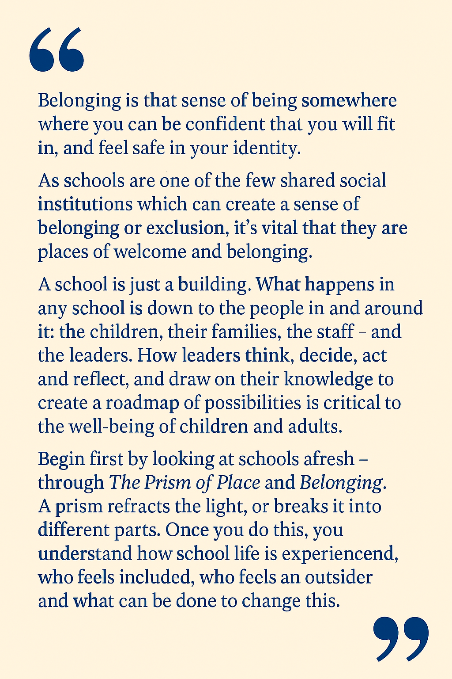
Acknowledgements
This resource has been informed not only by the published research literature but also by valuable professional discussions with leading researchers in the field of school belonging. We would like to acknowledge Professor Kathryn Riley (UCL Institute of Education) and Dr David Heyne (Deakin University) for their generosity in sharing their expertise and materials through personal communications. Their contributions have helped to shape the conceptual foundations and practical recommendations presented within this support pack.

by Kathryn Riley, Professor of Urban Education at IOE

Theoretical Foundations
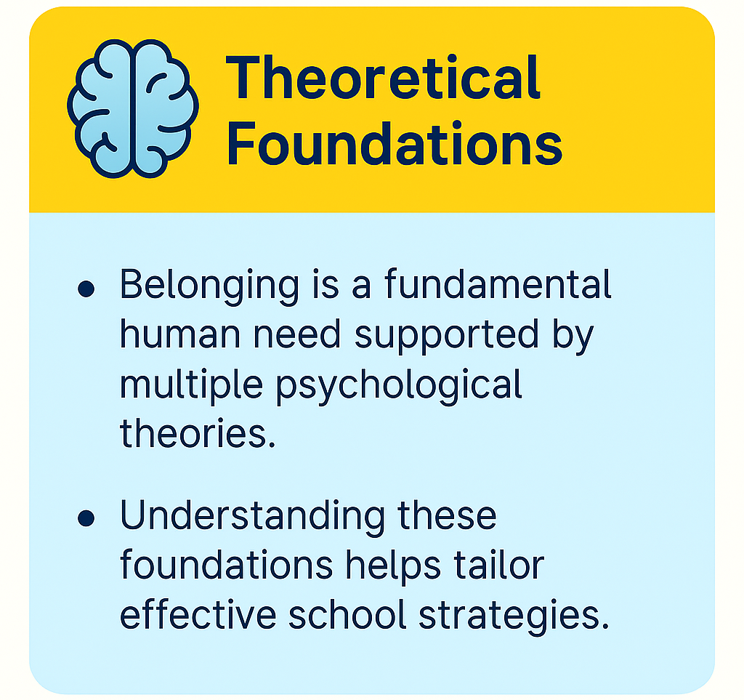
What is school belonging?
School belonging is the degree to which students feel accepted, valued, and included within their school community. It plays a vital role in supporting student wellbeing, attendance, and engagement. When students feel a genuine sense of belonging, they are more likely to thrive both academically and socially.
This is not a new concept, and schools already support belonging through everyday practices such as:
- Building positive relationships between staff and students.
- Creating inclusive classroom environments that celebrate diversity.
- Providing pastoral support and mentoring to meet individual needs.
- Encouraging student voice through initiatives like school councils and peer-led activities.

Strengthening these areas can make a meaningful difference, especially in secondary settings where identity and peer dynamics become more complex.
Theoretical Foundations:
School belongingness is grounded in psychological and educational theories that highlight the importance of feeling connected to others and valued within a community. Key ideas include:
-Belonging is a fundamental human need. This links to Maslow’s hierarchy of needs (see figure 1), where a sense of love and belonging is essential for self-esteem and self-actualization.
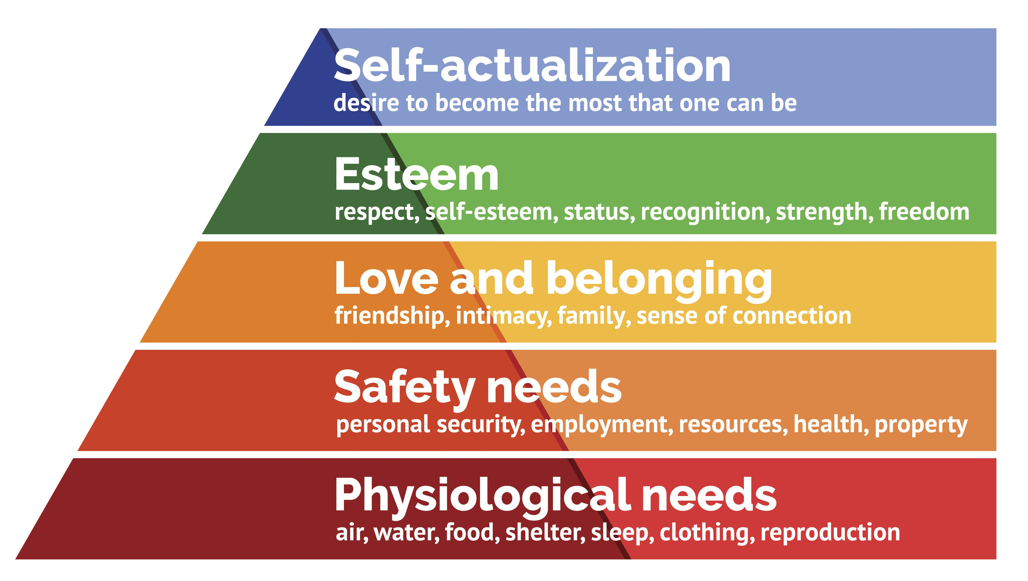
Figure 1. Maslow’s Hierarchy of needs
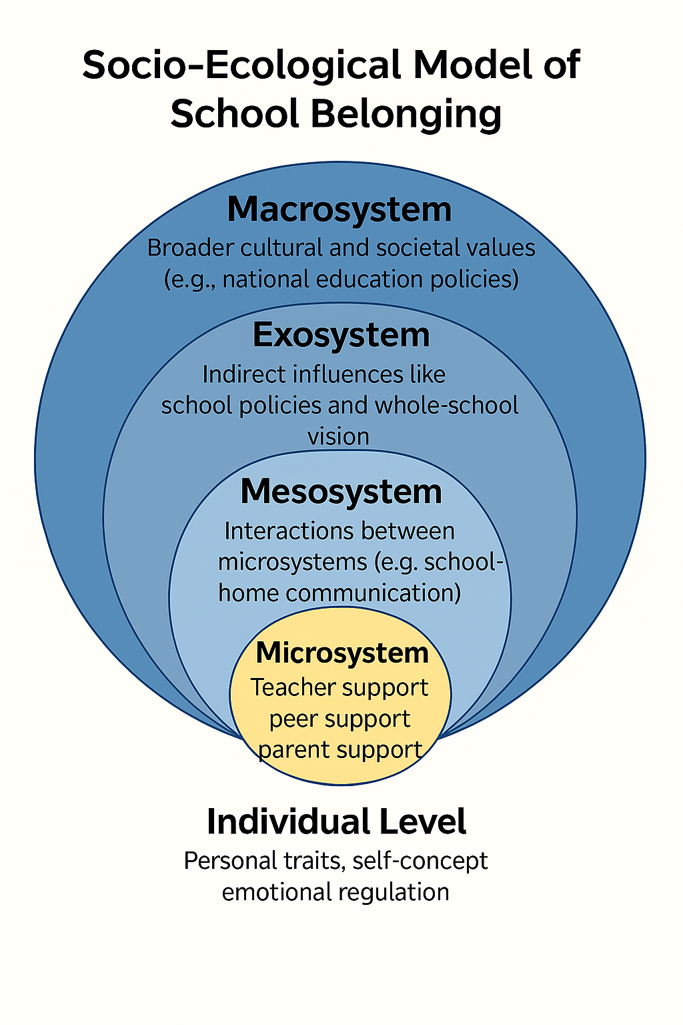
- Socio-Ecological Model of School Belonging (Allen et al., 2016) provides a systemic definition of school belonging as “a student’s sense of affiliation to his or her school, influenced by individual, relational and organizational factors insider a broader school community and within a political, cultural and geographical landscape unique to each school setting” (p.98). This model is grounded in Bronfenbrenner’s ecological systems theory and identifies five interconnected levels that influence a student’s sense of belonging:
Figure 2. Socio-Ecological Model of School Belonging (Allen, Vella-Brodrick, & Waters, 2018).
-Self-Determination Theory (SDT), developed by Deci and Ryan, posits that human motivation and psychological well-being are driven by the fulfillment of three basic psychological needs: autonomy, competence, and relatedness. The need for relatedness—feeling connected to others and experiencing a sense of belonging—is particularly relevant in educational settings. When students feel that they are genuinely cared for, accepted, and included by peers and teachers, their sense of relatedness is fulfilled, which in turn enhances their intrinsic motivation to engage in learning. In this way, SDT provides a strong theoretical foundation for understanding why fostering school belonging is essential: it not only supports emotional well-being but also promotes deeper engagement, resilience, and academic success.
-Attachment and belonging. Attachment theory, originally developed by Bowlby (Ainsworth, 1978) explains how early relationships with caregivers shape a person's ability to form secure connections. In educational contexts, this theory has been extended to understand how students form emotional bonds with their school environment—teachers, peers, and the school itself. Cooper (2008) developed a framework linking student attachment to school with emotional wellbeing and engagement. According to this view:
- A secure attachment to school mirrors the safety and trust found in healthy caregiver relationships.
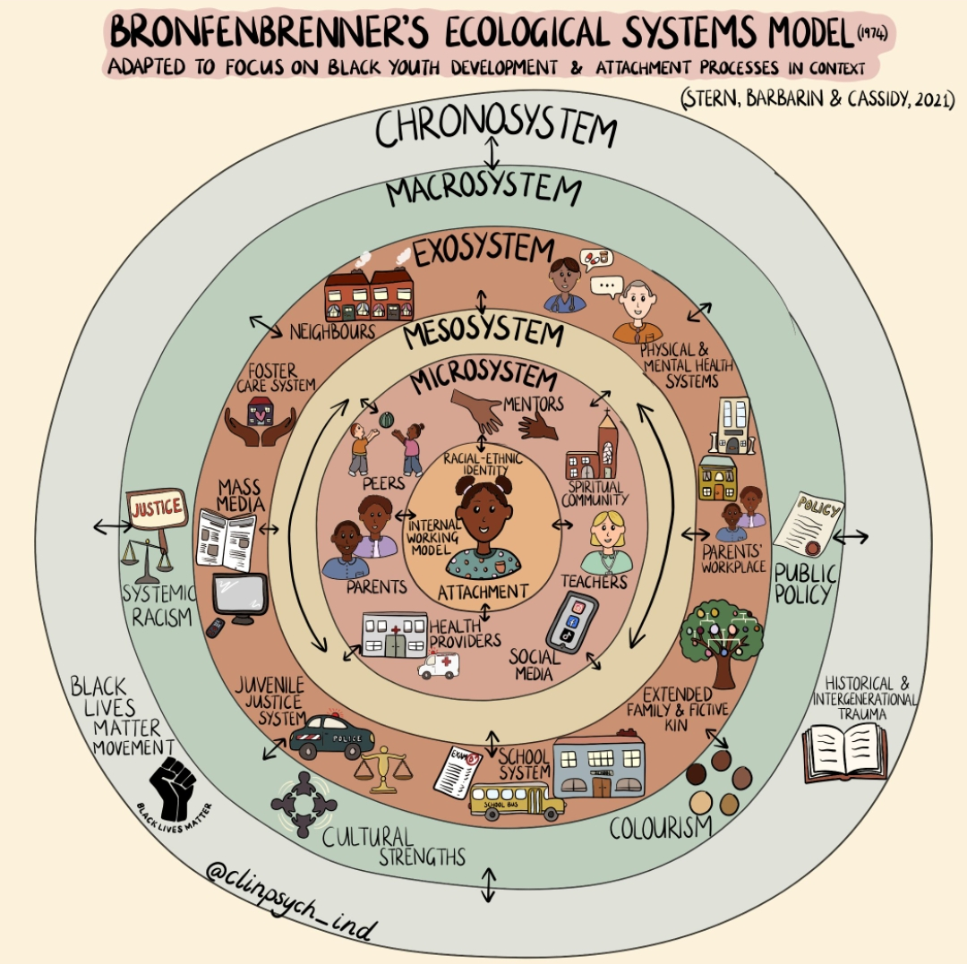
- Students who feel emotionally connected to their school are more likely to engage positively with learning and relationships.
-Identity, Equity and School Belonging
A student's sense of belonging is influenced not only by relationships within school but also by their social identities and experiences beyond school. Factors such as race, ethnicity, language, culture, religion, disability, socioeconomic background, care experience, poverty, gender identity, and sexuality can shape how included, valued, and understood a young person feels.

Drawing on Bronfenbrenner's ecological systems theory, school belonging is influenced by both immediate relationships and wider social, cultural, and political systems. Experiences of discrimination, exclusion, bias, or systemic inequalities can act as barriers to belonging, while inclusive and culturally responsive school environments can strengthen students' connection to school. The diagram above illustrates this model from a racial identity lens adapted to focus on Black Youth development and attachment processes in context.
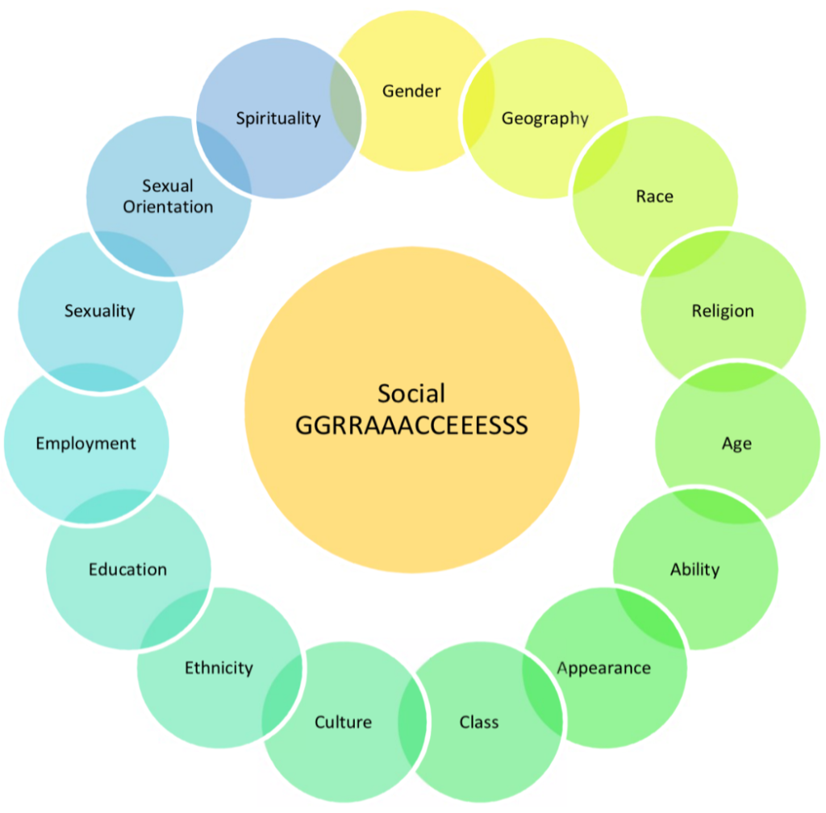
The Social GRACES framework (Burnham, 2012) reminds us that each person brings multiple aspects of identity that influence how they experience the world. These identities may confer privilege or disadvantage in different contexts and can affect opportunities for participation, representation, and belonging.
The Social GRACES framework encourages us to reflect on the factors described in the diagram below and how these may influence a student's experience of belonging, participation, and inclusion.

Figure 4. Social Graces (Burnham 2012)Image source: A transcultural supervision activity - edpsy.org.uk

Why School Belonging Matters: A Summary of Research Evidence
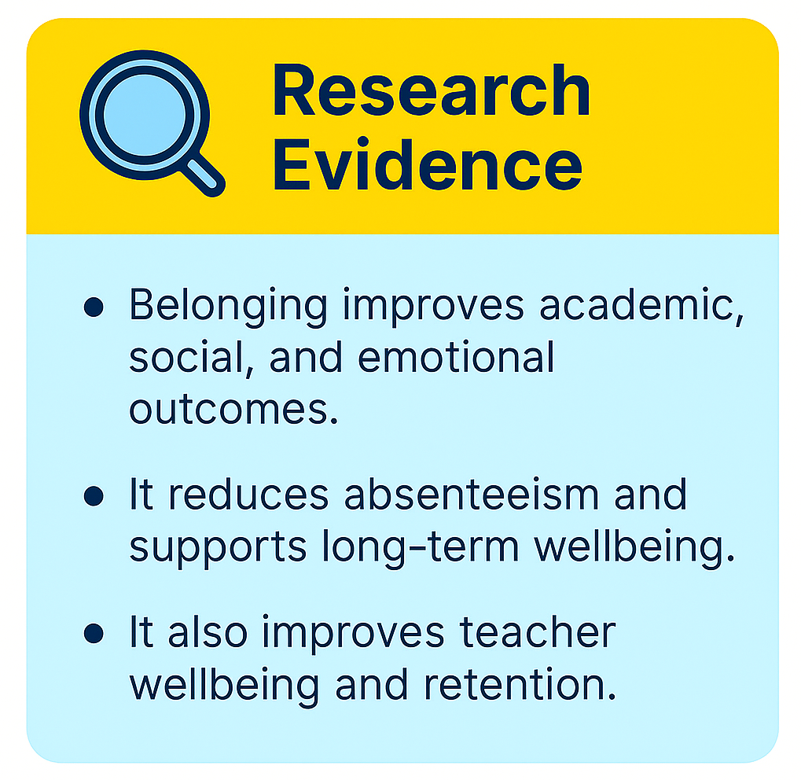
Research consistently shows that a strong sense of school belonging leads to a wide range of positive outcomes for students and for staff. Below is a summary of key findings, grouped into themes to support understanding.
Research consistently shows that students who feel a strong sense of belonging at school tend to experience a range of positive outcomes. These include improvements in academic achievement and stronger motivation, such as a focus on learning and personal growth. Belonging is also linked to better social-emotional wellbeing, including higher self-esteem and confidence, as well as increased engagement in learning—both in behaviour and mindset. Additionally, students with a greater sense of belonging are less likely to be absent or drop out. These patterns hold true across different age groups and socioeconomic backgrounds, highlighting the important role belonging plays in students’ overall school experience (Korpershoek et al., 2020).

Academic Development & Outcomes
A strong sense of belonging at school is a powerful driver of academic success. When students feel accepted, valued, and connected to their school community, they are more likely to engage positively with learning, show resilience in the face of challenges, and develop the confidence needed to reach their full potential. Belonging fosters emotional safety, which is essential for cognitive growth and motivation. Research consistently shows that students who feel they belong are more likely to attend school regularly, participate actively in class, and achieve higher academic outcomes. As such, belonging can have a positive impact on:

-Motivation & Effort:
Students’ drive to engage in schoolwork is closely tied to their sense of belonging.

-Positive Outcomes:
- Academic success, social inclusion, life satisfaction and socio-emotional health (Arslan et al., 2020; Brooms, 2019; Castro-Kemp et al., 2020)
- Reduced absenteeism, misconduct, disengagement, and early school leaving (Allen et al., 2016; Ansari et al., 2025)
- Increased academic hardiness (Abdollahi et al., 2020)

School Belonging as a Protective Factor
Belonging is inversely related to risk-taking behaviours (Goodenow, 1993; Slaten et al., 2016)
Roffey et al. (2019) emphasize that a strong sense of belonging:
- Reduces risk factors such as bullying, misconduct, truancy, and school dropout.
- Promotes resilience, emotional regulation, and prosocial behaviour.
- Supports academic motivation and long-term educational outcomes.
When schools intentionally foster belonging—through relational practices, inclusive environments, and consistent support—they help students form secure attachments to their learning environment. This not only improves behaviour and wellbeing but also creates a foundation for academic success.

Physical Health & Risk Reduction
Feeling a sense of belonging at school is closely linked to better mental and physical health in young people. When students feel connected and supported, they experience lower levels of stress, anxiety, and depression. This emotional security can also lead to improved sleep, stronger immune function, and healthier lifestyle choices. A positive school climate that fosters belonging not only supports academic success but also lays the foundation for lifelong wellbeing.

Health Benefits:
- Fewer internalizing/externalizing behaviours and improved wellbeing (Arslan, 2021)
- Lower risk of emotional distress, suicidal ideation, violence, and substance use (Steiner et al., 2019)

Belonging and attendance
A growing body of research highlights a strong link between students’ sense of school belonging and their attendance patterns. When students feel accepted, respected, and connected within their school environment, they are more likely to attend regularly and engage meaningfully in learning.
-A meta-analytic review by Korpershoek et al. (2020) found a negative correlation between school belonging and absenteeism, indicating that students with a stronger sense of belonging are less likely to be absent or drop out.
-Similarly, Štremfel et al. (2024) emphasized that school belonging is a key predictor of behavioural outcomes, including attendance, and called for multi-level interventions to support students at risk of disengagement. These findings underscore the importance of fostering inclusive, supportive school climates as a strategy not only for improving wellbeing but also for reducing chronic absenteeism and promoting educational equity.
Kearney and colleagues’ research (2020) highlights the critical role of school belonging in addressing problematic absenteeism. It emphasizes the need for multi-tiered interventions that include relational and psychological supports.

Staff Wellbeing and Retention: The Ripple Effect of Belonging
While much of the research on school belonging focuses on students, there is growing evidence that fostering a culture of belonging also significantly benefits teachers and school staff. A positive school climate where both students and staff feel connected, respected, and valued contributes to improved mental health and higher staff retention.
Recent research highlights the following:

Upbeat Research Report (2024) New Study Reveals Impact of Belonging and Wellbeing on Teacher Retention
  - A study by Upbeat, based on responses from over 15,000 teachers, found that a 10-percentage point increase in positive perceptions of belonging and wellbeing was associated with a 6-percentage point increase in teacher retention.
  - Schools with high belonging and wellbeing scores had retention rates over 16 percentage points higher than those with lower scores.
  - The impact was especially strong for early career teachers, who showed 18 percentage points higher retention when they felt a strong sense of belonging and wellbeing

National Education Union (NEU) Research (2023)
  - The NEU’s Place and Belonging in School inquiry found that staff retention was significantly higher in schools where teachers felt a strong sense of personal and professional agency and belonging.
  - Teachers in these schools reported feeling respected, accepted, and confident, which led to greater creativity, innovation, and commitment.
  - A shared language of belonging across staff and students contributed to a positive school culture and long-term staff engagement

Stark and Daulat Study on teacher wellbeing and retention (2025)
  - A peer-reviewed study found that greater psychological wellbeing among teachers predicts increased likelihood of staying in the profession and at their current school.

Broader Social Impact

Monash University:
Belonging is a potential solution to rising youth mental health issues, disconnection, and loneliness.

Kathleen Ethier (CDC):
The relational work done in schools has long-term impacts into adulthood — helping students feel safe, connected, and cared for.
These findings reinforce the importance of whole-school approaches to belonging that include staff as well as students. When schools invest in relational culture, everyone benefits.
In light of the evidence outlined in this section, the Schools’ White Paper sets out an expectation that all schools will measure pupils’ sense of school belonging by 2029 (DfE, 2026)

Notable Researchers
These experts specialise in school belonging, engagement, and climate, we recommend consulting their work if you want to develop further ideas in this area for your school:
- David Heyne: advocate for evidence-based frameworks that integrate student voice, family engagement, and school climate to improve attendance and belonging.
- Kelly-Ann Allen: A leading voice in school belonging.
- Sara Lindstrom Johnson: Expert in school climate and its impact.
- Professor Kathryn Riley: Professor of Urban Education and an international scholar whose work bridges policy and practice. She has contributed to produce ‘Creating Place and Belonging in Schools’ at UCL Institute of Education which offers many practical tools and resources.

Whole School Strategies: Creating a Culture of Belonging
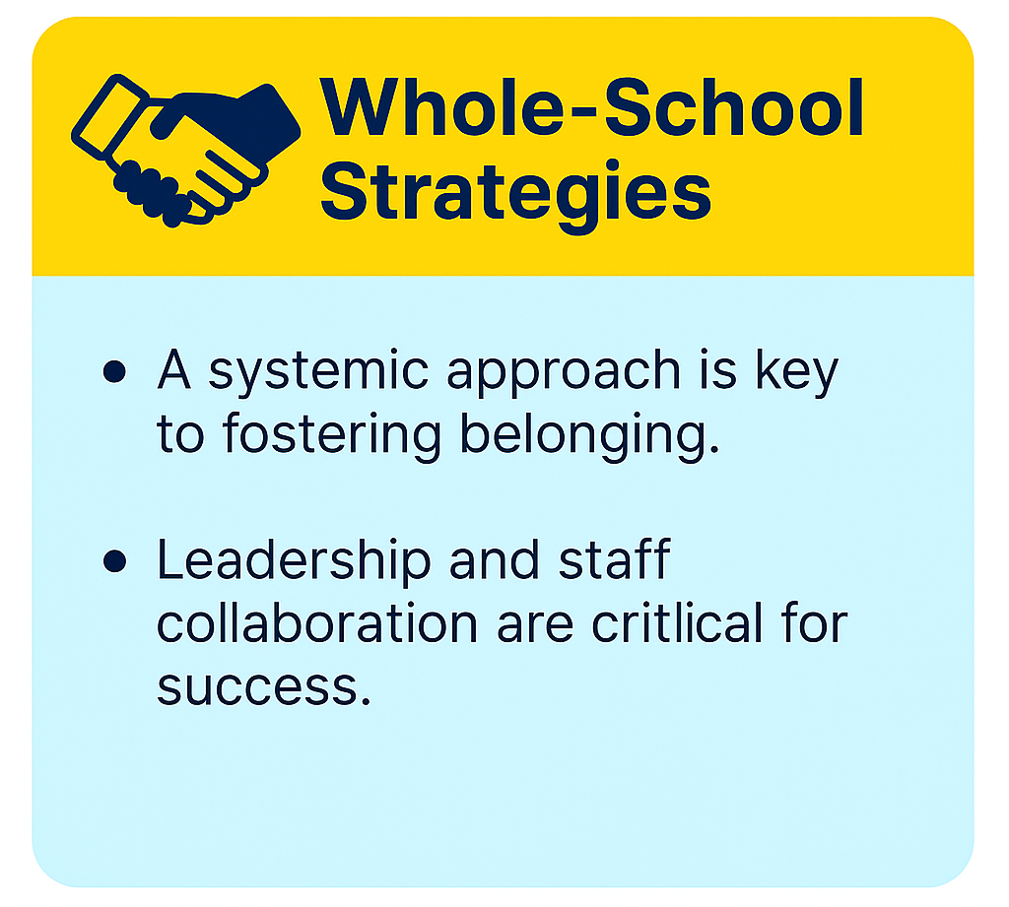
Creating a culture of belonging in schools is essential for fostering inclusive, connected communities where students and parents feel valued and engaged. “School cultures that foster trust and draw on the strengths of communities contribute to the development of young people’s sense of agency and belonging” (Riley, 2019, p.91).
This section provides practical strategies for promoting a whole school approach to belonging. Interventions should be inclusive, culturally responsive, and tailored to adolescent needs.
The Socio-Ecological Model of School Belonging mentioned before (see image below from Allen et al., 2016) emphasizes how working at the different system levels is important for the best outcomes.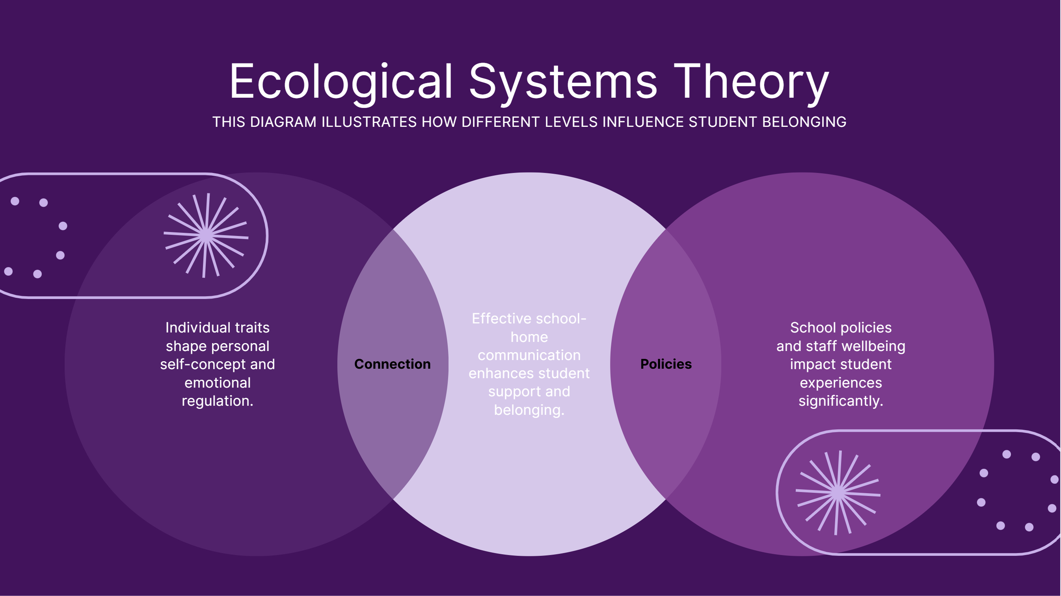
Figure 5. A Whole School approach to belonging from and Ecological Systems Theory lens
Schools should therefore adopt a whole-school approach that builds inclusive, collaborative communities. The following outlines key areas to focus on when developing a whole-school culture of belonging.

Encourage Positive Relationships
- Every student should have at least one trusted adult in school.
- Relationships with non-teaching staff are also important.
- Emotional support is as vital as academic support.
- A school that are actively inclusive of neurodiversity and emotionally differentiates according to the needs of different students. This means recognizing that some young people need a more nuanced emotional support than others.

Foster a Positive School Climate
- Leadership must clearly communicate the value of belonging.
- Behaviour policies should include expectations around fostering belonging.
- Teach social-emotional skills from the start to support peer connection.
- Flexible behaviour policies that promote relational approaches to discipline and emphasise restorative practice and empathy, and connection over punishment (see Rutledge (2022)

Value Learning
- Emphasise the purpose and relevance of learning.
- Set appropriate expectations.
- Teachers demonstrate confidence and passion in their teaching.

Proactively Support Mental Health
- Staff need CPD to identify and respond to wellbeing concerns.
- Knowing students well helps staff notice subtle changes in behaviour.
- Early intervention can prevent more serious issues.

Engage Parents
- Parents’ attitudes toward school influence their children’s sense of belonging.
- Communicate the importance of belonging.
- Build a strong sense of community with families.

Promote Equity, Inclusion and Representation
- Ensure pupils see their cultures, languages, identities and experiences reflected in displays, resources and the curriculum.
- Create opportunities for pupils, families and staff to share and celebrate diverse cultures, languages and traditions.
- Make communication accessible through translated materials and interpreters where needed.
- Challenge discrimination, prejudice and bias, including racism and microaggressions.
- Review attendance, behaviour and exclusion data to identify and address inequities affecting particular groups.
- Seek the views of underrepresented pupils and families and use their feedback to shape school practice.
- Avoid deficit narratives such as "hard-to-reach families" and adopt a stance of curiosity, collaboration and partnership.
- Ensure leadership opportunities, pupil voice groups and extracurricular activities are representative of the school community.
- Help all pupils feel that they are seen, respected, valued and able to belong as their authentic selves.
- 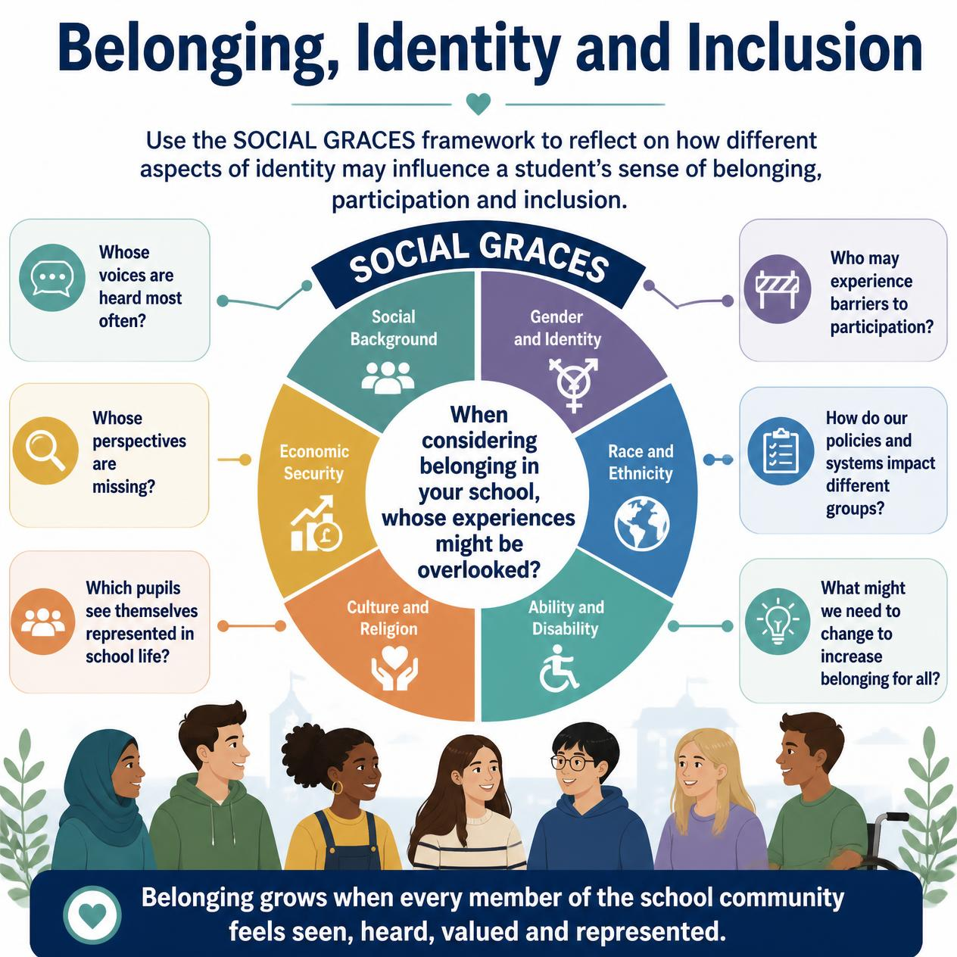

Figure 6. Social Graces applied to school belonging.

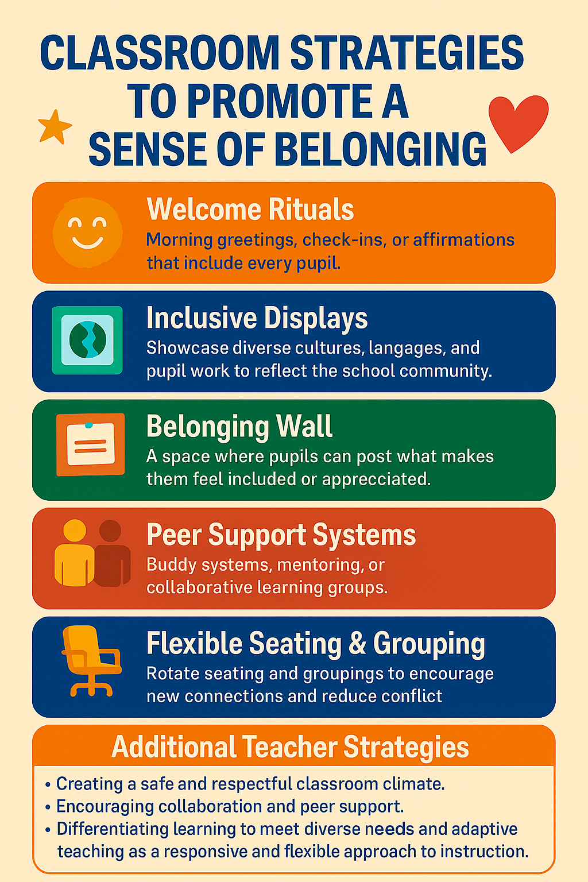
Classroom Strategies
Here are some practical ways to embed belonging into everyday classroom life.
Your link EP can support you in thinking about appropriate interventions for your context based on the above recommendations.

Conducting Action Research
Action research empowers schools to explore and enhance students’ sense of belonging through collaborative inquiry. It also helps you understand if your approaches are working. “Engagement in collaborative research inquiry about place and belonging helps develop that sense of belonging and is a powerful tool for positive school transformation” (Riley, 2019, p.91).
Suggested steps include:
- Assemble a committed research team. This could include school staff, students, governors, parents and outside professionals.
- Consider using the audit tool in our Learning Partnership Website to identify strengths, priorities for development and next steps for action..
- Conduct a baseline assessment using tools like the PSSM or PSSC (see below).
- Design and implement interventions focused on key areas identified.
- Monitor progress by re-administering the chosen instrument.
- Analyse data to identify subgroups needing support and refine strategies accordingly
Schools can use the School Belonging Tools (below) to assess students’ sense of belonging before and after interventions. This helps identify areas of need and evaluate the impact of strategies. Below are some examples of belonging scales you could use with students in your school.

School Belonging Scales

The Psychological Sense of School Membership Scale (PSSM)

- Developed by Goodenow (1993), revised by Wagle et al. (2018)
- 9-item scale using a 4-point Likert scale
- Measures students’ sense of being valued and accepted
- Validated across diverse populations

Quick and easy to use on the MS form provided (link above)

2. Perception-of-School-Social-Bonding-Instrument.pdf

Developed by Gentle-Genitty et al. (2024)

- 10-item self-report measure based on Hirschi’s social bonding theory
- Assesses attachment, involvement, and belief with a quick scoring system to plot school effectiveness for each area.
- Uses a 5-point Likert scale
- Valid for universal screening and identifying students at risk of disengagement
3. School Belonging Scale
Based on Allen et al. (2018), this tool helps schools identify which of the six key relational and individual factors are most relevant to their students:
Students rate 60 statements across six domains: teacher support, parent support, peer support, self-connection, learning connection, and help-seeking. Each domain has 10 items rated on a 3-point scale using a 3-point scale: Not at all (0), Somewhat (1), Very much (2). Each domain has 10 items, with scores ranging from 0 to 20. It can be used pre- and post-intervention to measure change and helps identify strengths and areas for targeted support. This scale is a more thorough assessment but will take a bit longer for students to complete but allows us to compare between the 6 domains, which could be helpful.
These tools provide practical ways to assess and monitor students’ sense of belonging and guide targeted interventions to improve school climate and student engagement.

More Practical Tools to support belonging

Staff Reflection Tools to Promote Belonging and Inclusion
These tools are designed to support staff reflection, problem-solving, and strategic planning in schools, with EP facilitation where appropriate:
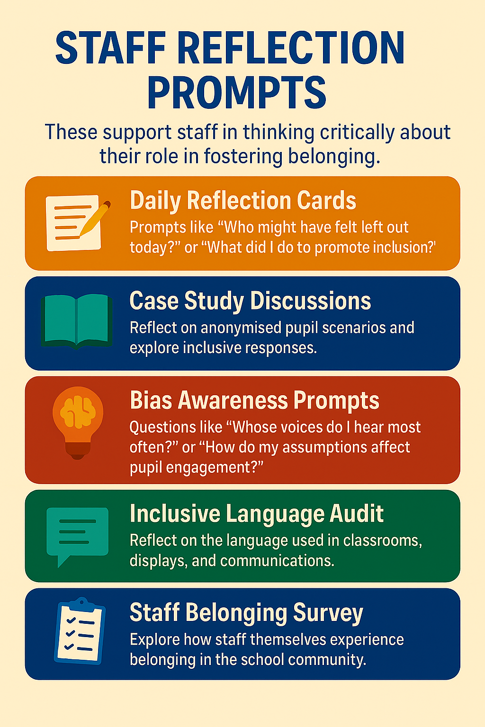

Solution Circles
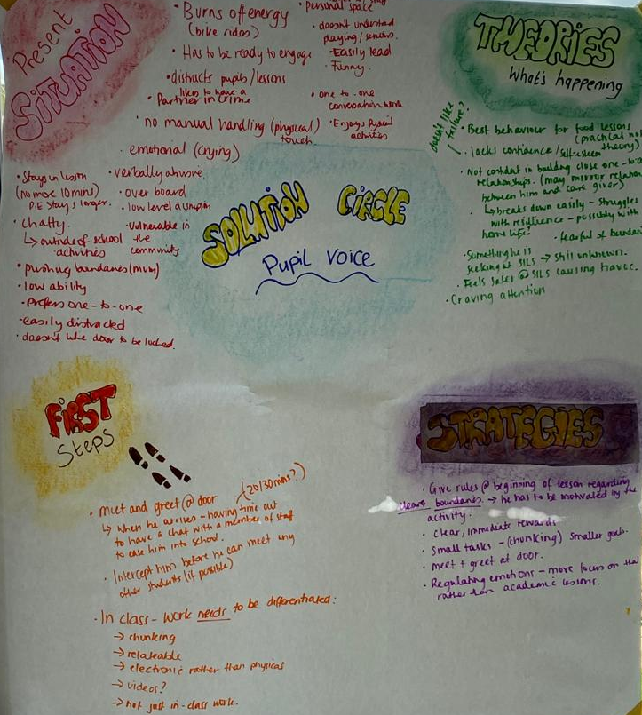
Purpose: A quick, structured peer-support tool for staff to collaboratively problem-solve around a pupil or situation.
Use: EPs can facilitate Solution Circles or share more information with school about this tool.
Link to Belonging: Encourages collective responsibility and creative thinking to support pupils at risk of exclusion.


Circle of Adults
Purpose: A problem-solving process which is intended to support teams of adults in school; particularly those who are working with young people with SEMH needs which can present challenges to the adults who support them.
Use: During the session, the group are guided through a set of questions by the facilitator, with the aim of gaining a deeper understanding of the young person’s behaviour, unmet needs (including belonging) and to develop new strategies to support them.
Link to Belonging: Builds empathy and shared understanding, helping staff feel more connected to the pupil’s experience.
Link to Belonging: Promotes hope, agency, and collective commitment to inclusion and pupil wellbeing.

Pupil Voice Activities
These activities aim to help pupils express their experiences, needs, and ideas around belonging.
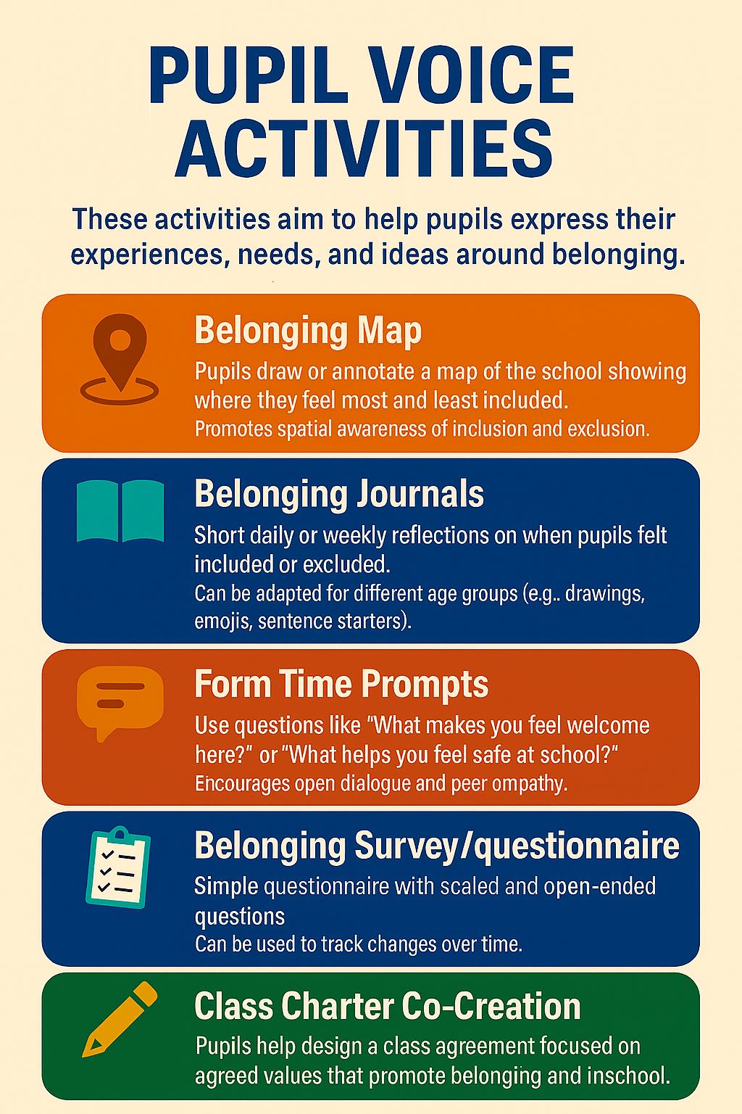
If you have identified individual pupils who are struggling with their sense of belonging to the school community, you could use the below person-centred techniques to better understand their needs:

PATH
A PATH (Planning Alternative Tomorrows with Hope) is a person-centred planning tool that brings together a young person and the people who are important to them to create a shared vision for the future. By ensuring the young person's voice is central to the process, PATH promotes agency, participation, hope and ownership, all of which are key foundations of school belonging. The collaborative nature of PATH also strengthens relationships and helps young people feel heard, valued and supported within their school community.

A typical PATH involves a group of 5-10 people chosen by the young person and usually takes around 90 minutes. The Educational Psychology Service can support schools to facilitate a PATH or provide further information about how it can be used to promote belonging and inclusion.

Drawing the Ideal School
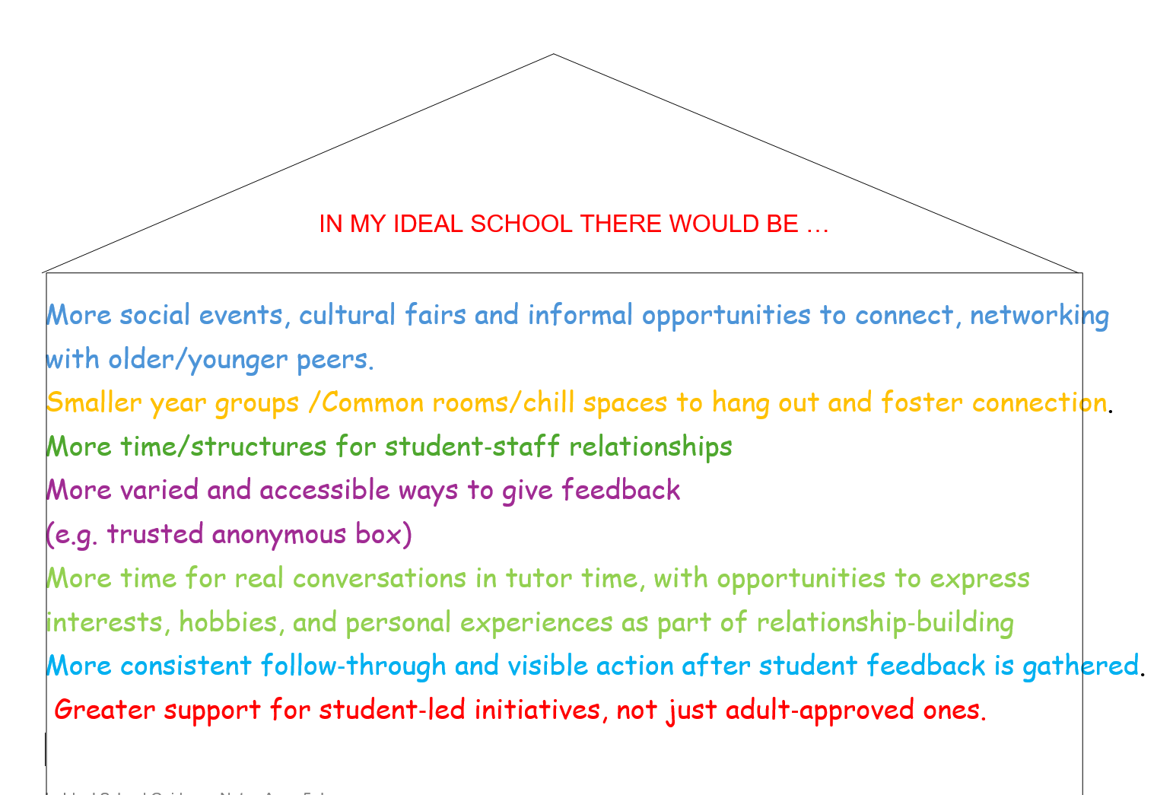
It is another person-centred visual tool where pupils create visual representations of what a welcoming, inclusive school looks like to them. It highlights what matters most to pupils and informs school culture and environment planning.

Using School Wellbeing Cards
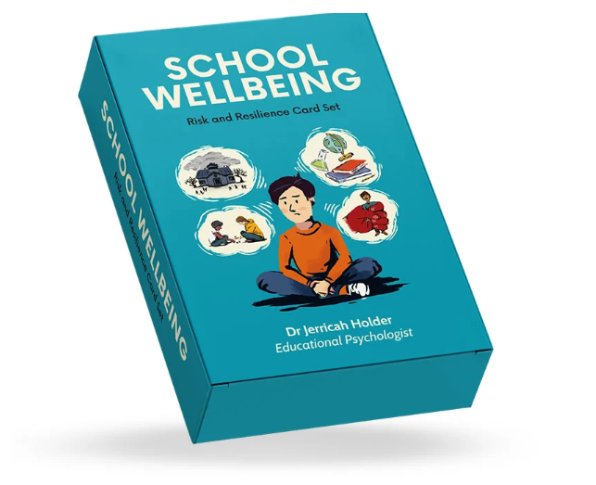
A structured tool to help pupils reflect on their wellbeing and school experience.
Supports emotional literacy and gives staff insight into pupil needs and strengths.

UCL (Professor Riley and colleagues) have created has a website with resources to help school develop a sense of belonging including videos and booklets.

Further Resources
Schools looking for a shorter introduction to the ideas in this document may wish to access the Belonging Resource Booklet, available on the Learning Partnership website. The booklet provides a practical overview of key concepts and strategies to support implementation.

References
Abdollahi, A., Panahipour, S., Akhavan Tafti, M., & Allen, K.-A. (2020). Academic hardiness as a mediator for the relationship between school belonging and academic stress. Psychology in the Schools, 57(5), 823–832.
Ainsworth, M. D. S. (1978). The Bowlby Ainsworth Attachment Theory. Behavioral and brain sciences, 1(3), 436-438.
Allen, K.-A., Jamshidi, N., Berger, E., Reupert, A., Wurf, G., & May, F. (2022). Impact of school-based interventions for building school belonging in adolescence: A systematic review. Educational Psychology Review, 34(1), 229–257.
Allen, K.-A., Kern, M. L., Vella-Brodrick, D., Hattie, J., & Waters, L. (2018). What schools need to know about fostering school belonging: A meta-analysis. Educational Psychology Review, 30(1), 1–34.
Allen, K.-A., Vella-Brodrick, D., & Waters, L. (2016). Fostering school belonging in secondary schools using a socio-ecological framework. Educational and Developmental Psychologist, 33(1), 97–121.
Ansari, A., Kadir, L., Plasman, J., & Purtell, K. M. (2025). Rebuilding connections post-COVID: The importance of school belonging for addressing absenteeism. Crane Center for Early Childhood Research and Policy at The Ohio State University. https://crane. osu. edu/ourwork/rebuilding-connections-post-covid-the-importance-of-school-belonging-foraddressing-absenteeism.
Arslan, G. (2021). School belongingness, well-being, and mental health among adolescents: Exploring the role of loneliness. Australian Journal of Psychology, 73(1), 70–80.
Arslan, G., Allen, K.-A., & Ryan, T. (2020). Exploring the impacts of school belonging on youth wellbeing and mental health among Turkish adolescents. Child Indicators Research, 13(5), 1619–1635.
Brooms, D. R. (2019). “I was just trying to make it”: Examining urban Black males’ sense of belonging, schooling experiences, and academic success. Urban Education, 54(6), 804-830.
Burnham, J. (2012). Developments in Social GRRRAAACCEEESSS: visible–invisible
and voiced–unvoiced 1. In Culture and reflexivity in systemic psychotherapy (pp.
139-160). Routledge.
Castro-Kemp, S., Palikara, O., Gaona, C., Eirinaki, V., & Furlong, M. J. (2020). The role of psychological sense of school membership and postcode as predictors of profiles of socio-emotional health in primary school children in England. School Mental Health, 12(2), 284-295.
Cooper, P. (2008). Nurturing attachment to school: Contemporary perspectives on social, emotional and behavioural difficulties. Pastoral Care in Education, 26(1), 13–22.
Gentle-Genitty, C. S., Keppens, G., & Kearney, C. A. (2025). Perception of school social bonding (PSSB) instrument: Structural and concurrent validity. Contemporary School Psychology, 29(1), 213-220.
Goodenow, C. (1993). The psychological sense of school membership among adolescents: Scale development and educational correlates. Psychology in the Schools, 30(1), 79–90.
Kearney, C. A., Heyne, D., & Gonzálvez, C. (2020). School attendance and problematic school absenteeism in youth. Frontiers in psychology, 11, 602242. Frontiers | Editorial: School Attendance and Problematic School Absenteeism in Youth
Korpershoek, H., Canrinus, E. T., Fokkens-Bruinsma, M., & de Boer, H. (2020). The relationships between school belonging and students’ motivational, social-emotional, behavioural, and academic outcomes in secondary education: A meta-analytic review. Research Papers in Education, 35(6), 641–680.
Maslow, A. H. (1943). A theory of human motivation. Psychological Review, 50(4), 370–396.
Riley, K. (2019). Agency and belonging: What transformative actions can schools take to help create a sense of place and belonging? Educational and Child Psychology, 36(4), 91–103.
Riley, K., Coates, M., & Allen, T. (2020). Place and belonging in school: Why it matters today. University College London Institute of Education.
Roffey, S., Boyle, C., & Allen, K.-A. (2019). School belonging – Why are our students longing to belong to school? Educational and Child Psychology, 36(2), 6–8.
Ruttledge, R. (2022). A whole school approach to building relationships, promoting positive behaviour and reducing teacher stress in a secondary school. Educational Psychology in Practice, 38(3), 237–258.
Slaten, C. D., Ferguson, J. K., Allen, K.-A., Vella-Brodrick, D., & Waters, L. (2016). School belonging: A review of the history, current trends, and future directions. Educational and Developmental Psychologist, 33(1), 1–15.
Stark, K., & Daulat, N. (2025). Teacher well-being and teacher retention: Establishing a link. Social Psychology of Education, 28(1), 147.
Steiner, R. J., Sheremenko, G., Lesesne, C., Dittus, P. J., Sieving, R. E., & Ethier, K. A. (2019). Adolescent connectedness and adult health outcomes. Pediatrics, 144(1).
Štremfel, U., Šterman Ivančič, K., & Peras, I. (2024). Addressing the sense of school belonging among all students? A systematic literature review. European Journal of Investigation in Health, Psychology and Education, 14(11), 2901–2917.
Wagle, R., Dowdy, E., Yang, C., Palikara, O., Castro, S., Nylund-Gibson, K., & Furlong, M. J. (2018). Preliminary investigation of the psychological sense of school membership scale with primary school students in a cross-cultural context. School Psychology International, 39(6), 568-586. https://doi.org/10.1177/0143034318803670

